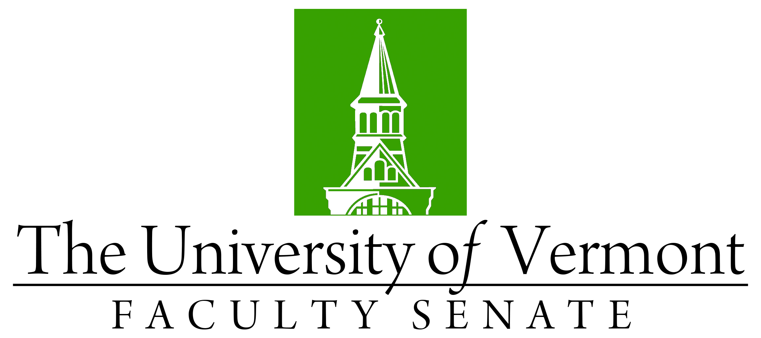

DRAFT

Faculty Senate Meeting
Monday, January 27th, 2020
4:00 – 5:30 pm, Waterman Memorial Lounge

Agenda

4:00 | - Faculty Senate President’s Welcome Remarks – Thomas Chittenden [10 min]
4:10 | - Consent Agenda (VOTE) [3 min]  - Minutes of the 12/16/19 Faculty Senate Meeting  Curricular Affairs  - New Post-Professional Doctorate in Occupational Therapy (CNHS/GRAD  - Name change PhD in Animal, Nutrition, and Food Sciences to the PhD in Animal Biosciences (CALS/GRAD)  - No contest termination Bachelor of Music degree (CAS)​
4:13 | - Conferral of Degrees (VOTE) [7 min]
4:20 | - Divestment of Fossil Fuels – Don Ross FPPC [15 min]  - RESOLUTION: The Faculty Senate affirms its support for divestment from the fossil fuel industry investments and requests Board action in 2020 (VOTE)
4:35 | - Residential Learning Community Assessment Plan – Alex Yin & J. Dickinson [15 min]
4:50 | - General Education Framework and Refinement Process– J. Dickinson [35 min]
5:25 | - New Business [5 min]
5:30 | - Adjourn

