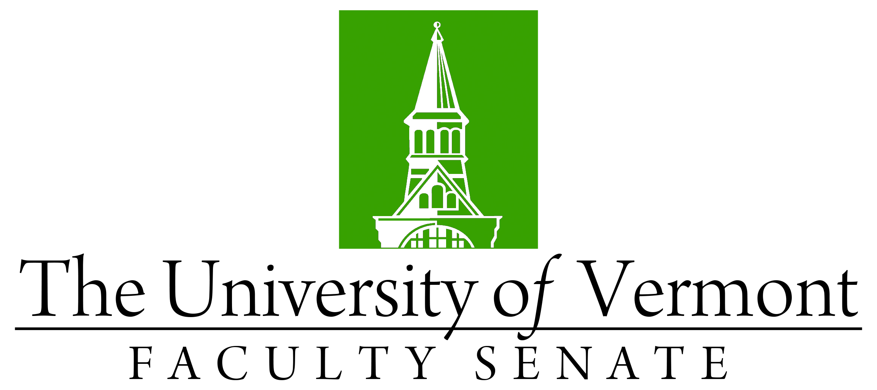

Faculty Senate Meeting

Monday, February 24th, 2020

4:00 – 5:30 pm, Waterman Memorial Lounge

Agenda

|  |  |
| --- | --- |
| 4:00 | 1. Faculty Senate President’s Welcome Remarks – Thomas Chittenden *[10 min]* |
| 4:10 | 1. Consent Agenda (vote) *[5 min]*    * Minutes of the 1/27/20 Faculty Senate Meeting   *Curricular Affairs*   * 1. Name Change: MS in Animal Science, CALS   2. Report Out: New Concentration for ENSC Major, CAS/CALS/RSENR |
| 4:15 | 1. Call for Nominations *[5 min].*  * *Senate President-Elect, and* * *two (2) at-large members to the Executive Council* |
| 4:20 | 1. Student Affairs Committee (SAC) Resolution: To Revise the University Policy on Repeated Courses – Ken Allen & Jen Prue (vote*) [20 min]* |
| 4:40 | 1. Student Affairs Committee (SAC) Resolution: To Revise the Students Rights and Responsibilities Policy Regarding Class Attendance – Ken Allen & Jen Prue (vote) *[20 min]* |
| 5:00 | 1. General Education Process Update – J Dickinson *[10 min]* |
| 5:10 | 1. University Disaster Preparedness & Decision-Making during Emergency Events – Gary Derr *[15 min]* |
| 5:25 | 1. New Business *[5 min]* |
| 5:30 | 1. Adjourn |