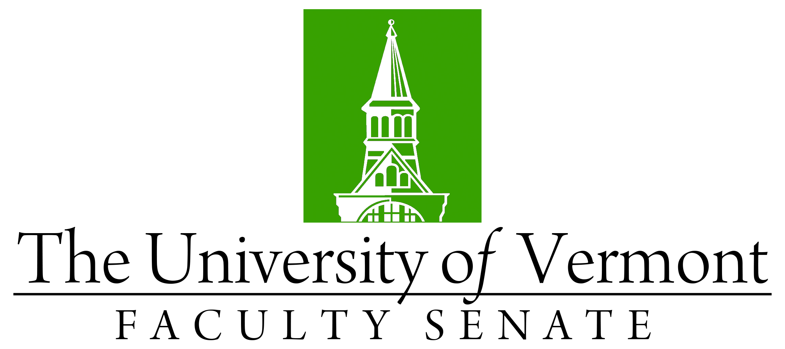

DRAFT

Faculty Senate Meeting
Monday, December 16th, 2019
4:00 – 5:30 pm, Waterman Memorial Lounge

Agenda

4:00 | - Faculty Senate President’s Welcome Remarks – Thomas Chittenden [5 min]
4:05 | - Consent Agenda (vote) [5 min]  - Minutes of the 11/18/19 Faculty Senate Meeting  Curricular Affairs  - New Minor Biosecurity (CALS)  - No Contest Termination BA in Engineering (CEMS)  - Policy Documents  - Revisions: Timeline for Policy & Proposal Review Process  - Report Out (no vote required): Substantial Changes to the Global Studies Major & Minor
4:10 | - Curricular Affairs: Proposal to Deactivate an Academic Program & Proposal to Reactivate an Academic Program – Laura Almstead (vote) [5 min]
4:15 | - Impact of the basing of the F35 at the Burlington International Airport (vote) [20 min]
4:35 | - Diversity Curriculum Review Committee Competencies Update – Pablo Bose (vote) [15 min]
4:50 | - UVM's contract with Elsevier's Science Direct - Dean of Libraries Bryn Geffert [20 min]
5:10 | - Residential Learning Communities Report – Chris Burns and J. Dickinson [20 min]
5:30 | - New Business [5 min]

