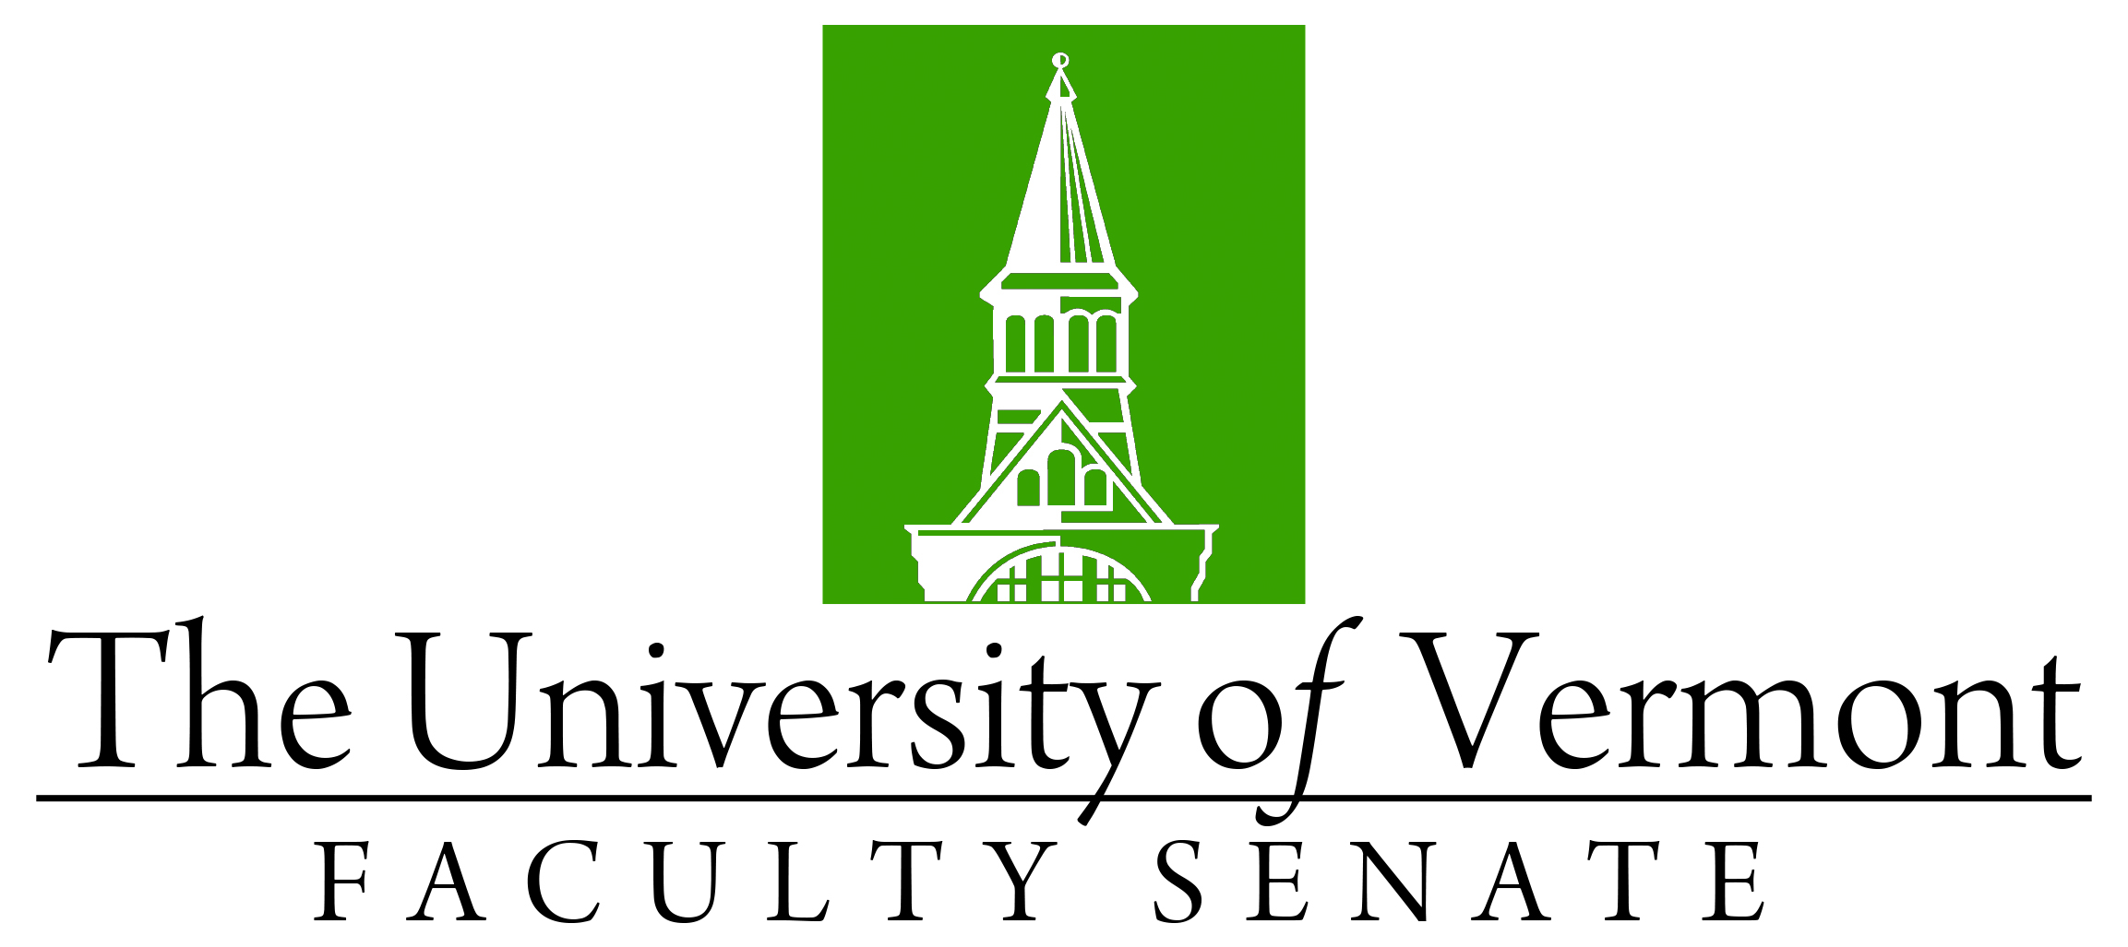

Faculty Senate Meeting
Monday, September 21, 2020
4:00 – 5:30 pm, Online via Teams

Agenda

4:00 | - Faculty Senate President’s Welcome Remarks – Thomas Chittenden [10 min]
4:10 | - Consent Agenda (vote) [5 min]  - Minutes of the 8/24/20 Faculty Senate Meeting  - Curricular Affairs  - Online option for existing CGS in Complex Systems & Data Science, CEMS  - New Credential: Micro-Certificate of Graduate Studies, Grad College
4:15 | - Conferral of Degrees (vote) [5 min]
4:20 | - Spring 2021 Academic Calendar Revisions – Bill Falls (vote) [25 min]
4:45 | - Liberal Arts Gen Ed Requirements– Pablo Bose (vote) [20 min]
5:05 | - UVM Re-organization Committee Update on Effort – Dean Jenemann [20 min]
5:25 | - New Business [5 min]
5:30 | - Adjourn

2020-2021 Faculty Senate Meetings
Mondays 4:00 – 5:30 PM (exceptions noted)
8/24/20 – 3:00 – 4:30 PM
9/21/20
10/19/20
11/16/20
12/21/20 – 3:00 – 4:30 PM
2/1/21
3/15/21
4/19/21
5/20/21 – 3:00 – 4:30 PM Thursday

