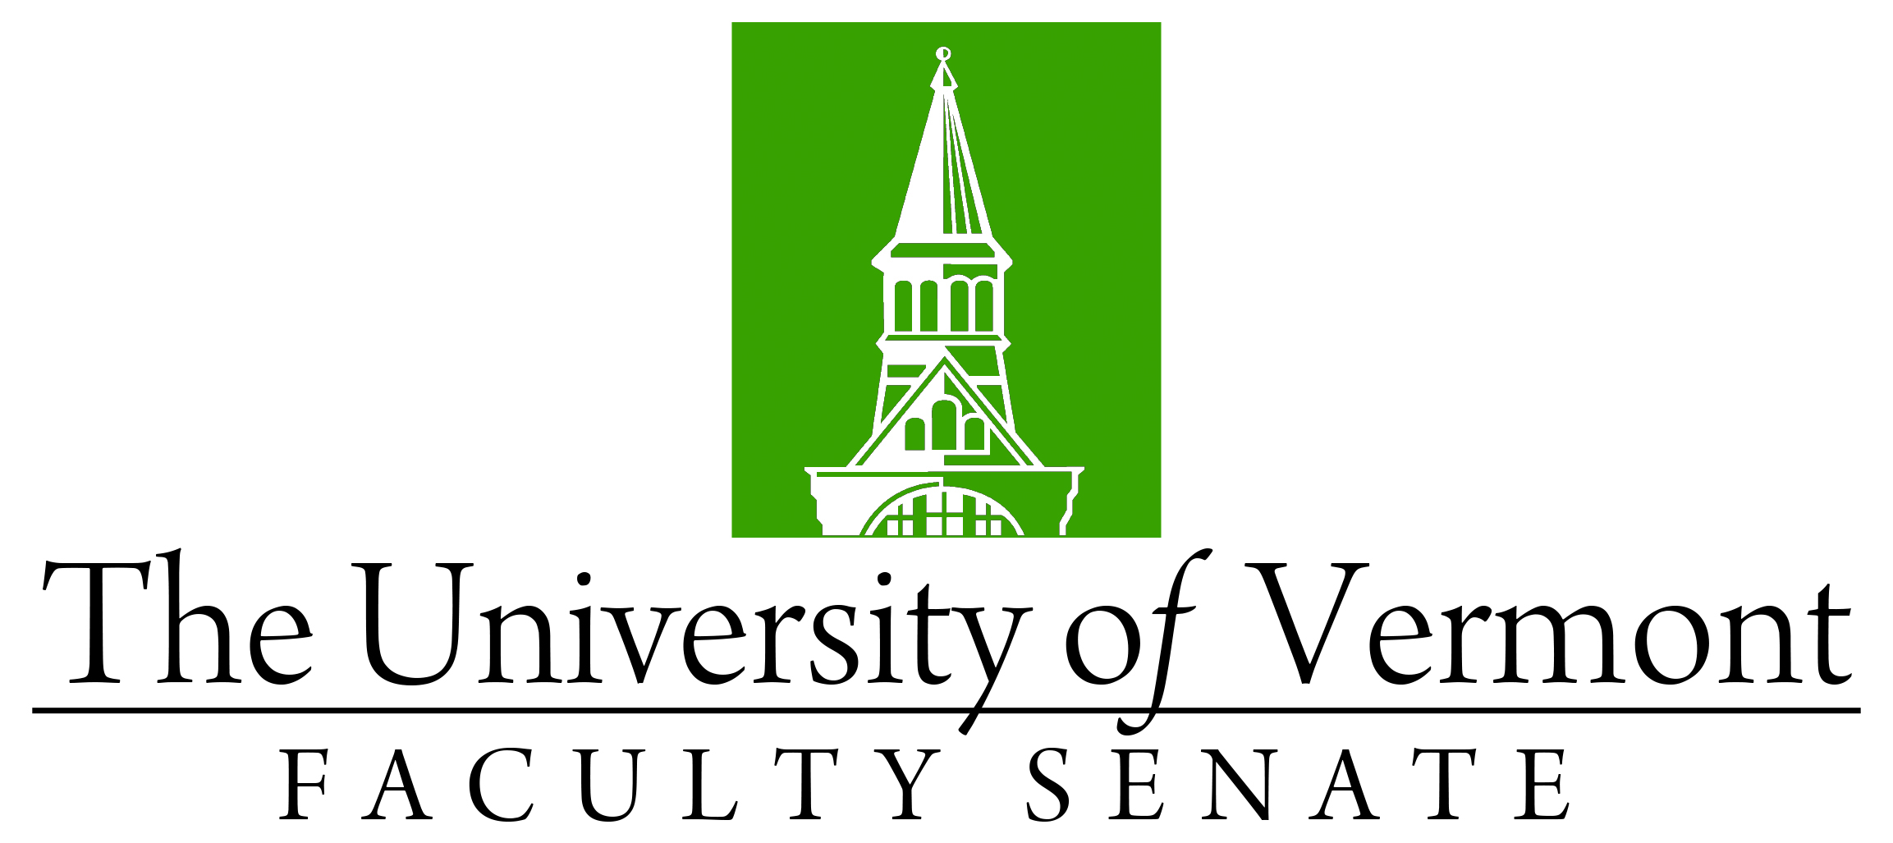

Faculty Senate Meeting
Monday, September 20, 2021
4:00 – 5:30 pm, Online via Teams

Agenda

4:00 | - Faculty Senate President’s Welcome Remarks – Thomas Borchert [5 min]
4:05 | - Consent Agenda (vote) [5 min]  - Minutes of the August 2021 Faculty Senate Meeting  - Curricular Affairs CAC Consent Agenda (vote)  - Name Change Department of Leadership and Developmental Sciences (DLDS) (CESS)  - No Contest Termination MS and PhD in Molecular Physiology and Biophysics (GRAD/LCOM)  - No Contest Termination PhD in Pharmacology (GRAD/LCOM)  - No Contest Termination PhD in Microbiology and Molecular Genetics (GRAD/LCOM)
4:10 | - Degree Conferrals (vote) [5 min]
4:15 | - Resolutions in Memoriam (vote) [10 min]  - Justin Joffe, Professor Emeritus of Psychology (CAS) - John Green  - James Loewen, Professor Emeritus of Sociology (CAS) - Thomas Macias
4:25 | - UVM Forward and COVID discussion – Gary Derr [20 min]
4:45 | - Procedures for various levels of Academic Organization (discussion) [attachments will be posted by Thursday, 9/16 at 5:00 PM] [25 min]
5:10 | - UVM and R1 Status – Kirk Dombrowski [attachments will be posted by Thursday, 9/16 at 5:00 PM] [15 min]
5:25 | - New Business [5 min]
5:30 | - Adjourn

2021-2022 Faculty Senate Meetings
Mondays 4:00 – 5:30 PM (exceptions noted)
8/23/21 – 3:00 – 4:30 PM
9/20/21
10/18/21
11/15/21
12/20/21 – 3:00 – 4:30 PM
1/24/22
2/28/22
3/28/22
4/25/22
5/19/22 – 3:00 – 4:30 PM Thursday

