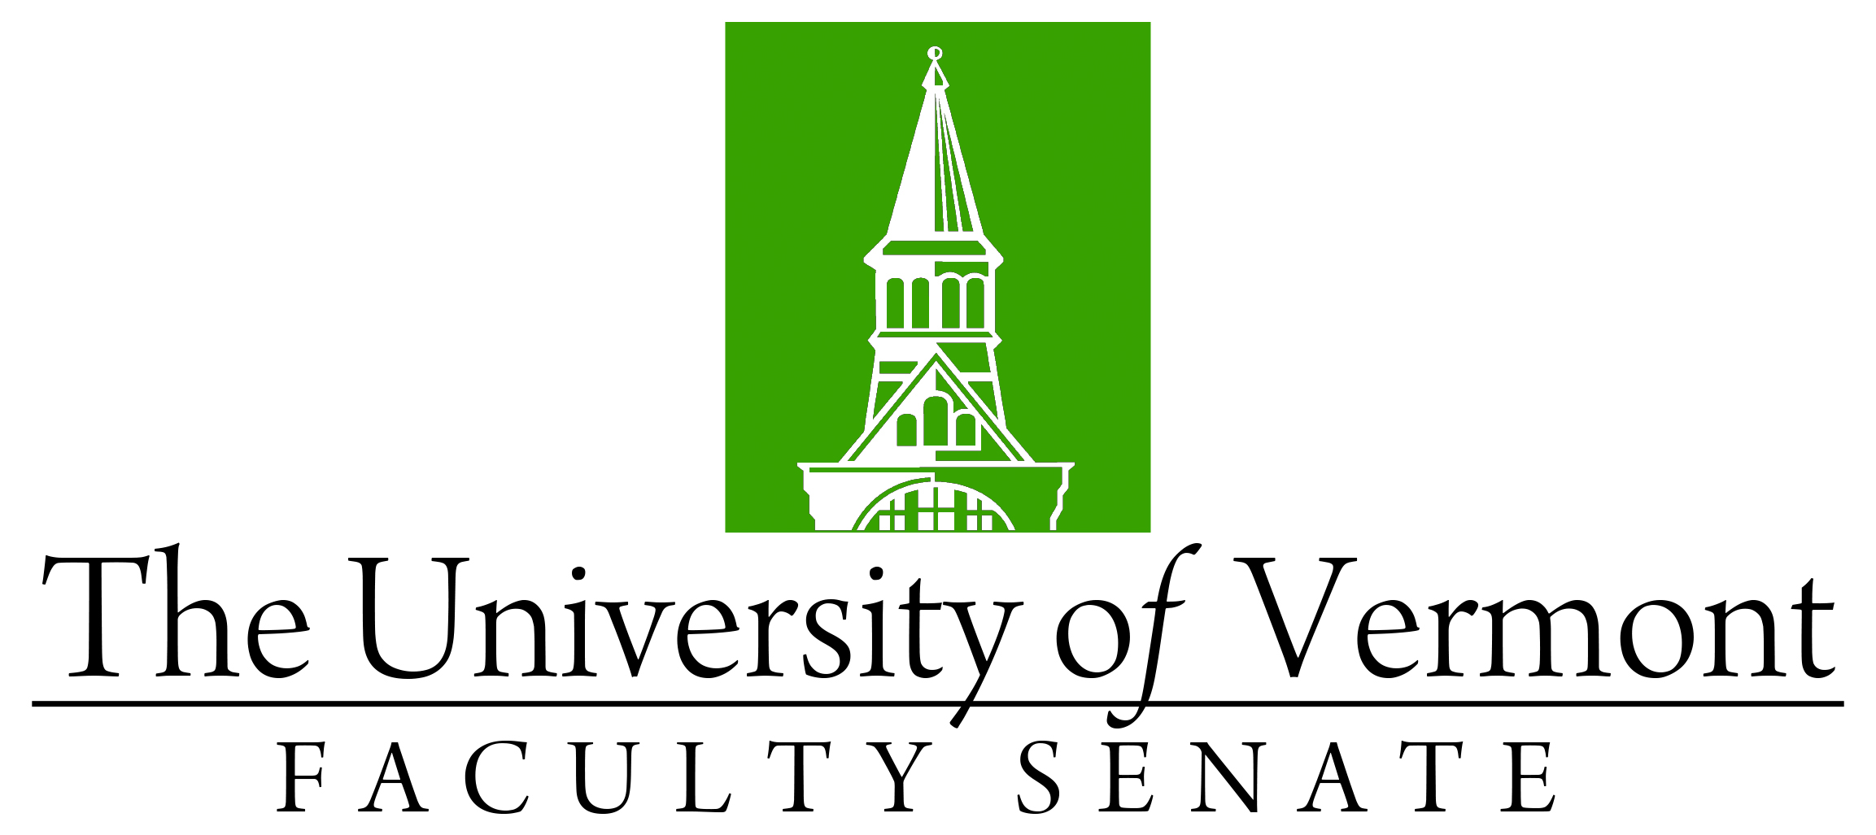

Faculty Senate Meeting
Monday, April 19, 2021
4:00 – 5:30 pm, Online via Teams

Agenda

4:00 | - Faculty Senate President’s Welcome Remarks – Chris Burns [5 min]  - Election Results  - Referendum Ballot for Bylaws Amendments
4:05 | - Consent Agenda (vote) [5 min]  - Minutes of the 03/15/21 & 3/22/21 Faculty Senate Meetings  - Curricular Affairs  - No-contest Termination Dietetics, Nutrition & Food Sciences major (CALS)  - Name Change Agroecology major (CALS)  - No-Contest Termination Sustainable Landscape Horticulture major (CALS)  - No-Contest Deactivation Consumer Affairs minor (CALS)  - No-Contest Terminations 16 Secondary Education minors (CESS)  CAC Report Out – Items that do not require Faculty Senate vote  - New concentrations in the existing Nutrition & Food Sciences major (CALS)  - New concentrations in the existing Agroecology major (CALS)
4:10 | - Review Processes for Proposals Relating to Academic Unit Structure [20 min]
4:30 | - Office of Engagement - Chris Koliba [20 min]
4:50 | - Financial update – Provost Prelock & Richard Cate [25 min]
5:15 | - Academic Reorganization update – Dave Jenemann [10 min]
5:25 | - New Business [5 min]
5:30 | - Adjourn

2020-2021 Faculty Senate Meetings
Mondays 4:00 – 5:30 PM (exceptions noted)
8/24/20 – 3:00 – 4:30 PM
9/21/20
10/19/20
11/16/20
12/21/20 – 3:00 – 4:30 PM
2/1/21
3/15/21
4/19/21
5/20/21 – 3:00 – 4:30 PM Thursday

