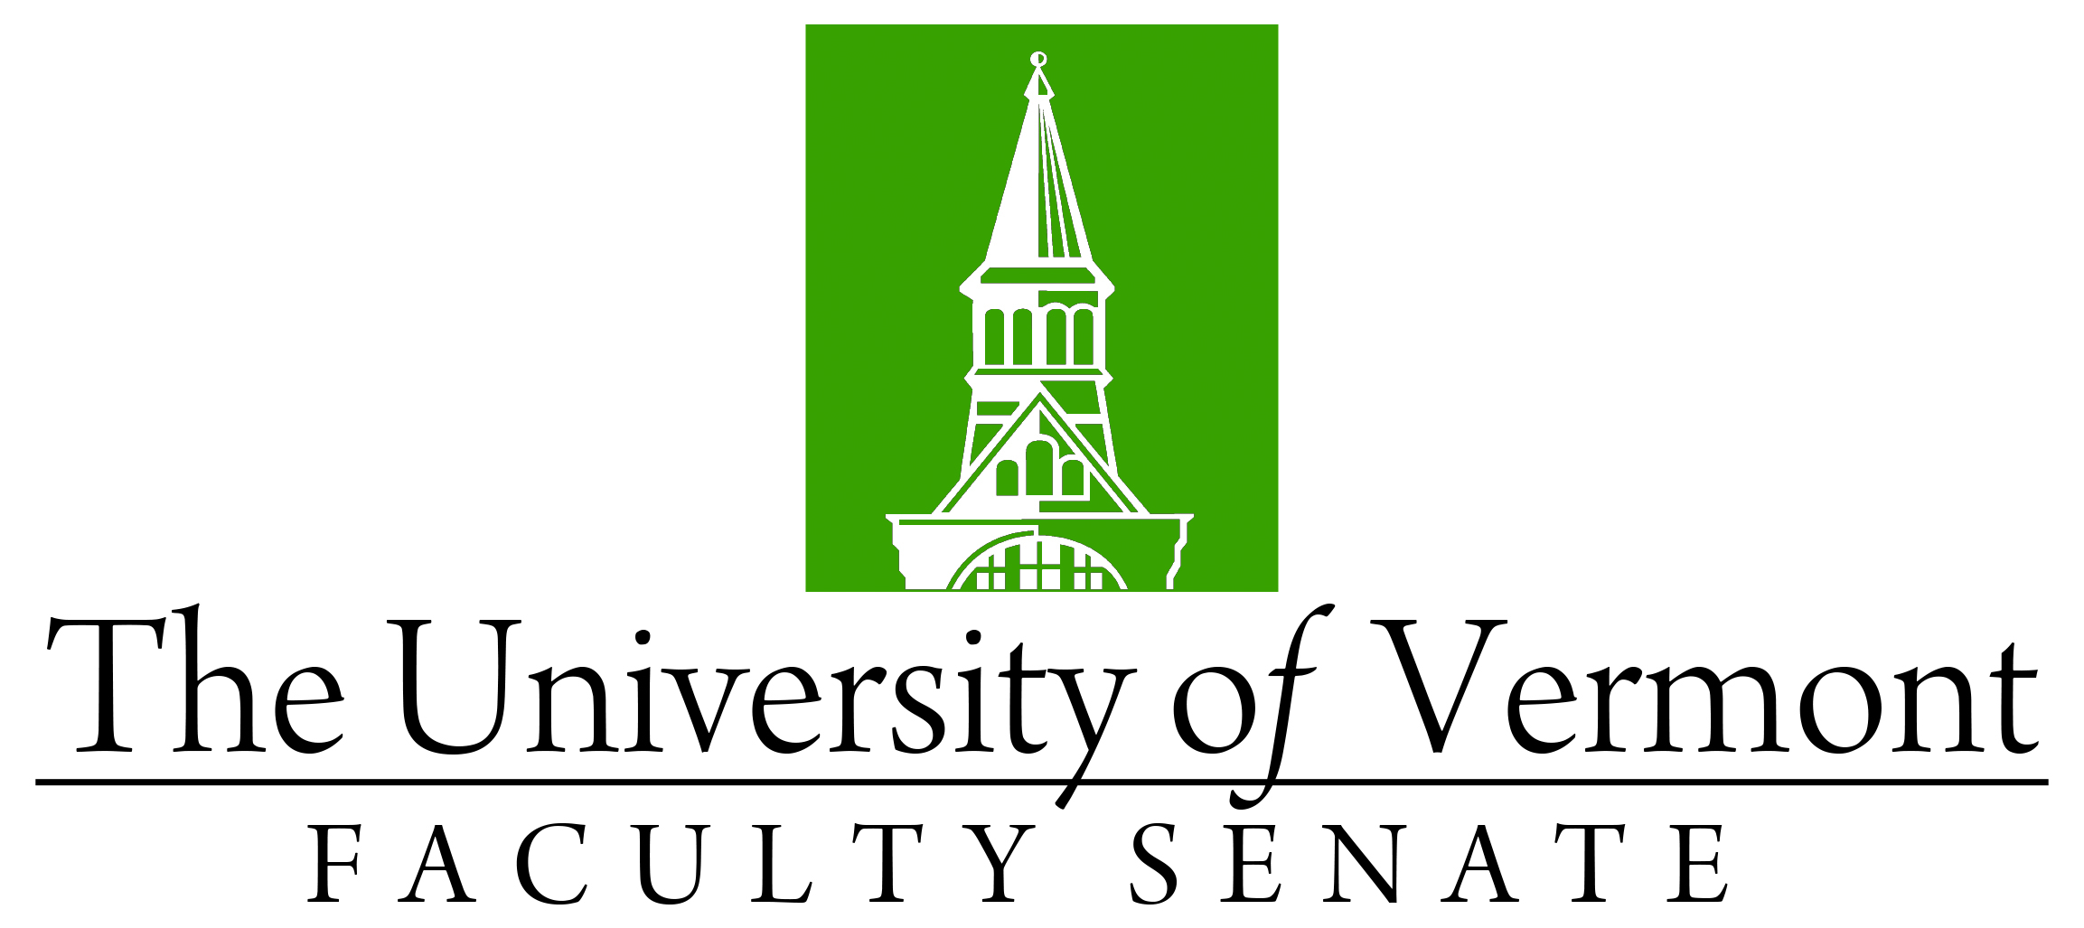

Faculty Senate Meeting

Monday, January 24, 2022

4:00 – 5:30 pm on Teams

Agenda

|  |  |
| --- | --- |
| 4:00 | 1. Faculty Senate President’s Welcome Remarks – Thomas Borchert |
| 4:05 | 1. Consent Agenda (vote)    * Minutes of the December 2021 Faculty Senate Meeting |
| 4:10 | 1. Accept nominations for Member at-Large to the Executive Council (Spring 2022) |
| 4:12 | 1. Conferral of Degrees (vote) |
| 4:20 | 1. Resolutions in Memoriam (vote):    * Charles Bushweller (Chemistry) presented by Christopher Landry;    * William Metcalfe (History) presented by David Massell |
| 4:25 | 1. School of the Arts Proposal (vote)    * Ad-Hoc Committee of the Faculty Senate Review of the School of the Arts Proposal    * Proposal for a School of the Arts in the College of Arts and Sciences |
| 4:45 | 1. Resolution in Support of the Library Budget (vote) presented by Mary Cushman, Co-Chair of the RSCA for the Research, Scholarship & the Creative Arts Committee and the Student Affairs Committee of the Faculty Senate |
| 5:00 | 1. Update from Enrollment Management - Jay Jacobs, Vice Provost for Enrollment Management (discussion) |
| 5:25 | 1. New Business |
| 5:30 | 1. Adjourn |

Spring 2022 Faculty Senate Meetings

*Mondays 4:00 – 5:30 PM (exceptions noted)*

1/24/22

2/28/22

3/28/22

4/25/22

5/19/22 – 3:00 – 4:30 PM Thursday