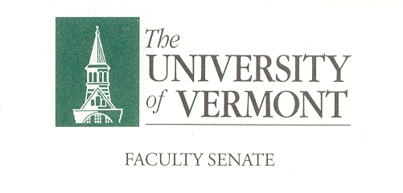

**Executive Council**

October 14, 2019 4:00 – 5:30 pm

Waterman 427A

**Agenda**

|  |  |
| --- | --- |
| 4:00 | 1. Approval of September 9, 2019 Minutes (vote) |
| 4:02 | 1. Degree Corrections (vote) |
| 4:05 | 1. Chair’s Remarks    1. Waterman Memorial Lounge Seating Configuration – thoughts?    2. May 2019 Minutes Correction    3. Thank You Tickets |
| 4:10 | 1. Faculty Letter regarding concerns with the Navigate advising platform – J. Dickinson |
| 4:30 | 1. The basing of the F35 at the Burlington International Airport – New Business Item Raised by South Burlington Resident, City Councilor and University Professor Meaghan Emery |
| 4:45 | 1. CAC Consent Agenda (vote)    1. Item 1    2. Item 2 |
| 4:55 | 1. Draft Agenda for Faculty Senate Meeting of October 28th    * Minutes of the 5//16 and 9/23 Senate meetings– 5 min*    * Senate President’s Remarks – 5 min    * Conferral of Graduate Degrees – 5 min*    * Two Resolutions in Memoriam – 10 min*    * General Education Alignment Task Force – J. Dickinson & Provost Prelock – 20 min    * CAC Consent Agenda – 5 min    * New Business – 5 min   *Item to be voted on  ***Additional Topics for the EC to Consider for this Agenda:***   1. EAB Navigate Faculty Concerns 2. The basing of the F35 at BIA 3. Class Attendance Expectations and Recent Dean Communications related to the Climate Strike |
| 5:25 | 1. New Business |
| 5:30 | 1. Adjourn |

*2019–20 Executive Council Meetings*

*November 11, 2019*

*December 9, 2019*

*January 13, 2020*

*February 10, 2020*

*March 16, 2020*

*April 13, 2020*

*May 4, 2020*

*2019-20 Meetings with the President and Provost*

All meetings are held in the President’s Conference Room

*Monday, November 11, 11:00 – 11:45 a.m.*

*Wednesday, December 11, 2:00 – 2:45 p.m.*