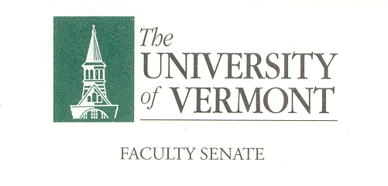
Executive Council
November 11, 2019 4:00 – 5:30 pm
Waterman 427A

Agenda

4:00 | - Approval of October 14, 2019 Minutes (vote)[2 min]
4:05 | - Chair’s Remarks [5 min]  - Consent Agenda Format
4:10 | - CAC Consent Agenda (vote) [5 min]  - Items to be determined on 11/7/19
4:15 | - Debrief the P&P meeting discussion [10 min]
4:25 | - Draft Agenda for Faculty Senate Meeting of November 18 [10 min]  - Faculty Senate President’s Welcome Remarks – Thomas Chittenden [5 min]  - Consent Agenda (vote) [10 min]  - Minutes of the 10/28/19 Faculty Senate Meeting  - CAC items TBD on 11/7/19  - Two In Memoriam [10 Min]  - Course Evaluation Platform Explorance Blue Update [15 min]  - Residential Learning Communities Ad Hoc Committee Update – Chris Burns & J Dickinson [20 min]  - The Basing of the F35 at the Burlington International Airport [25 min]  - New Business [5 min]  - Adjourn
4:35 | - Commission on Inclusive Excellence [45 min]
5:20 | - New Business [5 min]
5:25 | - Adjourn

2019–20 Executive Council Meetings

2019-20 Meetings with the President and Provost
All meetings are held in the President’s Conference Room

November 11, 2019
December 9, 2019
January 13, 2020 Monday, November 11, 11:00 – 11:45 a.m.
February 10, 2020 Wednesday, December 11, 2:00 – 2:45 p.m.
March 16, 2020
April 13, 2020
May 4, 2020

