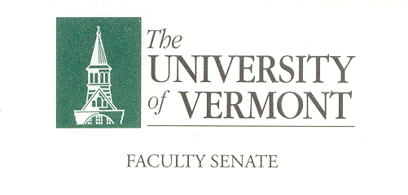
Executive Council
April 13, 2020 4:00 – 5:30 pm
Waterman 427A

Agenda

4:00 | - Plan for Voting at April full Senate Meeting – T. Chittenden & L. Eddy [15 min]
4:15 | - Approval of March 16, 2020 Minutes (vote) [5 min]
4:20 | - Chair’s Remarks [15 min]  - CNHS & LCOM Conferral of Degrees at April Meeting  - Final Exam Considerations  - 2020-21 Academic Calendar Contigency Planning
4:35 | - General Education – Timeline and Process. Cathy Paris [20 min]
4:55 | - Teaching Evaluations during Spring 2020. - Susanmarie Harrington [15 min]  https://josheyler.wordpress.com/2020/03/31/cancel-the-teaching-evaluations-too/
5:10 | - Agenda for P&P Meeting (date) [10 min]  - Teaching Evaluations?  - 2020-21 Academic Calendar Contigency Planning?
5:20 | - Draft Agenda for Faculty Senate Meeting of April 20th [5 min]  - See Separate Document
5:25 | - New Business
5:30 | - Adjourn

2019–20 Executive Council Meetings
April 13, 2020
May 4, 2020

