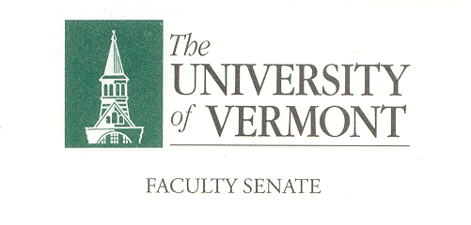

**Executive Council**

March 16, 2020 4:00 – 5:30 pm

Waterman 427A

**Agenda**

|  |  |
| --- | --- |
| 4:00 | 1. Approval of February 10, 2020 Minutes (vote) |
| 4:05 | 1. Chair’s Remarks    1. Nominations Update    2. Ron Lumbra May meeting    3. Don Ross – Retirement Prevention Programs |
| 4:25 | 1. Coronavirus (COVID -19) and UVM Disaster Planning and Prepardness – Gary Derr. |
| 4:50 | 1. Faculty Senate Constitution and Bylaws Comprehensive Review Committee – Thomas Chittenden |
| 5:00 | 1. Follow-up Discussion from the P&P Meeting (Monday, March 16, 2:00 – 2:45 p.m.)    1. Coronavirus Planning    2. Student Advising Center Fate, Student Fees and Campus Advising Strategies for next year |
| 5:10 | 1. Draft Agenda for Faculty Senate Meeting of March 23rd    * See separate document |
| 5:20 | 1. New Business |
| 5:30 | 1. Adjourn |

*2019–20 Executive Council Meetings*

*October 14, 2019*

*2019-20 Meetings with the President and Provost*

All meetings are held in the President’s Conference Room

*November 11, 2019 Tuesday, September 10, 4:15 – 5:00 p.m.*

*December 9, 2019 Tuesday, October 8, 9:00 – 9:45 a.m.*

*January 13, 2020 Monday, November 11, 11:00 – 11:45 a.m.*

*February 10, 2020 Wednesday, December 11, 2:00 – 2:45 p.m.*

*March 16, 2020*

*April 13, 2020*

*May 4, 2020*