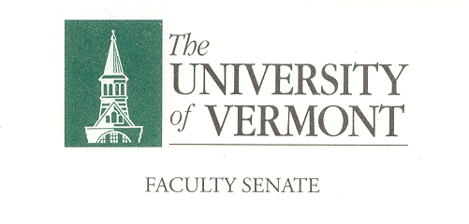
Executive Council
February 10, 2020 4:00 – 5:30 pm
Waterman 427A

Agenda

4:00 | - Approval of January 13, 2020 Minutes (vote)[2min]
4:02 | - Chair’s Remarks & Discussions [20 Min]  - Senate Calendar 2020-21  - Nominations  - Policies up for Comment/Review
4:22 | - CAC Consent Agenda (vote)[3 min]  - Name Change: MS in Animal Science, CALS  - New Concentration: ENSC Major, CAS/CALS/RSENR
4:25 | - Student Affairs Committee – GPA calculation and Repeated Courses – Ken Allen & Jen Prue (Vote) [10 min]
4:35 | - Student Affairs Committee – Attendance Policy – Ken Allen & Jen Prue (Vote)[10 Min]
4:45 | - Agenda Item – Campus Wide Faculty Conference – potential topic discussion – Jim Vigoreaux [20-min]
5:05 | - Agenda for P&P Meeting (Wednesday, February 12, 11:30am – 12:15pm)[10 min]
5:15 | - Draft Agenda for Faculty Senate Meeting of February 24, 2020 [10 min]  - (see attached)
5:25 | - New Business [5 min]
5:30 | - Adjourn

2019–20 Executive Council Meetings
March 16, 2020
April 13, 2020
May 4, 2020

