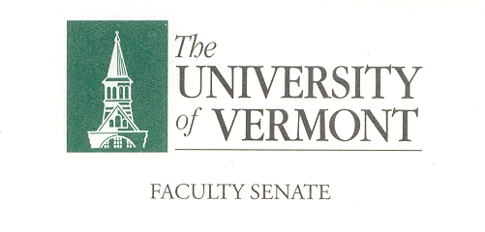
Executive Council
January 13, 2019 4:00 – 5:30 pm
Waterman 427A

Agenda

4:00 | - Approval of December 9, 2019 Minutes (vote)
4:02 | - Chair’s Remarks  - Welcome Dave Massell!  - Faculty Senate Meetings Schedule for 2020-2021  - RLC Discussion from Last Senate Meeting  - By-Laws Review Committee for 2020-2021
4:15 | - CAC Consent Agenda (vote)  - Items to be determined at the January 9th CAC meeting
4:30 | - FPPC – Divestment of Fossil Fuels Resolution – Don Ross
4:50 | - Committee Chair Updates
5:00 | - Agenda for P&P Meeting (Friday, January 24, 11-11:45 AM)  - RLC Assessment Next Steps  - Zero Tuition Increase Presentation to Senate
5:10 | - Draft Agenda for Faculty Senate Meeting of January 27th  - See Attached
5:20 | - New Business
5:30 | - Adjourn

2019–20 Executive Council Meeting
February 10, 2020
March 16, 2020
April 13, 2020
May 4, 2020

