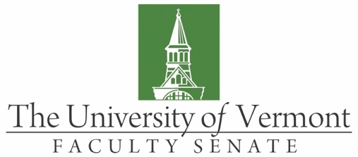
Educational & Research Technologies Committee

Minutes

Microsoft Teams

April 13, 2020

Present: Nick Bouffard (SGA), Thomas Chittenden (Faculty Senate President), Hung Do (BSAD), Deb Ellis (CAS), Lutz Kaelber (CAS), Jane Petrillo (CALS), Helen Read (CEMS), Lyman Ross (LIB), Regina Toolin (CESS), Scott Vanson (GSS)

Absent: Luben Dimov (RSENR), Elise Hotaling (LCOM), Tim Tourville (CNHS), Marie Wood (LCOM)

Guests: Mike Austin, J. Dickinson, Alex Messinger, Jenny Wilkinson

Co-Chair Helen Read called the meeting to order at 9:02 am via Microsoft Teams.

- Minutes. The minutes of March 2020 were approved with a correction to the date of the next meeting.

- Remote Learning and COVID-19. Due to the COVID-19 pandemic the University of Vermont has transitioned into remote learning after the regularly scheduled spring recess. This unprecedented change has created issues for both faculty and students. Some of the issues the ERTC discussed included:

    - Studio / lab courses and how they are delivered.
    - Access to reliable internet services.
    - Class meeting patterns, as some students live in different time zones.
    - How to keep students part of the learning community when they have no classroom intereactions.
    - Work load, how moving to remote learning has increased the workload tremendously for the faculty.

CTL has been extrememly helpful in the transition to remote learning. Students have been patient and overall the process is working well because of the hard work and dedication of both faculty and students. The university infrastructure is holding up and most of the issues that are being addressed are due to the end user and their access to reliable internet.

J. Dickinson is conducting a survey on remote learning. With only three weeks of classes left, this survey will be used to help provide insight for the future should the need for remote learning happen again. The hope is to be on campus in the fall but this survey will help prepare for the worst. There is a working group that is monitoring the situation and coming up with always changing plans. The ERTC would like to have representation on this committee. Regina and Helen will work with J. to make this request.

- Yellowdig, Jenny Wilkinson.
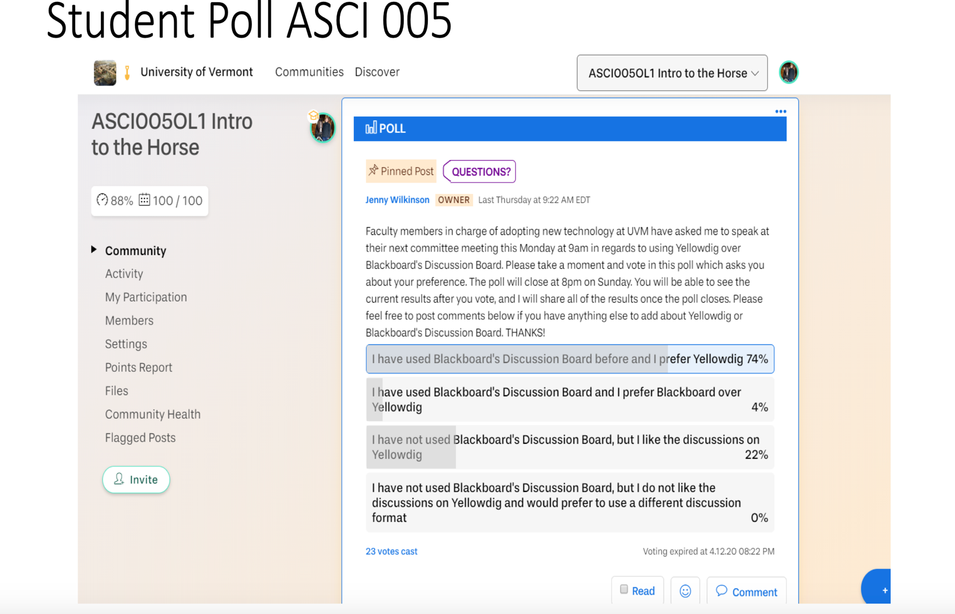
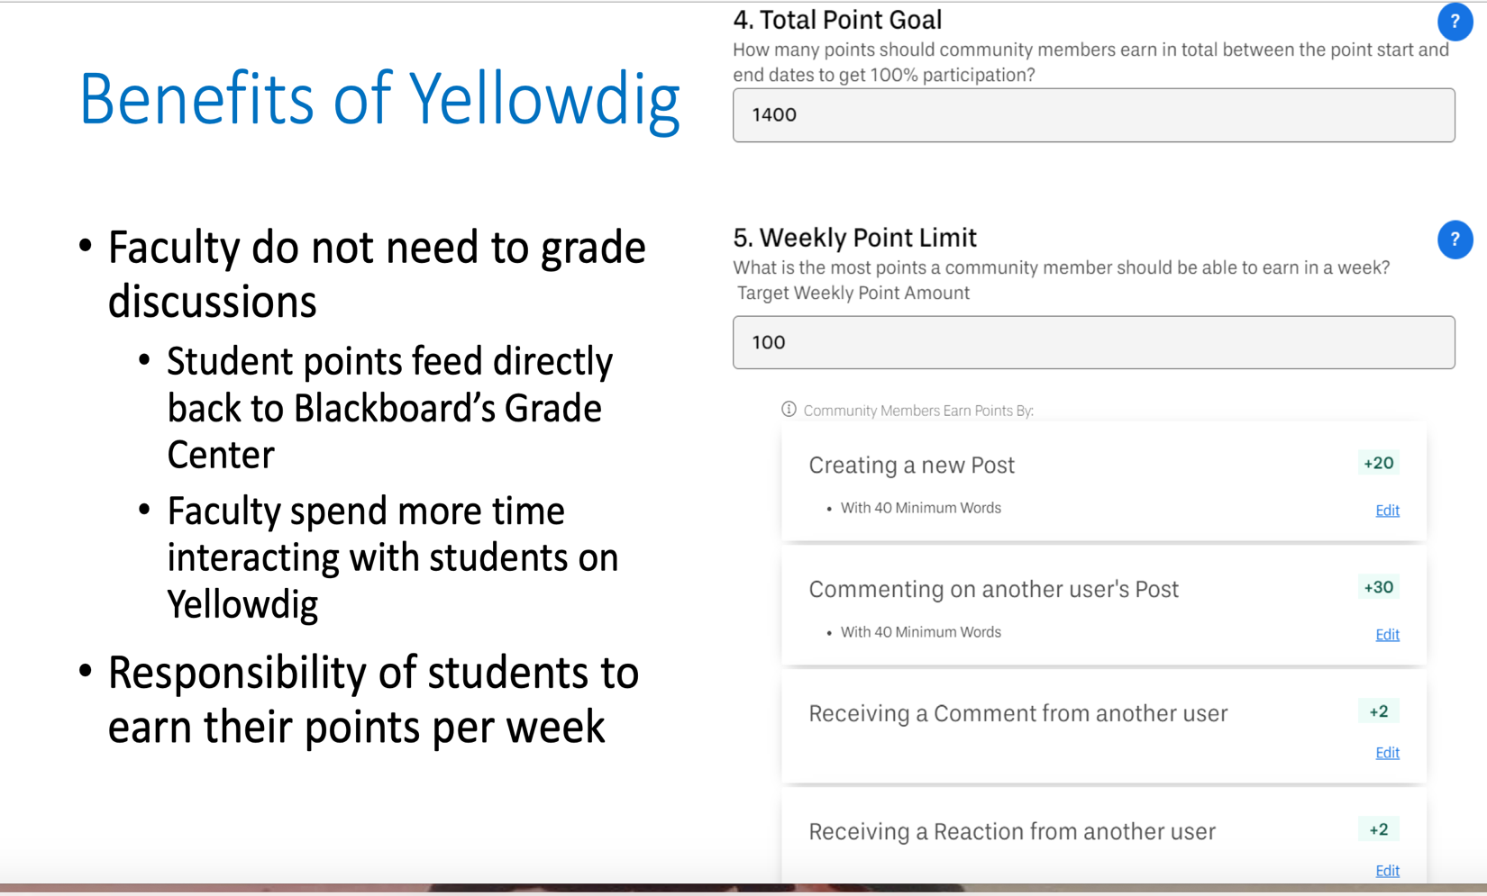
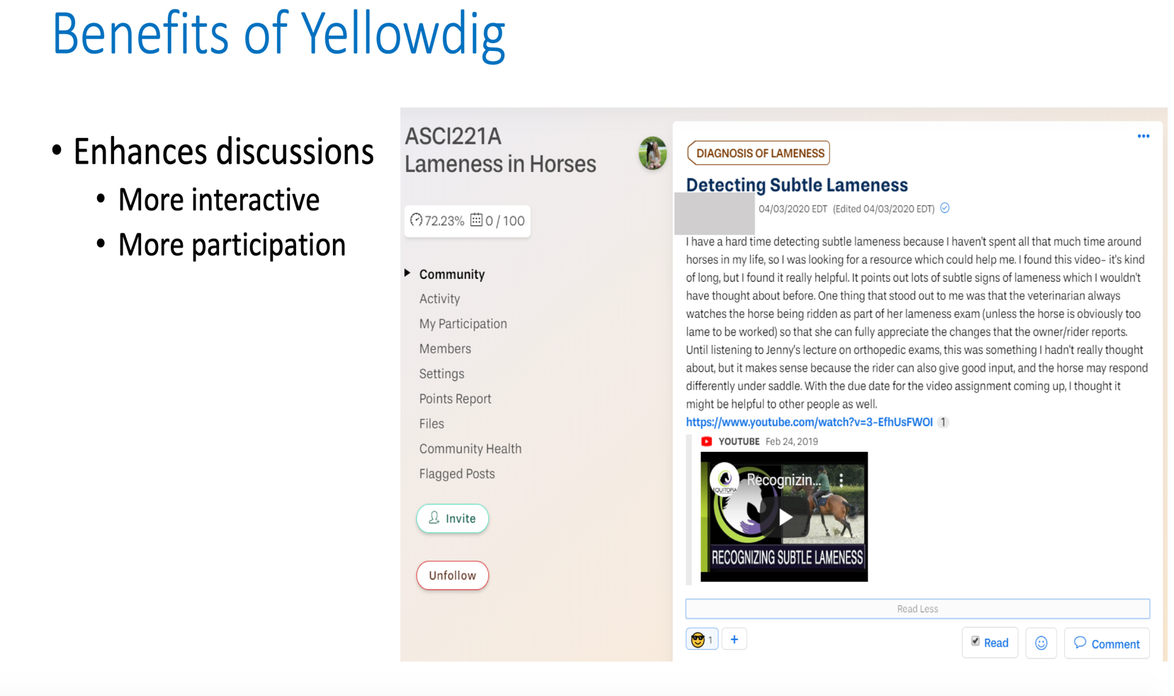

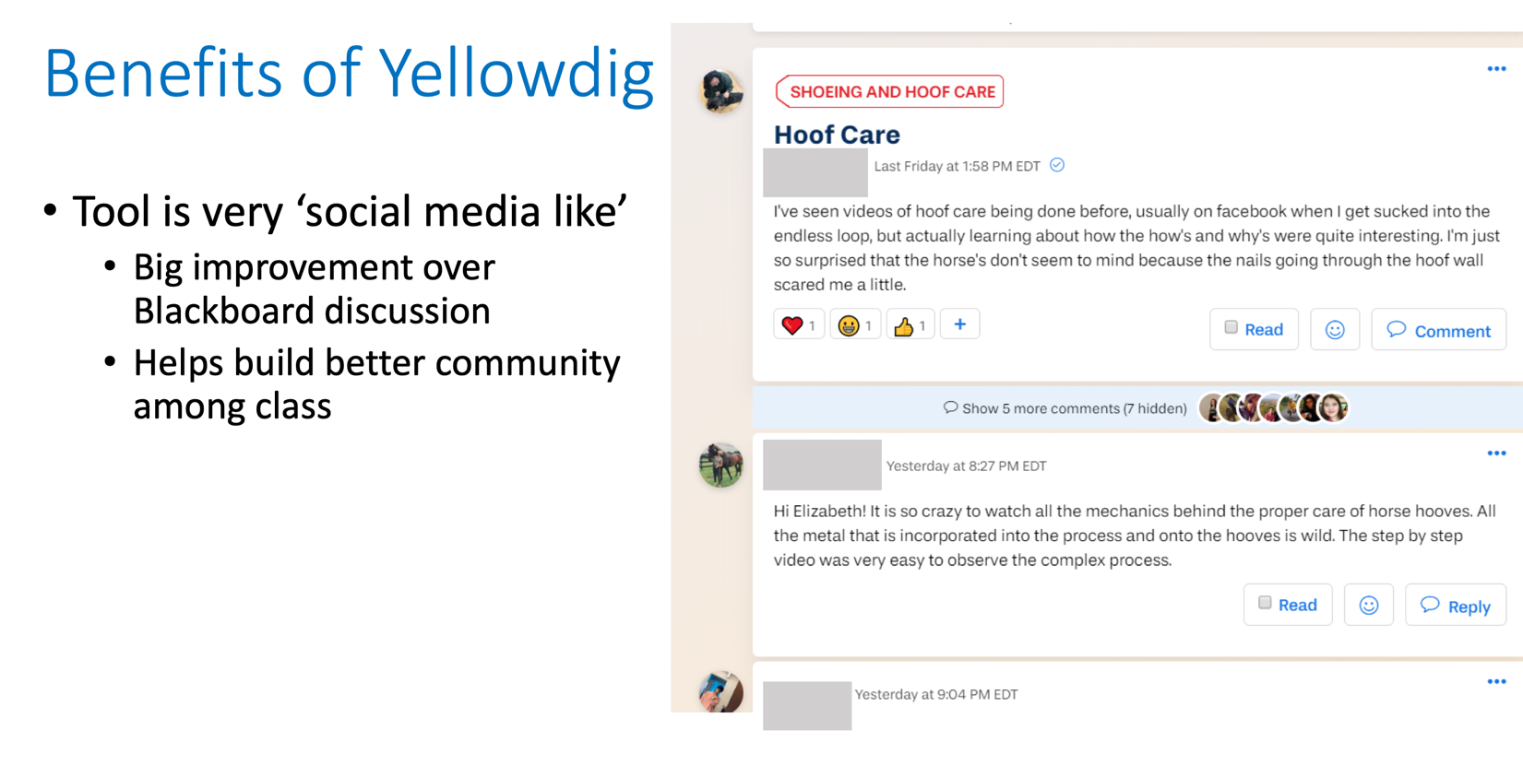
The committee was very excited about the prospects of Yellowdig. Alex Messinger is reaerching the cost and will report back to J. and the committee. The university currently has some licesnes and will continue to use them in cerain areas.

- Remote Learning Exam Schedule. Helen met with J. Dickinson and Wendy Bernback earlier to week to discus how exams will be administered during remote learning. There is more unforamtion on this on the university website including this article.

New Software to Support Remote Instruction and Exams
UVM is making Screencast-O-Matic screencasting software available for all faculty on a 6-month license. Faculty can download the software here. This software allows users to make a video capture (“screencast”) of the activity on a computer screen with audio narration. Instructions on how to use the software, and how to upload and share your videos with your students using UVM Streaming are available here. GTAs can download the free version of the software, which has many of the same features, here.
UVM has a site-wide license for two Respondus products that deter cheating on exams that are administered online.
- Respondus Lockdown Browser is a web browser which restricts student access to only UVM’s Blackboard server during an exam. When it is in use, all other applications and websites are inaccessible to students when taking a test.
- Respondus Monitor is a video “proctoring” add-on to Lockdown Browser; this tool is now available for all faculty to use. While these tools can’t fully prevent cheating, they can act as a deterrent. Instructions for faculty and students on using Respondus Lockdown Browser and Respondus Monitor are available here.
At this time, we are discouraging use of other proctoring software that passes a fee to the student. Faculty members should seek approval from their Dean if they anticipate the need to use a fee-based service.
Where possible, faculty should consider alternatives to long, high-stakes exams. In addition to academic integrity concerns, these exams can be difficult for students to complete if they have a poor internet connection. While not all alternatives will be scalable to larger classes, some examples of alternatives would be: have more frequent, shorter quizzes; use open-book take-home exams that require students to demonstrate their thinking process for a smaller number of problems/questions; create alternative assignments that require students to demonstrate and apply understanding of course concepts drawn from across the semester (short position paper; fact sheet; presentation; proposal). CTL and WID have added workshops that cover these and other techniques called “Reimagining Testing while Teaching Remotely” and “Transforming Tests into Alternative Assignments” to their upcoming events. CTL will also be adding a resource on alternatives to high stakes exams in the Teaching Continuity page early this week.

- New Business / Old Busines. There was no new / old business at this time.

The meeting adjourned at 10:30 am.
The next meeting of the ERTC will take place on May 4th via Microsoft Teams.

