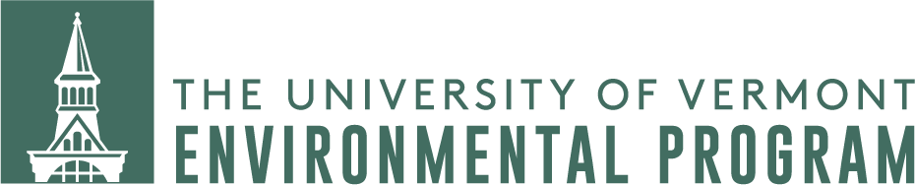

Summer Undergraduate Research Awards

Background
The Environmental Program at UVM is a university-wide interdisciplinary program encouraging high impact learning and active student engagement in building a sustainable future.

To meet that mission, the Environmental Program is offering summer research award funding of $3,000 (for salary and/or expenses) to UVM undergraduate students conducting environmentally-related research. We expect to offer several awards.

The student should have the direct support and supervision of a researcher who is knowledgeable and qualified to support the proposed research effort. Preference will be given to Environmental Studies majors.

Submissions should be made electronically by 5:00 p.m. April 10th to the Director of the Environmental Program, Brendan Fisher (bfisher@uvm.edu).

Awards will be announced by May 1.

Application process
Interested students should submit the following in a single PDF packet by 5:00 p.m. April 10th. Only full submissions will be considered.

Please submit a single PDF file containing the following elements:

1. Cover page with:
a. Student name, contact information, college, major/concentration and anticipated graduation date.
b. Supporting research supervisor name and contact information.
c. Title of research.
d. A one-paragraph synopsis of the research problem or question that the student will address and the approach planned.
2. A one-page work plan for the summer ending August 31 that will guide the student’s research activities. Please explain how many hours you expect to work, and how you intend to allocate those to the specific tasks and subtasks within your research.
3. A statement (up to 2 pages) by the student specifying their interest, qualifications and ability to address the research proposed and their interest (and plan) in continuing the research beyond the summer.
4. The student’s current resume (including GPA).
5. An endorsement of the research plan and student by a researcher or faculty member, stating how they know the student, how qualified the student is to carry out the work, why the research is important, how it links with their own research and what role they will play (if any) in the proposed research.

Criteria
Preference will be given to proposals that:
- Clearly address an environmental research topic with sound methodology.
- Supports an undergraduate student with the skills and motivation capable of carrying out the research.
- Connect to a mentor who has a demonstrated record of environmentally related research and evidence of engaging with undergraduate students.
- Are submitted by a student who is an ENVS major.

Timeline
Applications due April 10
Selection decision announced by May 1
Summer — research conducted
Research report submitted by Sept 15

Requirements
- Submit a report summarizing completed activities (3-5 pages) by September 15.
- Acknowledge the Environmental Program in related publications or activities.
- Participate actively in communicating their experience, e.g. presenting at conferences, speaking in classes and (required) attending UVM’s Student Research Day.
- Must be a degree student and not have graduated by Sept 1.

Note: This is structured as a merit-based research stipend, which should be in addition to, not instead of any existing student financial aid. However, students will be expected to pay relevant state and federal taxes on the hourly wages.

