

Department of Geology

Visitor’s guide to the Salmon Hole

The rock layers at the Salmon Hole record sediment that was deposited on the shoreline of an ancient ocean approximately 540 million years ago. The red-colored sandstone rock unit that is found here at Salmon Hole and at several other locations around Burlington (ex, Red Rocks Park) is called the Monkton Formation. The rocks of the Monkton Formation preserve the sediment, structures formed by extinct marine organisms, and sedimentary structures that formed on the shoreline of an ancient ocean. Evidence for this interpretation can be seen by walking on the rock layers of the Salmon Hole and looking down at the rocks under your feet. You are literally walking on what was an ancient sea floor.

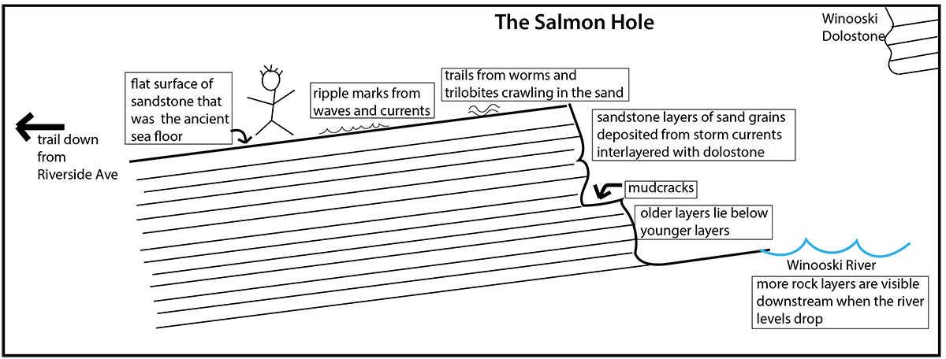

Most of the rock layers are composed of sand grains compacted and cemented together to form the sedimentary rock termed sandstone. There are sand grains of a variety of different sizes in these rock layers, which indicates that the velocity of the moving water varied. The red coloration of the sandstone layers reflects the presence of tiny grains of iron-rich minerals which have rusted (oxidized) and turned red. Another sedimentary rock type present here is buff-colored. Visible in rock layers in the cliffs at Salmon Hole, this rock is termed dolostone. Dolostone is a composed of tiny crystals of the mineral dolomite, which forms in sea water. The interlayering of these two sedimentary rock types tells us that conditions on the Monkton shoreline were continually changing. We believe that sand grains were washed onto the shoreline from storm events and then reworked by waves and tidal currents. During fairweather conditions dolostone formed.

The ridges that are found on the tops of rock layers are termed ripple marks. Ripple marks are produced by the back and forth motion of waves or from currents sweeping along the shoreline.
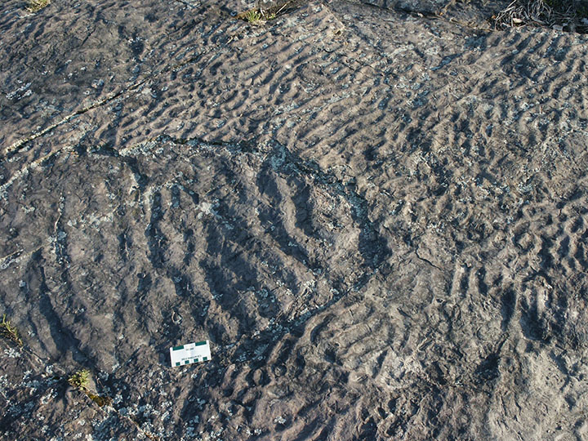
Different orientations of the crestlines of ripple marks on two sandstone layers, Salmon Hole

The size and spacing of the ripple crestlines indicates that the water was very shallow – probably barely a foot deep. The ripple crestlines are oriented in many different directions, even on the top of the same rock layer, which is a characteristic of the shoreline environment. Much less common than ripples are rock layers that contain mudcracks, evidence that periodically the sediment was exposed to air, dried out, and cracked.

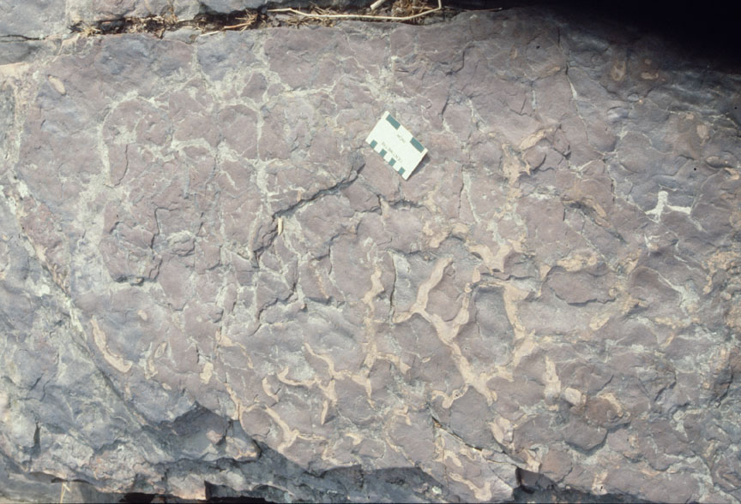
Mudcracks on the top of a sandstone bed, Salmon Hole. The cracks have been infilled with dolostone from an overlying layer.

The rock layers also preserve evidence of the movement of trilobites (small ancestors of horseshoe crabs) and worms through the sediment. Trilobite fossils have never been found at Salmon Hole but they have been noted in exposures of the Monkton Formation elsewhere.

DEPARTMENT OF GEOLOGY

Delehanty Hall, 180 Colchester Avenue, Burlington, VT 05405-1758

(802) 656-3396 - fax: (802) 606-0045 Equal Opportunity/Affirmative Action Employer

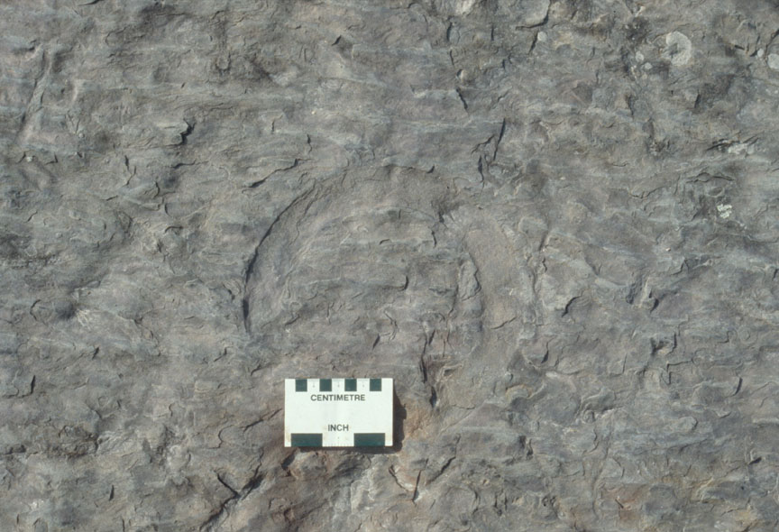
A curved track made by a trilobite crawling on the sea floor is just above the scale card.

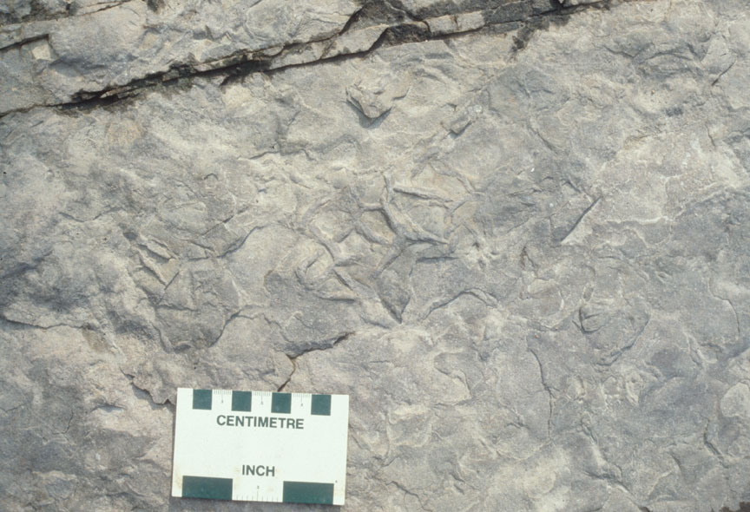
Worm burrows visible on the surface of a sandstone layer, Salmon Hole.
The Monkton Formation is not the only rock unit that can be seen at the Salmon Hole. The white-buff colored cliffs to the east, below the parking area at the top of the cliff, is the rock unit that overlies the Monkton, termed the Winooski Dolostone. This same rock unit forms the waterfalls visible to the north below the dam. As its name implies, the Winooski Dolostone is almost entirely composed of the sedimentary rock dolostone. Because the Winooski Dolostone sits on top of the Monkton Formation we know it is younger than the Monkton. The concept that in a stack of rock layers the older rocks lie below younger rocks is termed the “law of superposition.”

As you were walking around on the rock layers you might have noticed vertical cracks in the rocks. These are termed fractures and they formed from stresses placed on these rocks when the Green Mountains were uplifted nearly 450 million years ago. Notice that the cracks cut through the rock layers, therefore the cracks have to be younger than the rock layers that they cut through. The concept that a feature that cuts through a rock layer, such as a fracture or a fault, has to be younger than the rock layer it cuts is termed the “law of cross-cutting.”

DEPARTMENT OF GEOLOGY

Delehanty Hall, 180 Colchester Avenue, Burlington, VT 05405-1758

(802) 656-3396 - fax: (802) 606-0045 Equal Opportunity/Affirmative Action Employer

The Salmon Hole is a famous geology site visited by many professional geologists and school groups. Taking samples is prohibited. Please leave the site intact for future visitors.

Charlotte Mehrtens
May, 2019
University groups visiting the Salmon Hole can contact charlotte.mehrtens@uvm.edu for more technical information on the Monkton Formation.

DEPARTMENT OF GEOLOGY

Delehanty Hall, 180 Colchester Avenue, Burlington, VT 05405-1758

(802) 656-3396 - fax: (802) 606-0045 Equal Opportunity/Affirmative Action Employer

