Monda
GEOLOGY WEBINAR SERIES
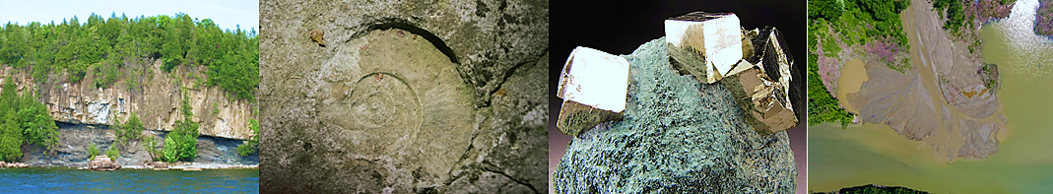

Fall Semester 2020
Monday on TEAMS at 4:15PM

A UVM Geology Feature series
10/05/2020 – Paul Bierman, Department of Geology, University of Vermont, VT:
“CUBA travelog: learning geology, hydrology, and teamwork on an Island forbidden to Americans”

10/12/2020 – Drew Christ, Gund Institute of the Environment, University of Vermont, VT:
“Fossils frozen beneath a mile ice: new insights from the first Greenland ice core”

10/19/2020 – Julia Perdrial, Department of Geology, University of Vermont, VT:
“Big picture or detail? Integrative Earth Science Research and the value of both”

11/09/2020 – Gabriela Mora-Klepeis, Department of Geology, University of Vermont, VT:
“New insights in the Evolution of Mexico and the Gulf of Mexico”

11/16/2020 – Keith Klepeis, Department of Geology, University of Vermont, VT:
“PFAS groundwater contamination near Rutland, Vermont: how to communicate geological research to the public and other non-scientist stake-holders”

Instructions for attending will be updated regularly

Sponsored by the Department of Geology Visiting Lecture Series
For additional information contact:
Nico Perdrial • Department of Geology •University of Vermont •180 Colchester Ave. Burlington, VT 05405
(802) 656-0665 • nperdria@uvm.edu

