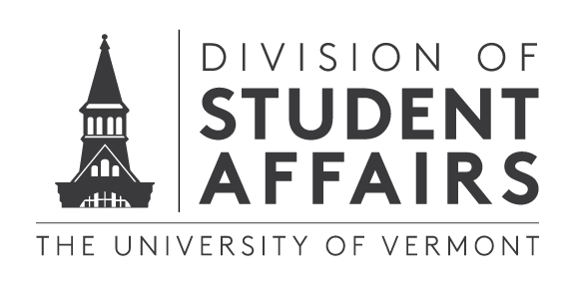

Visual Representation of UVM Learning Frameworks

Contents

Existing Frameworks 2

General Education Outcomes (Academic Affairs) 2

Council for the Advancement of Standards (Division of Student Affairs Learning Domains) 2

NACE Competencies (Career Center) 2

Emotionally Intelligent Leadership (Res Life) 2

AAC&U Leap Outcomes (Academic Affairs) 3

Important Mapping 3

CAS to General Education 3

Residential Life to CAS 3

AAC&U to CAS Mapping 4

NACE Competencies to CAS Domain Mapping 4

# Existing Frameworks

## General Education Outcomes (Academic Affairs)

## Council for the Advancement of Standards (Division of Student Affairs Learning Domains)

*http://www.cas.edu/learningoutcomes*

## NACE Competencies (Career Center)

*http://www.naceweb.org/career-readiness/competencies/career-readiness-defined/*

## Emotionally Intelligent Leadership (Res Life)

## AAC&U Leap Outcomes (Academic Affairs)

*https://www.aacu.org/value-rubrics*

# Important Connections

## CAS to General Education (Division of Student Affairs to Academic Affairs)

## Residential Life to CAS (Residential Life to Student Affairs)

## AAC&U to CAS Mapping (Academic Affairs to Student Affairs)

## NACE Competencies to CAS Domain Mapping (Student Affairs to Institution)