What do you want to do?
- Present – all you want to do is show content from your computer on the TV screen to people in the physical room. There are no remote attendees, and you are not using Microsoft Teams at all – See “BYOD Mode Instructions” below.
- Hybrid – You are using Microsoft Teams and at least one attendee is remote, e.g. a guest speaker – See “Teams Room Instructions” below.

BYOD (Bring your Own Device) Mode Instructions

Turn on the system from the wall plate:
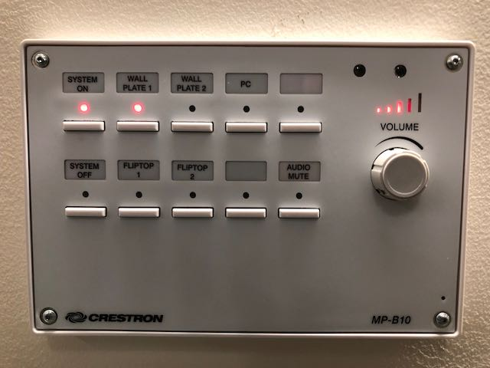

Select the appropriate HDMI connector according to where you plan to sit; example: Fliptop 1 and Fliptop 2 are the panels inset into the table with pull up HDMI connectors.

When you are done, disconnect the HDMI

Turn off the System via the System Off button on the wall panel.

Teams Room Instructions
The general idea here is that everyone in the physical E100 room is participating via the Teams Room device.
Note: All devices in the room other than the Rally system must have both microphone and speaker muted – otherwise you will get audio feedback. Recommended: also mute your laptop video camera to save confusion. See, “Mute mic, speakers and camera on your laptop before joining the meeting” below

In advance of the meeting, in Teams or Outlook, create your meeting and invite the room as an attendee
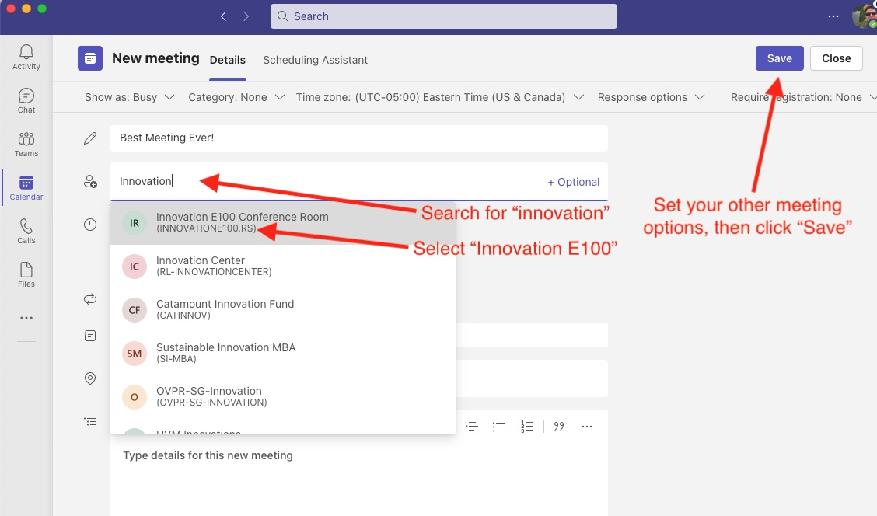
Note: your room request will go to a department admin who must confirm the request before the room is reserved for you.

Turn on the System using the wall panel and set the input to “Wall Plate 1”:
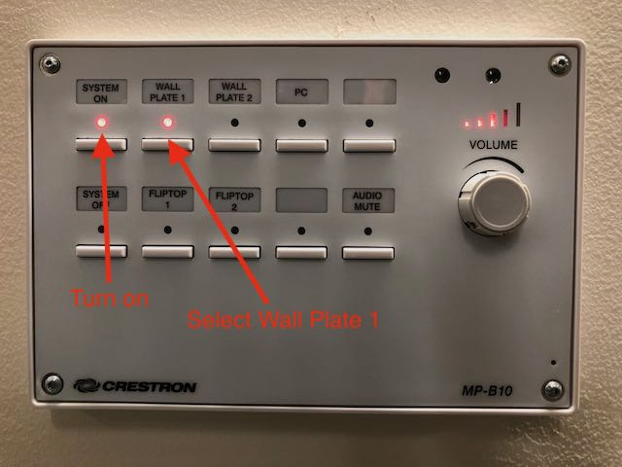

Your meeting should appear on the Tap touch panel at the time you scheduled it. Join The Meeting from the Tap touch panel on the conference room table
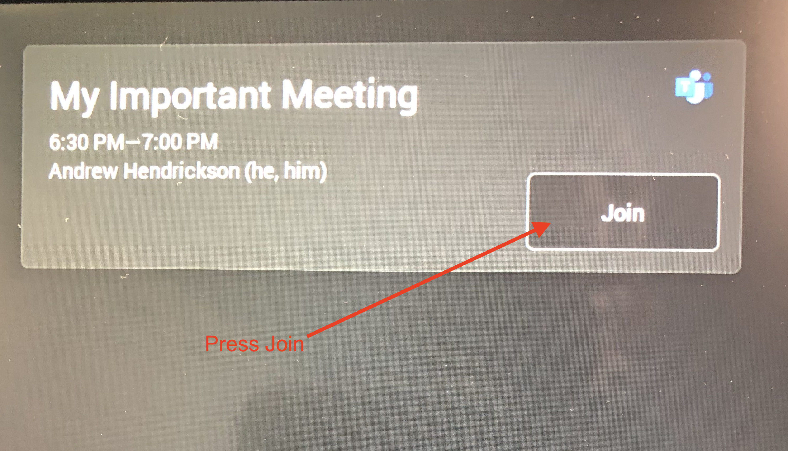

Control the meeting from the Tap touch panel including: muting microphones, Rally system volume, meeting layout, etc.

When finished, turn off the System via the System Off button on the wall plate.

Details

Mute mic, speakers and camera on your laptop before joining the meeting.
To avoid audio feedback, all devices other than the Rally system in the physical room and participating in the meeting must have mic, speakers and video muted. It is best practice to mute those settings on your computer before joining as audio feedback will start instantly. You can mute everything from the audio selection screen in Teams on your device prior to joining the meeting
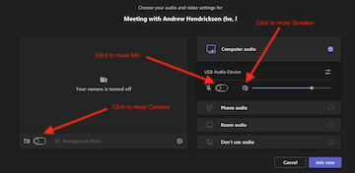

Sharing Content
If you want to share content in a hybrid meeting (e.g. a Powerpoint file) from your computer, join the meeting with your laptop (remembering to mute mic, speaker and camera first), then share your screen or window in the meeting as you normally would.
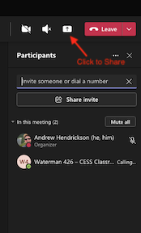

Recording the Teams meeting
If you want to record the session for later sharing on Blackboard, or for other purposes, join the meeting with your laptop, remembering to mute everything, then press Record in Teams on your laptop. The recording will be saved in your personal OneDrive cloud storage.
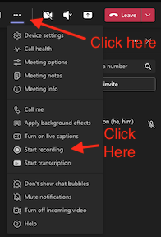

Troubleshooting
If the Tap touch screen is blank when you enter the room and does not wake up as you approach, or at a touch, the system is probably hung and needs to be restarted. Pull the white power cord out of the wall next to the black cabinet at the front of the room, wait briefly, then plug it back in and wait until the Rally system restars and the Tap touch screen is active again.

