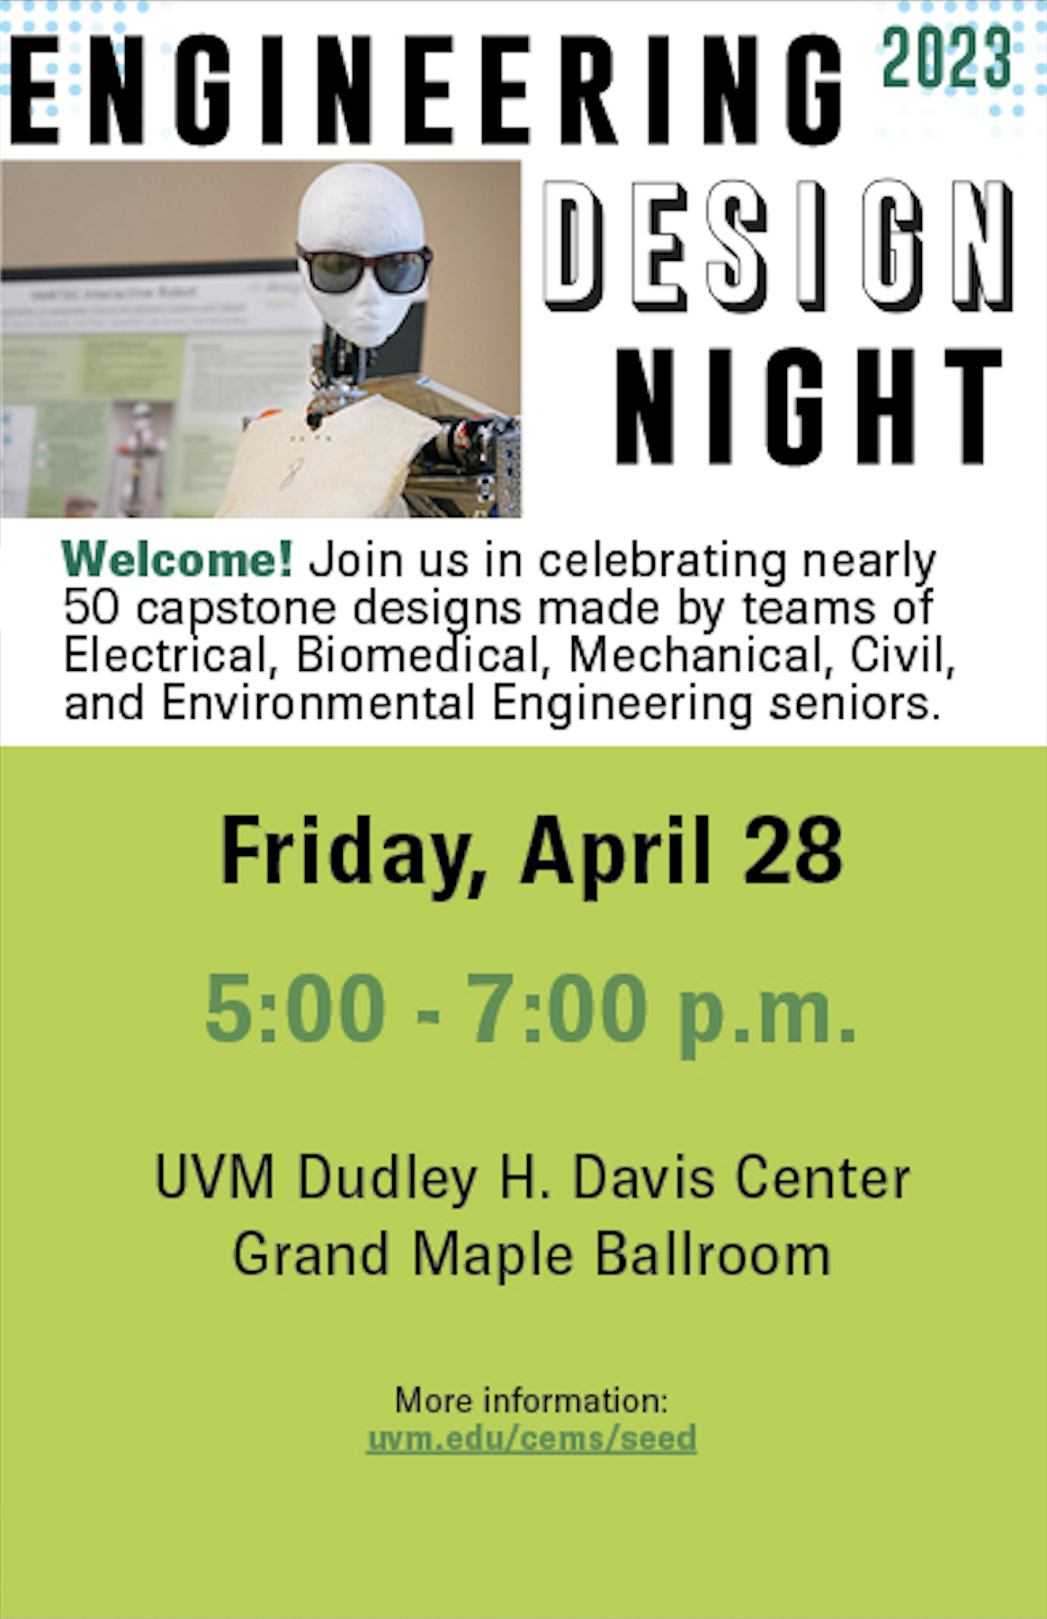
Engineering Design Night
Senior Capstone Poster Presentations

Friday, April 28, 2023

UVM Dudley H. Davis Center
Grand Maple Ballroom

Presentations of Student Projects and Posters from
Departments of Mechanical, Electrical & Biomedical, and Civil & Environmental Engineering

(ME 185-186, BME 187-188, EE187-188, CE-175)
Professor Dustin Rand
Professor Kenneth Burkman
Professor John Lens

Graduate Teaching Assistant Patrick O’Connor, Owen Brandriss, Dustin Pereslete, and Ryan van der Heijden

And Presentation of the Engineering
Honors Awards

Table Layout
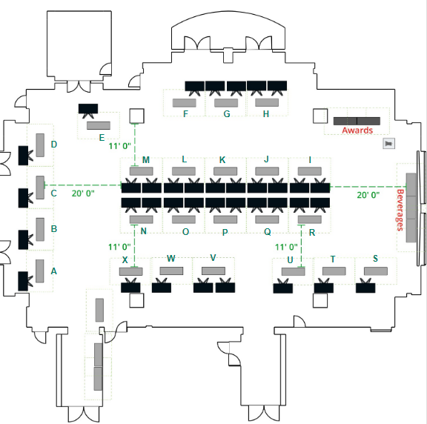

Friday, April 28th, 5:00 pm to 7:00 pm

ME and EBE Projects:
Project 1 (Table Q): Safe Endotracheal Tube- Rutland Eye Physicians
Designing solutions to reduce forces applied on the tracheal end of the endotracheal tube (ETT) for an intubated ICU patient.
Student Team: Gina Airoldi, Claire Leahy, Jacob Murphy, Liam Orr
Mentor: Prof. Rachael Floreani

Project 2 (Table U): Free Axis Elliptical- Agoge Fitness
Create an elliptical machine with the ability to allow an individual to use their own unique gait pattern. The elliptical will give them the opportunity for necessary physical activity without the weight-bearing aspect on their joints.
Student Team: Will Fischer, Lili Ross, William Wright, Juli McCabe
Mentor: Prof. Niccolo Fiorentino

Project 3 (Table N): Roller SecurShade Speed Control- SecurShade Inc.
Design a method to control the speed and downward force of an emergency closure of a roller window shade in a predictable and reliable manner. Add the ability to adjust the drop height and length externally when the shade is installed.
Student Team: Drew Dimento, Ethan Mosedale, Bella Rieley, Elijah Pedraini
Mentor: Prof. Dustin Rand

Project 4 (Table L): Racing Autonomous Vehicles- UVM CEMS
Design, implement and deploy a set of autonomous ground vehicles capable of racing and overtaking each other.
Student Team: Ryan Dessureau, Jacob Friz-Trillo, Jowl Pyfrom, Alexander Runci
Mentor: Prof. Lois Duffaut Espinosa

Project 5 (Table J): Lower Extremity Restraint- Healthy Design Ltd.
Design a lower extremity restraint and agitation monitor for patients confined to hospital beds that allow for maximum patient movement and comfort, notifies staff of high agitation levels, and protects them from unintended agitation-related behavior.
Student Team: Peter Cockayne, Nathaniel Bohrs, Dan Cameron, Marit Scott
Mentor: Prof. Niccolo Fiorentino

Project 6 (Table K): Endotracheal Tube Guard- Healthy Design Ltd.
Design an Endotracheal Tube (ETT) guard that allows an intubated patient to use their hands but prevents them from removing the ETT. Design a notification system that will alert hospital staff when the patient is attempting to remove the ETT.
Student Team: Aaron Duane, Patrick Frank, Kelly Jacobson, Cameron Killiany
Mentor: Prof. Rachael Floreani

Project 7 (Table H): Robot Maintenance Fixture- GlobalFoundries
Build a lifting fixture to safely lift mobile robots to allow technicians to work on and under the robot easily.
Student Team: Connell Phillips, Max Bonthrone, Luke Quine, Maury Smith
Mentor: Prof. Kenneth Burkman

Project 8 (Table G): Hole Carrier Punch- GlobalFoundries
Redesign an existing film punch system to triple the number of holes in the film while maintaining the quality of the holes with minimal increase in user force required.
Student Team: Will Baker, Alex Holder, Maguire Shea, Griffin King
Mentor: Prof. William Louisos

Project 9 (Table H): Test Probe Card Holder Jig- GlobalFoundries
Design a holder that allows technicians to easily clean and inspect a sensitive specialized test probe printed circuit card. The device requires the ability to magnify the image and rotate the card easily.
Student Team: James Vagell, Owen Smith, Nick Andersen, Anna Thornton
Mentor: Prof. Douglas Fletcher

Project 10 (Table G): Infrared Avalanche Photodiode- Global Foundries
Create an infrared-sensitive avalanche photodiode using a baseline photodiode process. The process would be designed, simulated, manufactured, and tested during the course of the project.
Student Team: Lauren Fennelly, Mac Mansfield-Parisi, Philip Papp
Mentor: Prof. Matt Gallagher

Project 11 (Table F): Wafer Stress Tester- GlobalFoundries
Build a device to apply and measure a controllable and consistent force or impact on a set of semiconductor wafers to help assess their fragility. Student Team: Gavin Turner, Alec Wonson, Thomas Wright, Andrew Buckley
Mentor: Prof. Yves Dubief

Project 12 (Table K): IV Roller Clamp- UVM Medical Center
Design a way to prevent healthcare workers from leaving IV roller clamps closed inadvertently when attempting to dispense medication via an IV pump system.
Student Team: Hunter Feeley, Emily Kastens, Gabby White, Sarah Jennings
Mentor: Prof. Dustin Rand
Sponsored by a generous donation from Jose Aguayo.

Project 13 (Table D): Pick and Place Robot- Monaghan Medical Corporation
Use a robot and vision system to pick and place products from a table or conveyor and package it into a final bag for shipping at a speed of 40 units /min.
Student Team: Ali Hussein, Jillian Holland, John Waligory, Parminder Kaur
Mentor: Prof. Jason Hibbeler

Project 14 (Table R): Auto Lift for AT Binding
Create a device that will automatically lift the risers on Alpine Touring (AT) Backcountry Ski Bindings to an appropriate height to allow for more ergonomic climbing.
Student Team: Andrew Donohoe, Dillon Jensen, Justin Rhoades, Sarah Wasson
Mentor: TA Owen Brandriss
Sponsored by a generous donation from Charlie Liamos.

Project 15 (Table E): Turret Pointing Accuracy- GD-OTS
Develop a device(s) and methodology to measure and validate the pointing accuracy of a turreted weapon system.
Student Team: Matthew Stryker, Sean Henderson, Kidron Kollin, Katie Neuharth, Nick Roy
Mentor: Prof. Dustin Rand

Project 16 (Table X): C-Bore Milling Machine- Hazelett
Design a device that can mill a precision counterbore into a hardened stainless-steel strap. The machine will need to quickly and accurately center on a hole in the strap and add a counterbore to a precise depth. Student Team: Jude Gallagher, Conor Borek, Alex Gingue, Karl Simon
Mentor: Prof. Dustin Rand

Project 17 (Table D): Graviton Stretch Table- Fortify Fitness
Redesign a rotating table that uses gravity to assist in human flexibility motions. The new device needs to be collapsible, lightweight, and usable by a single person.
Student Team: Jason Murray, Julianne Boughton, Holly Akey, Erin Kloostra
Mentor: TA Dustin Pereslete

Project 18 (Table O): Soil Moisture Sensor- NRG Systems
Design a low-cost sensor to periodically and automatically measure the water content of the soil that interfaces with industry-standard data loggers.
Student Team: Anna Casavant, Charlie Harper, Oscar Dring, Eve McGloon
Mentor: Prof. Yves Dubief

Project 19 (Table V): CS6 Chassis- AERO
Redesign the chassis for UVM AERO next-generation electric race care. The chassis design will be designed around the competition rules and include packaging of the frame and structural analysis.
Student Team: Nate Goldman, Jacob Decatur, Amelia LaPlume, Carter Lawless
Mentor: Prof. Yves Dubief

Project 20 (Table X): Towable Aircraft Lift- BETA Technologies
Design a system to lift the Vertical take-off and Landing (VTOL) aircraft Alia safely and quickly. The lift system should be towable behind a truck.
Student Team: Caleb Duggan, Mitchell Hom, Analiese Parsons, Will Robinson
Mentor: Prof. William Louisos

Project 21 (Table R): Prosthetic Snowboard Adaptor- UVM CEMS
Design a snowboard boot/binding adaptor for lower limb amputees to improve their mental and physical health. The device should be easy and safe to use.
Student Team: Matt Boyer, Ethan Clark, Victoria Pecovic, Ruth Spooner
Mentor: Prof. Mike Rosen

Project 22 (Table S): Adaptive Kayak Seat- Northeast Disabled Athletic Association
Design a device to help people with disabilities, and or weakness/pain in the lower extremities to easily and safely get out of a kayak.
Student Team: Josh Allen, Grace Kreuser, Natalie Lafleur, Stephen Stroz
Mentor: Prof. Mike Rosen

Project 23 (Table C): Unbound Mobility- Unbound Grace at Sentinel Farms
Design a chariot to be pulled by a horse on wooded roads and trails that can accommodate a driver and a person in a wheelchair. The chariot needs to provide a smooth and safe ride for the person in the wheelchair to allow them to enjoy the benefits of being outside with horses.
Student Team: Cameron Roy, Harrison Green, Jack Robbins
Mentor: TA Patrick O’Connor
Partial sponsorship by a generous donation from Jose Aguayo.

Project 24 (Table N): Salt Spreading Machine- UVM Custodial Services
Design a salt spreader/application approach that reduces the amount of deicing chemicals used and spreads at a controlled and adjustable rate. The device needs to be easy and ergonomic to use.
Student Team: Vikram Dalmiya, Steve Gallican, Megan Lindgren, Conor Doolin
Mentor: Prof. John Lens

Project 25 (Table M): Planetary Cabler Tensioning- Harbour Industries LLC
Develop a wireless tension measurement and braking system for a rotating planetary cabler system.
Student Team: Rye Fought, Noah Logan, Mason Redfield, Jenni Hill
Mentor: Prof. Dustin Rand

Project 26 (Table Q): Novel Grass Cutter- DR Power Equipment
Investigate and design a novel method for cutting grass. The design should be efficient and integrated into an existing mower with no modifications.
Student Team: Cole Reiner, Henry Clark, Noah Egan, Benjamin Spencer
Mentor: TA Owen Brandriss

Project 27 (Table B): HTP Generation Device- Benchmark Space Systems
Design a fixture to concentrate Hydrogen Peroxide quickly and efficiently for use in space applications.
Student Team: Mollie Clyde, Adam Sampsell, Gabe Frigo, Luca Schwartz
Mentor: Prof. William Louisos

Project 28 (Table I): Automatic Plate Deburring- Husky Technologies
Design a tool that will automate the process of deburring and polishing steel plates used for injection molding. The final prototype should be safe to operate and provide a clean finished product.
Student Team: Josh Ashooh, Ian Keene, Spencer Weingord, Cal Cook
Mentor: Prof. Zachary Ballard

Project 29 (Table O): Mr. Ohm- BetterBots
Design and improve several electrical circuits to be used in the Florescent Light Detection circuit for an education robot Mr. Ohm. Circuits may include photodiode amplifiers, Phase Locked Loop (PLL), Voltage Controlled Oscillators, and other analog circuitry. Design should be done with discrete components.
Student Team: Kyle Lambert, Cole O’Shaughnessy, Lindi Hang
Mentor: Prof. James Kay

Project 30 (Table P): Drone Snow Assessment- Transcend Engineering
Develop a sensor, deployable on a small drone, that can obtain information about the grain structure of snowpack at a distance and can survey large areas by day or night.
Student Team: Phil Fretwell, Ian Barnaby, Kyle Beebe, Davis Lavoie
Mentor: TA Patrick O’Connor

Project 31 (Table P): Cyclist Handlebar Cooling- Transcend Engineering
The project will develop an on-demand handlebar cooling/heating system to enhance the athletic performance of competitive cyclists.
Student Team: Jacob Maxham, Alex Nagle, James Cole, Kristina Sitcawich
Mentor: Prof. Kenneth Burkman

Project 33 (Table W): Pump Wash and Inspection- Ben & Jerry’s
Design a device to effectively clean and inspect the underside of large pumps used in the manufacturing of ice cream. The device should have a small footprint, be safe and easy to use, and be low-cost.
Student Team: Isaac Emery, Sophie Gessman, Paige Borden, Ben Jackson
Mentor: Prof. Dylan Burns

Project 34 (Table T): Ski Flex Tester- UVM Ski Safety Lab
Design an improved ski flex tester to apply loads and measure ski flex in multiple bending configurations, frequencies, and forces.
Student Team: Zac Cannon, Julia Sergeant, Adam Kruszyna, Drian Guido
Mentor: Prof. Douglas Fletcher

Project 36 (Table L): Protective Coating Application- UVM CEMS
Develop a metered coating system for NASA ablative thermal protection materials intended for future planetary exploration missions.
Student Team: Lexie Baker, Jack Goga-Blanchard, Dillon Ryan, William Burke
Mentor: TA Ian Ballou

CEE Projects: Fireplace Lounge
Project 1 : North Hero Water Storage Tower - Aldrich and Elliot Engineers and the Town of North Hero, Merrick Gillies
Design improvements to the drinking water system consisting of an elevated storage tank and appurtenances.
Student Team: Ryan Kochie, Oeghan Blanchard, Jeremy Rotenberg

Project 2 : East Hardwick Slope Stabilization - VTrans, August Arles
Design stabilization options for a section of slope between Route 16 and the Lamoille River that is sliding toward the river.
Student Team: Lauren Snow, Marina Vilanova, Delphi Bourassa, Gabe Lambert

Project 3 : Stowe Electric Site Use Optimization - Stowe Electric Department, Wendy Crozier
Design combined site pedestrian, bicycle, and vehicle access and parking improvements shared with an adjacent private property owner for optimized land use in Moscow village.
Student Team: Liza McLatchy, Angus Nilgitsalanont, Alexandra Greer, Benjamin Ashby

Project 4 : Stowe Electric Red Building Structural Stabilization - Stowe Electric Department, Wendy Crozier
Design structural and foundational stabilization improvements needed to allow reuse and repurpose of a historic timber building.
Student Team: Dalton Vassallo, Peter Kagan, Riley Deth, Luke Weiss

Project 5 : Camp Dream New Bathroom - Camp Dream, Elise Oshlag
Design a sustainable, very low operation and maintenance bathroom and handwashing space for 50 student campers in a remote setting.
Student Team: Matthew Kaplita, Courteney Hales, Connie Douthwaite, Ben Kidder

Project 6 : I-89 Wildlife Overpass - Chittenden County Regional Planning Commission
Design a bridge over Interstate 89 and US Route 2 for a wildlife crossing corridor.
Student Team: Parker Lambert, Maddie Parent, Evelyn Densmore, Noah Palker

Project 7 : Camp Dream Pond Access - Camp Dream, Elise Oshlag
Design a low operation and maintenance access ramp from roadway to pond level along a steep wooded shoreline section.
Student Team: Henry Dybowski, Jake Russoniello, Matt Young, Johannes Elliot

Project 8 : UVM Parking Access Improvements - Prof. John Lens
Design parking improvements for staff, faculty, students, and visitors for equitable and improved access and flexibility.
Student Team: Tyler Bodette, Jack Gustafson, Kyle Hart, Justin Bistrovich

Project 9 : Sand Bar State Park Wastewater Improvements - Vermont Agency of Natural Resources, David Webb
Design a sand filter wastewater treatment system replacement at the Sand Bar State Park.
Student Team: Marina Godley-Fisher, Katrina Seeberger, Luke Nienstadt, Matthew Aeschleman

Project 10 : UVM Biofiber Lab Wastewater Reduction - UVM Community Development and Applied Economics Program, Prof. Steve Kostell
Design a wastewater filtration system for the biofiber recovery laboratory to reduce water use.
Student Team: Abby O’Keefe, Molly Baker, Beatriz Altura, Ryan McKeown

Project 11 : UVM Miller Farm Barn Building Reuse - UVM College of Agriculture and Life Sciences, Dr. Guy Roberts
Design structural and foundation renovations needed to repurpose a former dairy barn into a working space for UVM College of Agriculture and Life Sciences researchers.
Student Team: Owen Chamberlain, Nate Heil, Jared Huck, Ben Stevens

Project 12a : Adams Acres Stormwater Improvements - Town of Middlebury, Emmalee Cherington
Design stormwater mitigation for an existing collection of properties to comply with new Vermont stormwater regulations.
Student Team: Olenka Duncan, Maya Sage, James Amenta

Project 12b : Springside Drive Stormwater Improvements- Town of Middlebury, Emmalee Cherington
Design stormwater mitigation for a residential neighborhood subject to frequent stormwater impacts of erosion and flooding.
Student Team: Nathan Claessens, Anna Terrenzi, Margaret McMahon

Heartfelt thanks to …

All who contributed to the success of the many projects including graduate students, faculty, and staff.

Graham Sherriff, University Engineering Librarian
Susanmarie Harrington, WID
Lee Diamond, Risk Management & Safety
Floyd Vilmont, The Machine Shop
James Catalan, CEMS Lab Engineer
Instrumentation and Model Facility Team
Corine Farewell, UVM Innovations
Andrew Zehner, Associate General Counsel
Jen Karson and the Fab Lab Team
Jen Main, The Dean’s Office
Lauren Forcier, Department Administrator for Mechanical Engineering
Asa Burton, ME Work-study student for delivering all the packages.

Practicing professionals who have generously contributed their time and talents to supporting our teams throughout the year and our hardworking Work-study students!

Engineering Honors Awards- 2023

Civil & Environmental Engineering

Civil Engineering Junior Award- Matt Sitnik
For outstanding scholarship and commitment to civil engineering during junior year.

Environmental Engineering Junior Award- Kate Hunter
For outstanding scholarship and commitment to environmental engineering during junior year.

Sophomore Civil Engineering (Millbank) Award- Jack Haley
Reginald Milbank (Sophomore) Award
In honor of Professor Reginald V. Milbank, who served the program for 23 years, this award was established in 1970 and is awarded annually to the “outstanding sophomore enrolled in Civil and Environmental Engineering and the University of Vermont.”

Sophomore Environmental Engineering (Millbank) Award- Jacob Mccoy and Ian Welch
Reginald Milbank (Sophomore) Award
In honor of Professor Reginald V. Milbank, who served the program for 23 years, this award was established in 1970 and is awarded annually to the “outstanding sophomore enrolled in Civil and Environmental Engineering and the University of Vermont.”

Student Scholastic Achievement Award- Connie Douthwaite
In recognition of outstanding academic success and placement on the Dean’s list throughout the college career

Douglas P. Fay Award- Danica Dytioco
Established in 1973 in honor of former faculty member this award is given to the student who has made the greatest contribution to civil or environmental engineering during the past year.

Electrical and Biomedical Engineering

Senior EE Award- Noah Logan
Atwater-Kent (Senior) Award
For an undergraduate student who has demonstrated extraordinary qualities of integrity and commitment to others through outstanding service to faculty, staff, and students at the College of Engineering and Mathematical Sciences

Senior BME Award- Emily Kastens
For excellence in performance and greatest promise of success.

Junior BME Award- Shannon Young and Abbey Knobel
For excellence in performance and greatest promise of success.

Junior EE Award- Molly Ramires and Rebecca Holt
For excellence in performance and greatest promise of success in electrical engineering.

IEEE Award- Benjamin Jackson
For fostering technological innovation and excellence for the benefit of humanity.

BME Program Award- Adam Zuchowski
For fostering inclusion, excellence, and awareness of all aspects of Biomedical Engineering.

BME Graduate Award- John Ramsdell
For research excellence and greatest promise of success.

Veinott Graduate Award- Yasaman Pedari
Cyril G. Veinott (Graduate) Award
For excellence in performance and greatest promise of success.

Mechanical Engineering

ME Grad Teaching & Outreach Award- Evan Zelesnik
For excellence in performance and greatest promise of success.

ME Graduate Research Award- Irfan Tahir
For excellence in performance and greatest promise of success.

Senior Award- Will Robinson and Analiese Parsons
Edmund F. Little (Senior) Award
For meritorious work in the mechanical arts.

Engineering Management Senior Award- Justin Rhoades
In recognition of academic success in Engineering Management.

Junior (Fahey) Award- Edie Cay
Sean O’Flaherty Fahey Commemorative (Junior) Award
For a junior mechanical engineering student who reflects the engineering achievements and spirit of Sean O'Flaherty Fahey.

Sophomore Award- Colton Glasgow
For outstanding scholarship and commitment to mechanical engineering.

ME Undergraduate Research Award- Anna Casavant
For excellence in performance and greatest promise of success.

ME Undergraduate Service Award- Emily Rygula
For excellence in performance and greatest promise of success.

ASME Award- Gabe Johnson
For meritorious work in the student chapter of the American Society of Mechanical Engineers.

Dean’s Office Awards:

June Veinott Award- Alisson Fernandez Tuiro
June Veinott (Women in Engineering)
To the female student who, at the end of her first year of study, shows the greatest promise of being successful in the engineering profession.

Engineers Without Borders- Jared Ardman
For the greatest contribution to the activities and objectives of the student chapter of EWB.

Society of Women Engineers- Venus Rohra
For the greatest contribution to the activities and objectives of the student chapter of SWE.

Tao Beta Pi Outwater Prize- Katrina Seeberger
John O Outwater (Tao Beta Pi)
To the outgoing president of Tau Beta Pi who, by virtue of the office, has demonstrated skill, tact and initiative.

Student Engineer of the Year:
Nominees
- Riley Deth (CE)
- Courteney Hales (EENV)
- Marit Scott (BME)
- Noah Logan (EE)
- Benjamin Jackson (ME)

