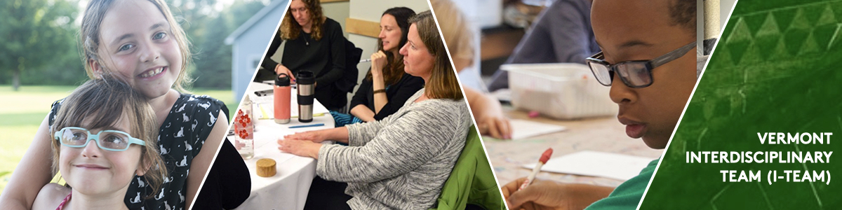

September 8, 2022

Dear Special Education Administrators and Special Educators:
The Agency of Education (AOE) is recommending that I-Team consultative services be reflected in the I-Team referred student’s IEP. However, before any IEP amendment, the LEA completes the I-Team technical assistance request paperwork, and has the parent sign the requisite consents to I-Team services and releases of records. The LEA then submits the entire technical assistance request package to the I-Team. After that, the I-Team reviews the application paperwork, and if everything is in order, sends a Consultative Services Agreement to the LEA for signature.
Services are provided on a school year basis, not on an IEP year basis. In order for the consultative services to be reimbursable by AOE, the LEA will need to amend the current IEP to include the I-Team consultation services. This can be done by agreement with the parent to an IEP amendment without a meeting.
As we understand it from AOE, for consultation occurring 2-3 times a year, the IEP Amendment should include a statement on the IEP service page to refer the reader to the narrative section for additional information.
The amendment should then have the following language added to the Program Supports and Accommodations section of the IEP:
“During the 2022-2023 school year, the I-Team will provide consultative services regarding [the student] to the IEP team and LEA personnel. The specific content, and type of services are within those available from the I-Team and will be informed by I-Team recommendations with input from the IEP team including the parent.”
For on-going consultation, this can be written into the service page grid like with other services.
If you have any questions about an I-Team referral, contact me directly at my email: darren.mcintyre@uvm.edu or at 802-495-6538.

Thank you,
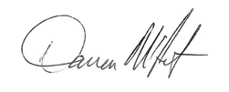
Darren McIntyre
VT I-Team Director

