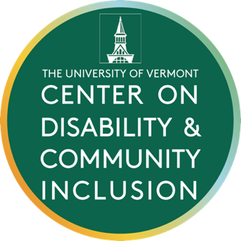
Community Needs Assessment Feedback

Purpose
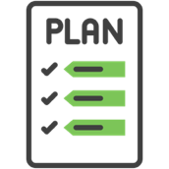
- CDCI makes a new plan every 5 years.
- Our new plan is due Spring 2023.
- We must include needs of people with disabilities and their families.
- We want your advice on how to learn about needs in Vermont.

Who should we talk with?
For our last plan we talked with people from many groups:
- People with disabilities
- Family members
- Service providers
- Green Mountain Self-Advocates
- Vermont Family Network
- Vermont Developmental Disabilities Council
- Disability Rights Vermont
- Vermont LEND
- Vermont Center for Independent Living
- Vermont Federation of Families for Children’s Mental Health
- Local and state agencies
- Vermont Care Partners
- University of Vermont
Who else should we talk to this year?

What questions should CDCI ask to learn about needs in Vermont?
For our last plan, we asked:
- What are the biggest needs of people with disabilities and their families?
- Look at a list of what we do now (list is on last page). Which are most important to you?
- What feedback do you have about the work we do now?
- We want to do more in a several areas. Which are most important to you?
  - Diversity, equity, and inclusion.
  - Transition to adulthood.
  - Health.
  - Helping partners use data to make decisions and improve services.
- What other things should CDCI do? Our work must help people with disabilities and fit in our four areas: Teaching, research, community services, and sharing resources and stories.
What other questions should we ask?

How should we learn about people’s needs?
We know we will use:
- Information that has already been collected.
- Information from other disability organizations.
- Feedback our CAC members have given over the past 5 years.
- Surveys to ask a lot of people to answer a small number of questions.
- Conversations with people and groups to ask for more detail.
Do you have advice on how CDCI should learn about needs?

What do we do with needs that we cannot meet?
- We will learn about needs that we cannot fix.
- What should we do with those?
- How could we share what we learn with others?

List of work CDCI does now:
- Assistive technology services
- Helping schools include students with disabilities
- Helping professionals collaborate and work together
- Supporting early intervention and early childhood services
- Helping schools improve student behavior
- Improving services for children and youth who are Deaf, Hard of Hearing, or DeafBlind
- Inclusive and supported employment
- Increasing partnerships between families schools and communities
- Working with self-advocates and family members
- College opportunities for people with disabilities
- Supporting health of people with disabilities
- Supporting independence in toileting
- Sharing the life stories of people with disabilities
- Researching what services and supports help people with disabilities
- Teaching students at UVM about culture and disability

