**Community Advisory Council**

**Bylaws**

Center on Disability and Community Inclusion

At the University of Vermont

**Table of Contents**

Introduction 3

History 3

Vision 3

Mission 4

The Council 5

Who Can Be a Member 6

Rules About Membership 7

The National Council 8

Leaving the Council 8

Officers 8

Meetings 9

Accessibility 10

Responsibilities 10

Council Member Responsibilities 10

The Center’s Responsibilities 11

Committees 11

Executive Committee 11

Membership Committee 11

Reimbursement for Expenses 11

Travel 12

Per Diem 12

Travel to National Meeting 12

Changing Bylaws 13

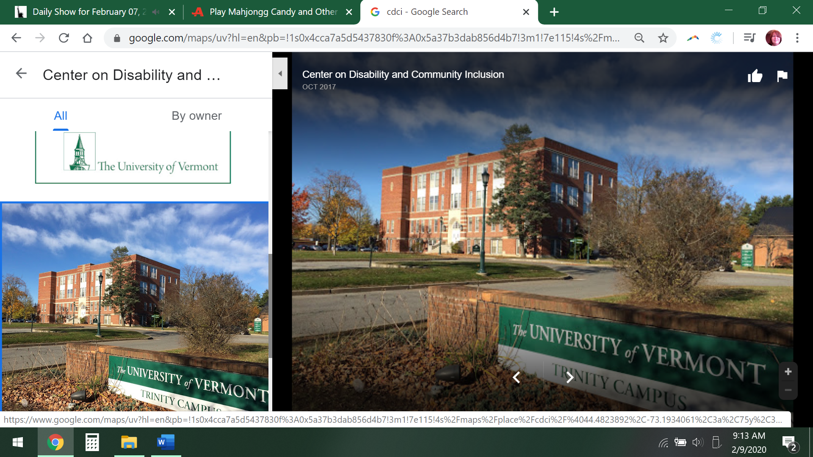**Introduction**

The Center on Disability and Community Inclusion is at the University of Vermont. It is also called CDCI or the Center.

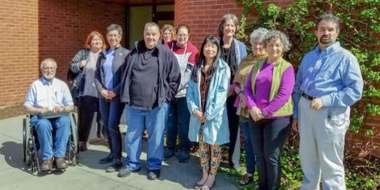

The Center has a Council. It is the Community Advisory Council. It is also called the Council or the CAC.

**History**

The DD Act is a federal law. It tells people with developmental disabilities that they have rights. They have the right to:

* make choices that are important to them
* and have the same chances to live, learn, work and love as people without disabilities.

The DD Act gives money to the University of Vermont to work on these issues. They run the Center on Disability and Community Inclusion. The Center:

* does research
* provides training on how to support someone with a disability
* and shows others how to include people with disabilities in all parts of everyday life.

A summary of the Centers’ **Vision** The Center believes in a future where all people are fully included in their schools, jobs and communities. People who experience developmental and other disabilities are respected and valued members of our world. They will help design supports and services that work for them. They will not leave anyone out because of:

* their disability
* their race
* their culture
* who they love
* their gender identity (this means how they see themselves male, female, a blend of both or neither
* what language they speak.

Everyone has the right to self-determination. It is making choices based on your interests. You decide what you want. It is also about the opportunities a person is given.

Simply said, the Centers’ **Mission** is to provide

* + education
  + support
  + research
  + and information

to make sure Vermonters with disabilities and their families can live the lives they choose.

We partner with and support **people with developmental disabilities**, their **families**, service **agencies** and **communities**.

We promote:

* personal choice and control,
* meaningful relationships,
* meaningful activities,
* living in a home and community,
* safety and health,
* equity and human rights, and
* full inclusion in society.

**We respect people from different cultures**. We meet the needs of people who speak languages other than English. We connect our community partners and university programs.

**The Council**

The Council is required by law. It is included in the DD Act 2000. In the law the Council is called “Consumer Advisory Committee.”

The Council makes recommendations that assist the Center to follow their mission. In the DD Act 2000 it is required that the Council will:

1. Consult with the Director of the Center to make a 5-year plan;
2. Determine if the Center is meeting its goals. Comment on this once a year.
3. Suggest how to make the plan better.

The Council is a way for people with disabilities, their families and providers to say what is important. Together they suggest ways to improve the Center. The Center value~~s~~ guidance from the Council. The Council’s advice improves how the Center does training and research. Suggestions from the Council improve technical assistance and direct services. A new year for the Council starts on July 1 and ends on June 30.

**Who Can Be a Member?**

At least half of the Council must be people with developmental disabilities or family members. The DD Act says what it means to have developmental disabilities. Members with disabilities or family members cannot also represent a disability group. For example, self-advocates from Green Mountain Self Advocates must choose to represent Green Mountain Self Advocates or people with developmental disabilities on the Council.

There **must** be at least one person from:

1. Disability Rights Vermont;
2. The Vermont Developmental Disabilities Council; and
3. Green Mountain Self Advocates

There should also be members from:

* The Vermont Family Network;
* The Vermont Assistive Technology Project;
* The Vermont Developmental Disabilities Services Division
* Other groups concerned about people with developmental disabilities.

Membership shall not exceed 20 members. The diversity of the people who live in Vermont should equal the diversity of people on the Council. At least 25% of members should represent diverse groups:

* Race
* sexual orientation
* gender
* national origin, and
* income.

## Rules About Membership

The Membership Committee of the Council finds people to apply to be on the Council. Anyone interested can fill out an application. A person can also ask the Center for help to complete an application. The Committee interviews the people who apply. The Committee writes notes about why a person wants to be on the Council. During a meeting they share their notes and applications with the Council. The Council votes “Yes” or “No” to accept new members.

One term as a member is 3 years. The Council makes a schedule, so people join and leave every year. The goal is to not to have everyone leave at the same time. It is best to have less than 5 new people each year. However, more can be added if needed to follow the rules in the DD Act.

Members can do 2 terms in a row. At the end of 3 years a member tells the Membership Committee if they want to apply for 3 more years. The Committee gives applications to the Council to vote on. The Council votes “Yes” or “No” to accept a member to do a second term. No member may vote on their own recommendation for membership.

There is one more important rule about picking members. Members can be on the Council for more than 6 years if they represent a group. And the Center Director may decide to allow a person to serve more than 6 years.

## 

## The National Council

The Center is part of the Association of University Centers on Disabilities (AUCD). AUCD has a Council made up of people with disabilities and family members. They are from each state. This National Council is called the Leadership in Advocacy. The Council picks one person to be on the National Council. They get one vote.

## Leaving the Council

Participation on the Council is voluntary. Members may choose to leave. If a member cannot attend a meeting they must let the Center know ahead of time. If a member misses two regular meetings in a year without telling the Center they will no longer be a member.

**Officers**

Officers will be two Co-Chairs. One officer must be a person with a developmental or related disability and one officer must be a family member of a person with a developmental disability. Officers will serve two-year terms. They can be re-elected. If possible, one Co-Chair's term will begin on an even year and the other will begin on an odd year. Co-Chairs will be nominated and elected by the Council when a Co-Chair is needed.

## 

## The duties of the Co-Chairs are to:

1. Discuss and prepare meeting agenda with the Director of CDCI or designated staff at least one month prior to meeting date;
2. Appoint members to committees as needed;
3. Facilitate meetings; and
4. Communicate with the Center Director and other relevant staff on a regular basis.

**Meetings**

Regular meetings will be held at least 3 times a year. Meeting dates will be set for the year by the first meeting in the Fall. Either the Co-Chairs or Center Director may call special meetings.

It is important for members to participate in meetings and other Council activities. Representatives from required groups may send someone to attend if they need to be absent.

It is best to attend meetings in person. Participating by phone is allowed if necessary. Each member who attends a meeting by phone will:

1. Identify himself or herself when the meeting begins; and
2. Be able hear what is discussed and communicate throughout the meeting.

## A quorum means how many members must be present to have a meeting

A Council meeting must have at least one-third of the members present who are:

* people with developmental or related disabilities
* or family members of people with developmental disabilities.

For example, if the Council has 20 members, there must be at least 7 members present who are disabled or who are family members.

An **announcement** of each Council meeting and the **agenda** will be sent to members at least one week before the meeting. It will also be posted on the Center’s website. Minutes will be taken by Center staff. Draft minutes will be sent to the Council and posted on the Center’s website. The Council will review and approve the minutes at the next meeting.

**Accessibility**

The Center will provide accommodations requested by members. The Council will use the “Get on Board and Make a Difference! Effective Practices for Including People with Disabilities and New Members on Boards and Committees” (2003) written by Green Mountain Self Advocates and the ARC of Vermont to ensure accessibility for all members.

**Responsibilities**

## Member are responsible to:

* Attend and participate in Council meetings.
* Become familiar enough with what the Center does. Be aware of current issues impacting people with disabilities. Think about this information when making suggestions for the Center.
* Give advice to the Center Director to make a 5-Year Work Plan.
* Each year, review and com­ment on the Center’s progress in meeting the goals in the 5-Year Work Plan.

## The Center is responsible to:

* Find an accessible place to hold meetings.
* Provide refreshments.
* Provide staff to:
  + Take notes of all meetings.
  + Keep a list of contact information for Council members.
  + Keep copies of meeting minutes and committee lists.
  + Send out information in a timely manner to the Council.
  + Give information to Co-Chairs when asked.

**Committees**

The **Executive Committee** includes the Co-Chairs and the Center Director. The Associate Director of the Center may or may not be on this Committee. Duties of the Executive Committee include:

1. Set the agenda for the Council meetings;
2. Select members for other committees;
3. Address issues that come up outside the regular schedule meetings.

The **Membership Committee** should have at least 3 Council members. They are appointed by the Center director. Other committees are formed when needed. They are established by the Center director.

**Reimbursement Of Expenses**

## Travel Reimbursement

Any Council member can ask the Center to pay for their travel costs to attend a meeting. It will be paid as long as they are not getting money from their employer to pay for travel. The University decides how much to pay for travel.

## Stipends For Council Members

The Center will pay a per diem to Council members for attending meetings. The director of the Center decides how much to pay. The amount will be based on the length of the meeting. The amount will be similar to per diems paid by other Councils. Any Council member can get a per diem if:

1. They ask for it
2. They are not already being paid to attend the meeting
3. They are present for the whole meeting.

## 

## Annual Meeting In Washington DC

Each state has a Council. Each year, Council members from all over the country go to a conference in Washington DC. It is called the AUCD conference. At least once every 5 years travel costs will be paid for one member to go to this conference.

1. The member must represent people with developmental disabilities or families
2. The member cannot be a representative from an organization
3. If money is available, travel costs can be paid each year.
4. The Council decides who will go.

**Changing these Bylaws**

Any member can suggest a change to these bylaws. Here are the rules:

1. You must tell all Council members you want to change the bylaws. Let them know 2 weeks before you vote.
2. 75% of all members need to vote to change the bylaws. For example, if there are 20 members, at least 15 members must vote.
3. And at least 75% of the people voting must be members with disabilities or family members.
4. It is okay to email or mail your ballot.