DM Available in Forages
From USDA Documentation Forms for Organic Livestock Producers
https://www.agriculture.nh.gov/publications-forms/documents/dry-material-intake-calculation-resources.pdf

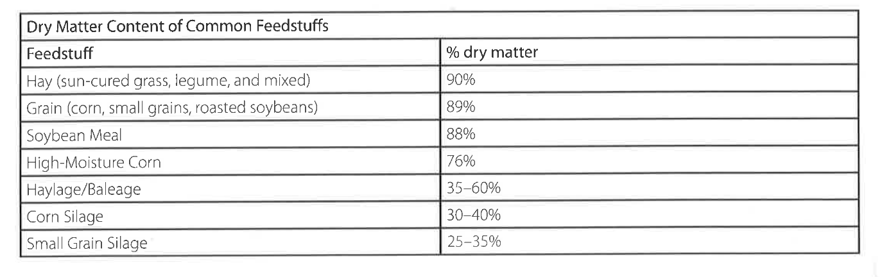
Haylage/baleage: 40-90% DM, estimate ~500 lbs DM per round bale baleage
Pasture: 15-20% DM

Estimating DM Availability in Pasture
(lbs pasture DM/acre-inch) – credit to Jim Gerrish for this table
Stand density | Fair | Good | Excellent
Pasture Species | Lbs/acre-inch | Lbs/acre-inch | Lbs/acre-inch
Tall Fescue + N | 250-350 | 350-450 | 450-550
Tall Fescue + Legumes | 200-300 | 300-400 | 400-500
Smooth Bromegrass + Legumes | 150-250 | 250-350 | 350-450
Orchardgrass + Legumes | 100-200 | 200-300 | 300-400
Bluegrass + White Clover | 150-250 | 300-400 | 450-550
Mixed Pasture | 150-250 | 250-350 | 350-450

