5 P’s of Carrot Marketing

FARM A:
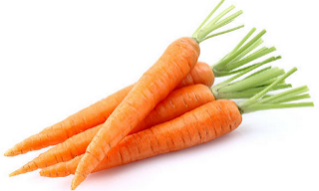
100 Acres +
Cost of Production: $0.35 per pound
Certified Organic
FARM B:
2 acres
Cost of Production: $1.45 per pound

FARM C:
No Single Farm Identity – aggregated product
Cost of Production: $0.90 per pound
Biodynamic

PRODUCT AND FORM

PRICE

PLACE

PROMOTION

PEOPLE

Notes:

