Native Tree Nursery Roundtable Meeting Mintutes
Watershed Forestry Partnership
December 10, 2024

Attendees
In person: Katie Kain, Justin Minott, Daniel Koenemann, Brooke Fleischman, Christine Cramer, Ben Fishbein, Kiana French, Ellen Fox, Tim Larned, Cassidy Gale, Jess Colby, Clara Fernandez Odell, Gabi Marchesani, Andrea Luchini, Spenser Hardy, Ben Rodgers, Phoebe Judge, Shawn White
Remote: Ben Gabos, Joanne Garton, Sadie Brown, Althea D, Rainier Lucas, Carrie Pershyn, Sadie Brown, Chris Olsen
Agenda
2:00 Welcome and Introductions (Shawn White, Watershed Forestry Partnership Coordinator, UVM/Lake Champlain Sea Grant)
2:15 US Fish & Wildlife, Conservation Reserve Enhancement Program (CREP), and Wetland Reserve Easement (WRE) projects (Katie Kain, Fish & Wildlife Biologist, US Fish & Wildlife)
3:25 Native Tree Species- Preferences and Availability (Ben Rogers, Nursery Sales Manager, Intervale Center)
4:00 Announcements

Katie Kain (Fish & Wildlife Biologist, USFWS) - Conservation Reserve Enhancement Program (CREP) and Wetland Reserve Easement (WRE):
Numbers of stems and species used in CREP
About 100,000 stems planted in VT in 2023 in all programs, the majority of which were for Conservation Reserve Enhancement Program (CREP), and Wetland Reserve Easement (WRE) projects. Other smaller programs like Trees for Streams and Watersheds United Vermont Woody Buffer Block Grant have been supporting other planting projects around the state.
For CREP alone, 100,000 stems were planted in the last 4 years. Individual project sizes ranges from 2 acres to 20+. All stems planted in these programs are bareroot (due to cost and ease of transport across large areas of land). Generally, CREP will plant at least 20K stems per year (but varies dependent on an active Farm Bill.
The species used in these projects have changed over the years. After monitoring the success of different species and finding that early successional species did the best. Most projects are in old ag fields where competition is very strong, so important to use fast-growing species. Planting sites are experiencing much more stress than they used to – longer growing seasons, drought, flooding. Deer browse, in particular, has really increased over the past decade.
Katie handed out graphs showing the trees and shrubs that were ordered for CREP projects over the past 4 years:
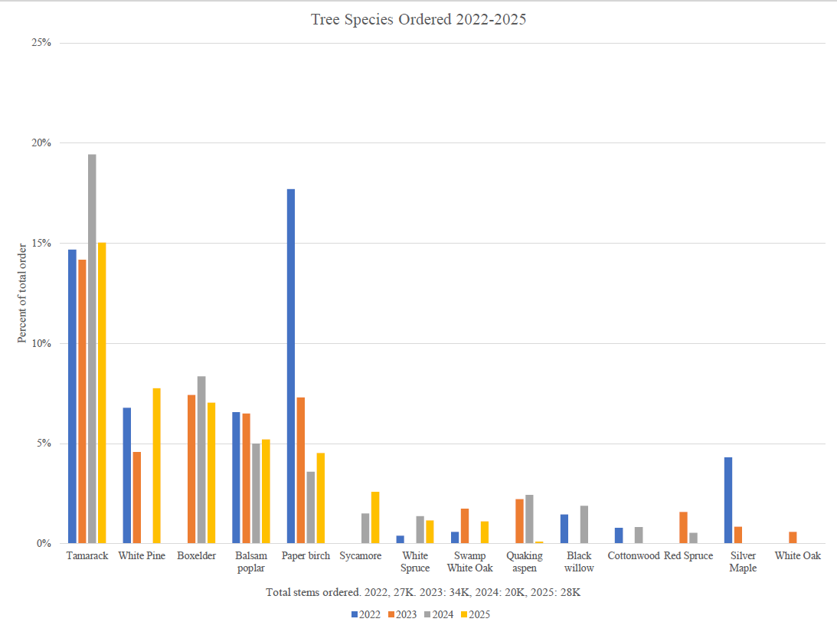
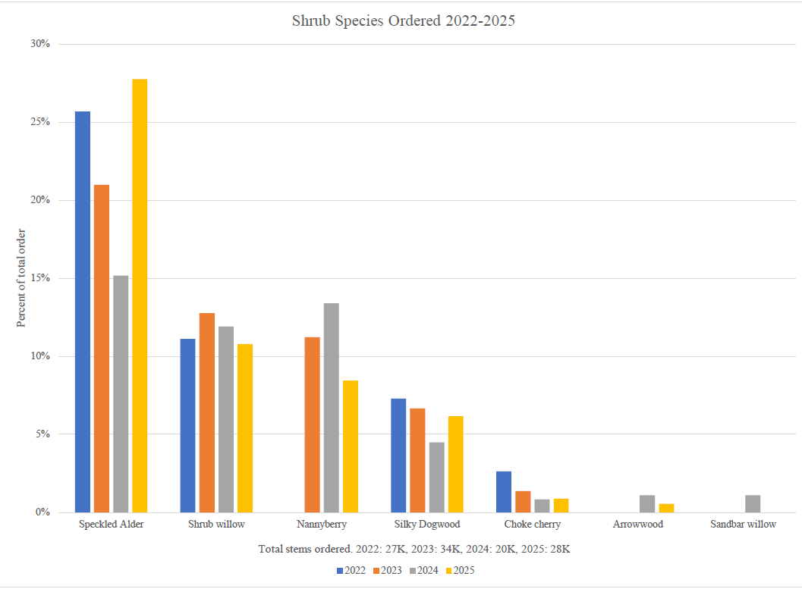

Note that these are the plants that were ordered, not their original wish list. Reflects species that were more resistant to deer browse and other stressors. (Not using tubes, doing some sort of follow-up like weed-whacking around stems). Would have liked to use more balsam poplar and box elder but couldn’t get those. Can see that some species have recently been dropped recently, like silver maple and paper birch.
Cassidy - WRE species list is very similar to Katie’s. Would add swamp white oak and gray dogwood to Katie’s list. All woody bareroot or live stakes. They want high genetic diversity and local ecotypes. Number of plants they order varies a lot from year to year, but want to make it easier on nurseries.
Ben G - would like to incorporate more sycamore
Katie – this is a living list – wants to incorporate more species diversity – would like to hear about possible species that could be tried. Can’t overstate how challenging the deer are becoming.

Cost Caps on federal programs
CREP projects have cost caps, while WRE has a competitive bid process where the lowest bid usually is awarded the project
WRE costs: Cassidy says WRE projects usually go to lowest bid. Bid includes site prep (invasive removal) in addition to plants & planting. They have the ability to weight bids toward those that provide genetic diversity, local ecotypes, and source from local nurseries, but the contractors don’t always know what local native tree nurseries are out there.
CREP cost cap: Ben G – always trying to increase the cap. It’s gone up a little bit over the past few years. Currently $3750K/acre for new contracts – 300 stems per acre, equates to $12.50/planted stem (includes plant material and labor). Usually have to implement something first year after contract is signed with landowner, so contract growing would be hard.
Katie - With these federal projects, looking to contract with somebody to provide/source the plant material, do the site prep and planting. So the Tree Hub becomes a really important way for growers to tap into these larger projects.
Ben G – It’s not the landowners choosing where to buy trees, it’s the contractors. Contractors they’re worked with over the years are mostly NorthWoods Stewardship Center, Intervale Conservation Nursery, Redstart. Total CREP demand over the year exceeds what they can get at the Intervale, so contractors have to go elsewhere. Redstart is starting to grow some of their own material.
Cassidy said if you’re interested on bidding for a WRE project, let Shawn know.

Contract growing:
Cassidy mentioned that wetland projects often take place over longer time frame of ~3 years, and there’s more flexibility to extend project timeframe, so more opportunity for contract growing. That is, if contractor can’t find local stems at first, could do contract growing with local nurseries rather than sourcing from out of state.
Katie asked whether contract growing would help nurseries with stability of demand.
Ben – yes. Takes the risk off. Nurseries don’t know what the need is going to be in three years, so great if can define that earlier.
Brooke – Will the ~25K stems per year stay constant in the future?
Ben G – There is so much year-to-year variability. Feast or famine in terms of the projects lined up. We can’t pile up a bunch of projects and plan for 3 years out. We’ve got to implement practices the first year of the contract. He estimated the minimum per year to be at least 15 - 20 acres minimum and 300 (trees/acre), so 4500-6000 trees. Generally about 20K trees per year. Maybe if nurseries bid on both CREP and WRE projects they could get would be more consistency.
Shawn – Seems like we need to make a directory of all the growers with the species each has. And use the Tree Hub idea to contract and group-source.

Thoughts about plants that are harder/more expensive to grow
Katie - USFWS needs to know which are hard to grow so they can avoid spec’ing those. Knows that nannyberry has been mentioned as an example. Maybe it doesn’t make sense to grow some species locally. They would probably still source those from out-of-state since the list of species that work well is already so limited.
Ben R – ICN has a bit of flexibility to experiment with these species -can growth these and is it worth it? Tricky since we don’t really know what that threshold is. If our mission as an organization is to streamline this whole thing and work with other growers to get more VT-grown trees on the ground, wonders if it makes sense to do any of that if there’s the cap and you can get trees for $2 a tree from Michigan.
Katie – I don’t think that’s the case, but there a line – if trees cost $10/stem that only gives us $2.50 for planting labor. Prices are set for the whole country at the federal level. We can provide feedback and we do. So it's really helpful to have actual tree costs so we can show when they are more than the program can afford. Cost caps have increased over the past three years.
Shawn – Sounds like we should know not only which species are expensive to grow but also the ones that are cheapest so they can be packaged together to increase species diversity but keep the average cost per stem low enough.
Monitoring data:
Kiana asked whether there is any monitoring data / organized graphs showing what species have done well over the years
Katie and group: Nothing recent. We have some data collected historically, which was used to inform the current list, but no one has had the capacity to run a monitoring effort. Maybe it’s time to revisit that. Currently there’s no money to do monitoring but maybe a UVM student could be recruited to collect data. We had also talked about having site maintenance crews like Intervale’s do some of that. ICN has talked about that, but wants to ease into it. They don’t want to find themselves with more work than they can handle.
Cass mentioned that WRE projects are monitored annually.
Ellen – Soils themselves are going through successional process. We should be thinking of how to get soils on the right trajectory and creating microenvironments that would allow other species. Maybe bring in seeds to create that second layer.
Species that have been tried but have not done well:
Katie said oak, red & sugar maple are examples and that she could compile and distribute a list. Red maple is particularly susceptible to browse. She would love to hear what people are doing further south where they’ve had even more deer. Feels we’re in a hard place right now – things would be different if we could manage the deer.

Deer protection:
Tree tubes are often not appropriate for use in floodplains, , are expensive and not always covered by grant money. USFWS tried repellant (blood-based Plantskydd) and that helped a little. Might be that’s what we’ll need to do -spray every tree with blood
Ben R – for the time being we could be planting the deer resistant species that are cheap to grow.

Species that are cheapest to grow:
Brooke listed willows, balsam poplar (Salicaceae) are the cheapest to grow because they don’t have dormancy requirements and grow fast. Wants to play with basswood, nannyberry, etc., but probably can’t produce a whole lot of stems. There are nurseries that manage to grow, but they can spray (herbicide).
Willow sourcing and species were discussed: Cassidy – do you differentiate between willow species, or it just shrub willow? Brooke - just mixed-species shrub willow right now, but we’re getting to the point where we can ID the different willows. Christine – also growing willows from seed to avoid having to do cuttings from parent plants they’re not the source sure of, that are old, and have been used for a long time. Spencer – Would like to put in a plug for sand bar willows – cool species, easy to identify. (but not common) Cassidy – Sandbar is S3. Can’t do S1, S2, S3 species (threatened or endangered) without special permission. Brooke – We’re not allowed to collect those anyway.

Follow-up items:
Cassidy – Provide desired WRE species list to Brooke and Ben.
Shawn – Make a directory of nurseries that CREP contractors can source from (with availability of local genotypes)
Shawn & Katie – Follow up on monitoring needs
Shawn & Cassidy – Work together to summarize WRE monitoring data

(break)

Native Tree Species- Preferences and Availability (Ben Rogers, Nursery Sales Manager, Intervale Center)
At the last meeting we discussed how the Intervale can serve as a resource to other growers. As a follow-up, put out a survey to other growers – find out what support is needed, learn what grows well at their site, what species they are interested in. Will incorporate this info in how the Intervale operates. Goal is to reduce the number of stems sourced from out-of-state.
What nurseries are already growing or can grow: cottonwood, grey birch, chokecherry, elderberry, some can’t provide anything now, but will be ready a few years from now.
Still need to figure out what the Tree Hub will look like. May be more than just central hub for trees and shrubs. May also mean Intervale will provide access to their infrastructure like greenhouse space for starts, cooler space, technical assistance, access to seed collection & processing. ICN is ready and willing to provide these and will start marketing these services soon. Brooke mentioned that ICN can give out seeds for free. They have 40 species collected this and last year - can be source-identified. If people really want a specific species, can’t help in that way, but if others collect species the ICN doesn’t, the seed cleaning & processing (scarifying and stratification) equipment is available to them.
Clara said technical assistance would be really helpful – greenhouse and field operations, cultivation practices at a species-specific level. Christine said ICN could give a tour of their production, whatever comes to mind, they can help with that.
ICN primarily uses the Woody Seed Manual for seed germination info. Brooke is hoping to put more educational materials on their website.
Nasami Farm expanding seed-growing and processing infrastructure and capacity with the goal of serving as the regional seed bank. Mostly herbaceous, some woody.
ICN recently sent out their 2025 availability list, has some very preliminary data about what species are selling. Hits: balsam poplar, box-elder, silky dogwood, shrub willow, speckled alder (quarter of all stems so far), nannyberry, tamarack, white pine, sycamore. Most of these species are being grown at the Intervale, except nannyberry, some of the tamarack, white pine. Not so hot so far this year: grey birch, red maple, red oak, ROD, silver maple, Aronia, arrowwood, black cherry, bur oak.
Kiana wanted to know how much size factors into what was ordered. Would people not order certain species because they were the wrong size? FWR likes 3-5’, CRC likes tall trees, WNRCD likes ~4’. Katie feels 5’+ gets too much transplant shock; 2-3’ is sweet spot for USFWS.
The expected survivorship was discussed. Katie said they assume ~70% survival after 2 years. The primary killers are voles, drought, beavers. Mowing around trees may help with voles.

Hildene Nursery has been exploring taking on the same role as the Intervale for the southern part of the state.

Estimated prices ICN could afford to contract with other nurseries to provide stems at the following rates:
1-2 foot stems $3.27
2-4 foot stems $4.72
4 foot plus stems $6.17
Ben hasn’t reached out to nurseries to see if they could make this profitable. Eventually would want these to be grown from Vermont seed (local ecotypes with genetic diversity – not cuttings/clones). They are aware, though, that there may be an interim period where some stock may not fit this.
Intervale is on track to meet sales goals from last year. Still not sure why they were so undersold last year. They started off this season with 28K. 15K still available plus 8K of Cold Stream stock. Has a lot of large stock in the field since they still have leftovers from last year. Won’t be able to sell those past next year. Will hire a second planting crew this summer.

Shawn had two announcements in closing:
- Lake Champlain Basin Program will be putting out an RFP for their Nursery Support grant ($1M available again this year) very soon. Not sure when due date will be for that yet. She thinks nurseries who have already received a grant from LCBP will still be eligible but needs to confirm.
- The Watershed Forestry Partnership annual meeting will be Feb 20, and there will be a Nursery Roundtable meeting session. If anyone has agenda items they’d like to include let Shawn know.

