[](http://www.google.com/url?sa=i&rct=j&q=&esrc=s&source=images&cd=&cad=rja&uact=8&ved=0ahUKEwjqk5jsrdPPAhWEbj4KHVitDsgQjRwIBw&url=http://www.newpaltz.edu/wilderness50/&psig=AFQjCNHVquSGla5RvdhnxQLQCwAUBQcm7Q&ust=1476296129719100)

**Summary of Preliminary Deer Impact Assessment on Upland Oak Forest Saplings at Mohonk Preserve (Summer 2017)**

Site selection, deer exclosure construction, and sampling methods in accordance with Environmental Monitoring & Management Alliance (EMMA) Protocol

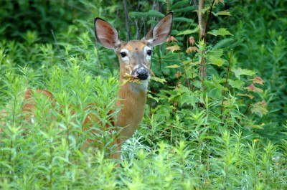

2017 Data Collection & Analysis Performed By:

Catherine Ferreri

Anthony Montoya

Megan Napoli

Mike Vivirito

|  |  |  |
| --- | --- | --- |
| **Species** | **# Saplings Sampled** | **% Browsed by Deer** |
| Chestnut Oak | 59 | 81.4% |
| Hickory sp. | 31 | 67.7% |
| Red Oak | 70 | 62.9% |
| White Oak | 34 | 50.0% |
| White Ash | 11 | 45.5% |
| Sugar Maple | 9 | 44.5% |
| Maple-leaf Viburnum | 106 | 38.7% |
| American Hornbeam | 9 | 33.3% |
| Red Maple | 25 | 32.0% |
| Hop-Hornbeam | 17 | 17.6% |

**Table 1.** Overview of the species of tree saplings sampled at eight 100 m2 plots throughout Mohonk Preserve study site. Percentage of browsed saplings calculated based on the total number of saplings across all study plots in both fenced and unfenced treatments during study year zero. The species list from top to bottom may be reflect the dietary preferences of White-Tailed Deer (*Odocoileus virginianus*).

**Mohonk Preserve Paired Plot Locations**

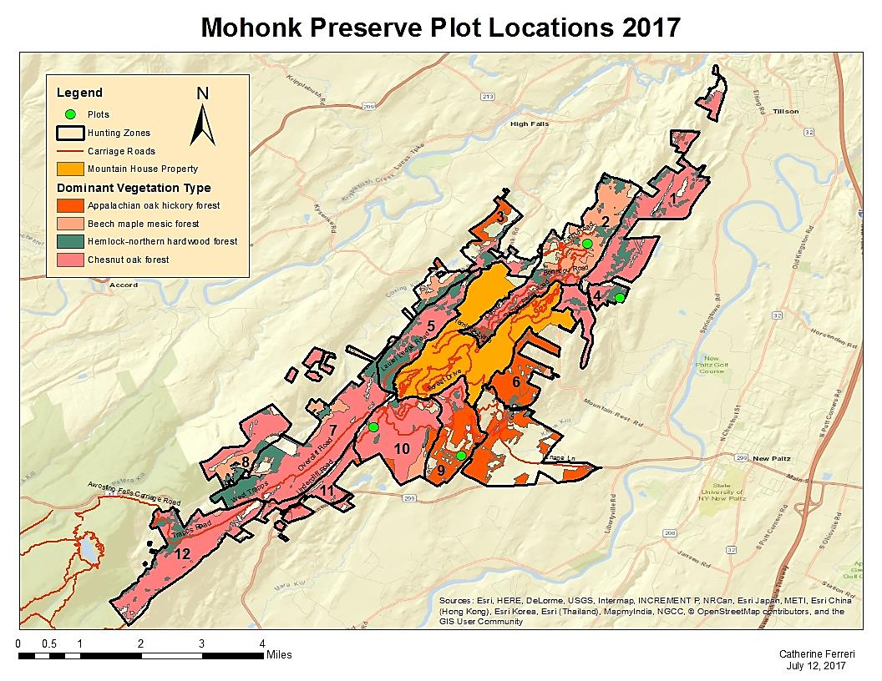**Figure 1.** Map of the entire Mohonk Preserve study site. Four paired plot locations are displayed as green circles in designated hunting zones. Each pair of plots occurs in a different dominant forest vegetation type.

**E**

**D**

**C**

**A**

**B**

**E**

**A**

**D**

**B**

**C**

Hunting Zone 9

Located near Glory Hill Road

(41.74764, -74.14738)

Sampling Dates: 6/26/17 & 6/27/17

|  |  |
| --- | --- |
| **Plot 1 Species** | **Saplings Sampled** |
| American Hornbeam | 1 |
| Hickory sp. | 18 |
| Hop-Hornbeam | 1 |
| Red Maple | 2 |
| Red Oak | 12 |
| Sugar Maple | 1 |
| White Ash | 7 |
| **Total** | **42** |

Percentage of Saplings Browsed = 59.1%

|  |  |
| --- | --- |
| **Plot 2 Species** | **Saplings Sampled** |
| Black Birch | 1 |
| Hickory sp. | 9 |
| Hop-Hornbeam | 2 |
| Red Maple | 1 |
| Red Oak | 2 |
| Sugar Maple | 8 |
| White Ash | 4 |
| White Oak | 4 |
| **Total** | **31** |

Percentage of Saplings Browsed = 61.3%

Mean Percentage of Saplings Browsed = **60.2%** (Figure 2)

**E**

**D**

**C**

**B**

**A**

Hunting Zone 10

Located near Undercliff Road

(41.7543, -74.16813)

Sampling Dates: 6/27/17 & 6/29/17

|  |  |
| --- | --- |
| **Plot 3 Species** | **Saplings Sampled** |
| American Hornbeam | 5 |
| Chestnut Oak | 13 |
| Hickory sp. | 1 |
| Hop-Hornbeam | 1 |
| Mapleleaf Viburnum | 2 |
| Red Maple | 2 |
| Red Oak | 2 |
| **Total** | **26** |

Percentage of Saplings Browsed = 70.4%

|  |  |
| --- | --- |
| **Plot 4 Species** | **Saplings Sampled** |
| Chestnut Oak | 19 |
| Hickory sp. | 2 |
| Mapleleaf Viburnum | 6 |
| Red Maple | 1 |
| Red Oak | 10 |
| **Total** | **38** |

Percentage of Saplings Browsed = 76.3%

Mean Percentage of Saplings Browsed = **73.3%** (Figure 2)

**E**

**D**

**C**

**B**

**A**

**E**

**D**

**C**

**B**

**A**

Hunting Zone 2

Located near Cedar Drive at Spring Farm

(41.79766, -74.11761)

Sampling Date: 7/11/17

|  |  |
| --- | --- |
| **Plot 5 Species** | **Saplings Sampled** |
| Chestnut Oak | 9 |
| Hop-Hornbeam | 12 |
| Mapleleaf Viburnum | 53 |
| Red Maple | 8 |
| Red Oak | 3 |
| **Total** | **85** |

Percentage of Saplings Browsed = 32.9%

|  |  |
| --- | --- |
| **Plot 6 Species** | **Saplings Sampled** |
| American Hornbeam | 3 |
| Chestnut Oak | 18 |
| Hickory sp. | 1 |
| Hop-Hornbeam | 1 |
| Mapleleaf Viburnum | 45 |
| Red Maple | 4 |
| Red Oak | 3 |
| **Total** | **75** |

Percentage of Saplings Browsed = 50.0%

Mean Percentage of Saplings Browsed = **41.5%** (Figure 2)

**E**

**D**

**C**

**B**

**A**

**E**

**D**

**C**

**B**

**A**

Hunting Zone 4

Located near Canaan Road

(41.78685, -74.11249)

Sampling Date: 7/3/17

|  |  |
| --- | --- |
| **Plot 7 Species** | **Saplings Sampled** |
| Red Maple | 5 |
| Red Oak | 19 |
| White Oak | 9 |
| Witch-Hazel | 1 |
| **Total** | **34** |

Percentage of Saplings Browsed = 55.9%

|  |  |
| --- | --- |
| **Plot 8 Species** | **Saplings Sampled** |
| Red Maple | 1 |
| Red Oak | 19 |
| White Oak | 21 |
| Witch-Hazel | 1 |
| **Total** | **42** |

Percentage of Saplings Browsed = 47.6%

Mean Percentage of Saplings Browsed = **51.8%** (Figure 2)

**E**

**D**

**C**

**B**

**A**

**Figure 2.** Graphic comparison of the mean proportions of saplings sampled at paired plots (n=4) that showed indications of browse by deer in year 0. The dashed line represents the grand mean of all plots (n=8) and signifies that 56.7% of all saplings measured showed evidence of browse. The greatest proportion of saplings browsed by deer occurred at the location near Undercliff Road while the least proportion occurred at the Spring Farm along Cedar Drive. One-way ANOVA test revealed that at least one paired plot mean differed from the grand mean. Error bars represent standard error.

**Plots 3 & 4**

**Plots 7 & 8**

**Plots 5 & 6**

**Plots 1 & 2**

**Figure 3.** Mean sapling heights arranged by tree species measured at each paired plot location.