Appendix C1 Field Protocols for Establishing and Permanently Marking Plots

This is a description of the process used to establish each LEMP plot.

- Each new LEMP plot center was arbitrarily located in the middle of a uniform area of landform, soils and vegetation, meeting the Plot Location Parameters. Each new plot was given a unique name to reflect its location on the GMNF, and plots were sequentially numbered in the order that they were located. The LEMP plot center is also the center of subplot 1.

- Next, the other three subplot centers were located using the Volume 1: Field Data Collection Procedures, sections 0.0 and 0.1 (pages 13-16), and the Units of Measure on page 13 of that document. Subplots 2, 3, and 4 are located 120 feet from center at azimuths of 120, 240, and 360 degrees. Distance measurements are made with a metal or cloth tape, pulled tightly. Azimuths are established using a good quality, hand-held compass, set with a declination of 14.5 degrees west. While the FIA Protocols recommend measuring in horizontal distance, the LEMP plot distances were measured in slope distance.

- Permanent monuments were installed at each of the four subplot centers. Each monument consists of a one-inch diameter, 24 in. or 40 in. long, galvanized metal stake topped with a round, 3.5 inch diameter brass cap. Twenty-four inch stakes were used for plot centers in Wilderness Areas and in shallow soils (soils less than 20-30 in. deep to bedrock). Forty-inch stakes were used in deeper soils (soils greater than 30 inches deep to bedrock) outside of Wilderness Areas. Stakes were driven into the ground with a sledge hammer. As they were driven in, three outwardly-curving prongs were forced out of the end of the metal stake (see figure 1). These prongs minimize the potential for stake movement over the long-term. Brass caps are labeled: “Long-term Ecosystem Monitoring Plot, USDA Forest Service, Est. 200_ (insert the year), Subplot # __ .” (see Figure 3). Some plots also include the LEMP plot number. In Wilderness Areas, most monuments were installed so that the top of the brass cap is 1-2 inches below the top of the duff layer. In a few instances the stakes could not be driven in far enough to allow the caps to be in the duff layer, so rocks were loosely placed around the cap to hide it. Outside of Wilderness Areas, monument caps protrude about one foot above the soil surface (see Figure 2).

- Three witness trees were marked at each subplot center using two diagonal bark scribes at DBH (diameter at breast height), and one scribe on the tree trunk within two feet of the ground (see Figure 2). These scribes should be maintained to ensure their visibility over the sampling intervals. The distance and azimuth from each witness tree to the plot center were recorded.

- GPS coordinates were recorded using a Garmin GPS unit. GPS locations are estimated to be within 50 feet of the actual plot centers. During the 2010 field season, we plan to collect survey-grade GPS information on all plots using a Trimble unit. In the future, plot monuments will be located using the GPS coordinates, scribed trees, and monuments. A metal detector will be needed to locate monuments in Wilderness areas.

Figure 1. A metal stake showing
the three outwardly-curving prongs
at the end of the stake

. 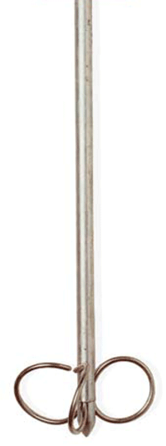
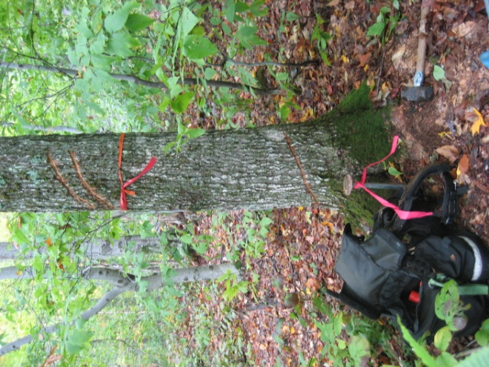
Figure 2. Plot monument and scribed tree outside of Wilderness. The pink flags were temporary markings.

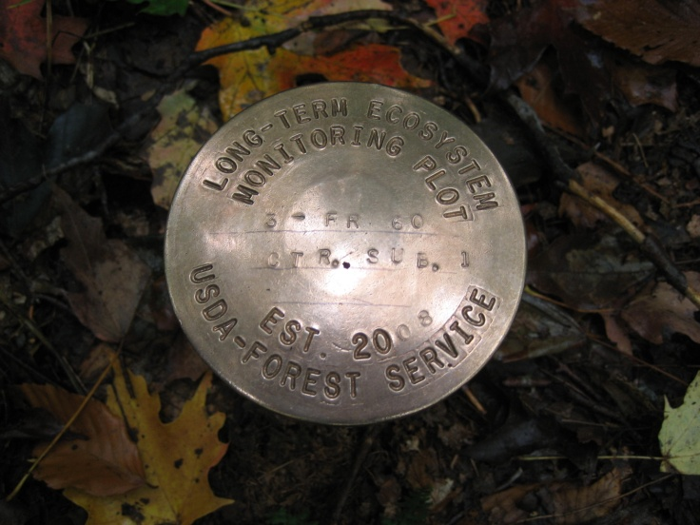

Figure 3. A typical brass cap with the inscriptions:
- Long-term Ecosystem Monitoring Plot
- 3 – FR60, meaning LEMP plot #3 – Forest Road 60; note that the plot number and name were omitted on some monuments.
- Est. 2008, meaning Established in 2008.
- USDA-Forest Service

