Thain Family Forest Soil Field Sampling
Standard Operating Procedure 1.1
Authors: Brad Oberle and John Zeiger Date: 5/31/2024
- PURPOSE AND SCOPE:
The Thain Family Forest (TFF), a 20 ha stand within NYBG, Bronx, NY, is the largest old growth forest in New York City and the epicenter for 125 years of urban forest inventory and ecosystem monitoring. By building on prior analyses and aligning with international standards, NYBGs ongoing forest monitoring will reinforce the forest’s status as the world’s premier urban research forest with high quality, transparent and repeatable data across the spectrum of forest structures and functions.
This standard operating procedure establishes systematic sampling for soils in the TFF, with the goals of (1) aligning with an international standard and (2) establishing a scalable framework for repeatedly measuring multiple features of soil structure and function. Doing so will (A) maximize comparability with other research forests and (B) inform analyses of (i) change in soils from key historic datasets, (ii) belowground impacts of current and proposed management and (iii) ongoing monitoring of soil health, especially related to carbon stocks and fluxes.
To accomplish these goals, this protocol adapts the Smithsonian Institution Forest Global Earth Observatory (ForestGEO) protocol (Smithsonian institution n.d.) to maximize overlap with the existing Continuous Forest Inventory (CFI) aboveground plots and soil types. Sampling at an intensity of 1 20x20 m square soil sampling array ha⁻¹, the 20 soil plots capture 48 CFI plots on all 8 major soil types (Figure 1). Soil plots consist of 9 sites along three transects sampled to different depths and aggregated in different ways depending on overlap with the CFI. For coarse-resolution data in all 20 plots, we physically aggregate samples from 0-10, 10-20 and 20-50 cm depths from the outer transects parallel to the CFI plots (Figure 2 rows “N” and “S”) and the center transect (Fig. 2 row “PLOT”) at depths below 50 cm in 50 cm increments. In 16 soil plots that overlap CFI plots, we will process individual, disaggregated cores at the upper two depths. At all sampling locations, we will record litter depth, earthworm casing presence depth of refusal and organic horizon depth. We will process litter and soil samples onsite in the NYBG Pfizer Lab.
The development of this SOP was supported with resources from the Forest Ecosystem Monitoring Cooperative. Data collection activities are indicated by the symbol “○” with named fields on the datasheet labeled in bold underline
- SAFETY:
This section highlights some, but not all, of the safety concerns you should be aware of while working in the Forest. Using required PPE and immediately reporting any concerns or injuries to Supervisory Staff is crucial for maintaining a safe work environment.

  - Personal Protective Equipment (PPE)
It is REQUIRED that all personnel working on this study:
1. wear a provided hard hat at all times in the Forest (no hats beneath!)
2. wear long pants
3. wear closed-toed shoes (preferably boots)
4. bring a full bottle of water into the Forest
5. wear gloves when working in plots with poison ivy
It is highly recommended that personnel also have:
1. spare shoes, socks and pants for subsequent lab work and transit
2. a bag to store clothes exposed to poison ivy until they can be washed
3. a rain jacket in case of light rain
b. Reporting an Injury
All injuries or safety concerns must be reported to on-site Forest Staff and to the Forest Manager. Personnel must complete a Personnel Report of Accident/Injury form for all reported injuries.
- Additional safety information related to risks from Sun & Heat; Poison Ivy & Other Plants; Ticks, Mosquitoes, Wasps & Other Pests; Trips & Falls; Trees & Limbs; Weather; If the emergency requires immediate medical attention and/or an EMT; are outlined in Appendix 1.
- Use of laboratory drying ovens entails fire hazards. Never stack samples in the drying oven and ensure open circulation around samples.
- Outline of Procedures
- Personnel
- Materials
- Measurement and Collection Procedures
- General procedures and locating plots
    - CFI plot transects
    - Other transects
2. Litter-related measurement and sampling
i. Litter measurement and sampling
ii. Litter subsampling
iii. Earthworm activity
3. Soil-related measurements and sampling
    - Notes on Coring
    - Measuring the soil and identifying sampling locations
    - Soil Bulk Density
    - Organic Horizon
    - Soil subsampling
4. Chain-of-Custody and interim storage
d. Cleaning sampling materials
e. Data Entry

- Personnel
- Brad Oberle is the project PI responsible for data collection, developing and revising SOPs, training personnel and conducting quality assurance activities. Brad is the supervising personnel responsible for lab-based activities.
- John Zeiger is the Thain Family Forest Manager who is responsible for implementing the Thain Family Forest Management Plan. John is the supervising personnel responsible for field-based activities.

- Materials
Prior to fieldwork, personnel must check all of the components of the following devices.
- Data recording
  - Printed field datasheet (see appendix)
  - 2x pens
  - Field clipboard
- Plot and site location
  - Smartphone with Avenza Maps app for locating sampling plots that overlap CFI
  - GPS for recording locations of sampling sites that do not overlap CFI
  - Compass for measuring bearing
  - Clinometer for measuring slope
  - 50-m tape for measuring distance
  - 10 pin flags for temporary site marking and measuring the depth of the litter layer
  - 50 cm x 50 cm PVC quadrat for marking litter collection area
- Soil sampling
  - Steel Rod for measuring the maximum depth or “depth of refusal” of soils
  - Eijkelkamp 2” bulk density sampler kit, including
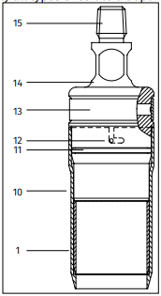
    - Hammering handle
    - Extension rod
    - Sampling cup connector
    - Sample ring holder
    - 20 clean sample rings
    - 40 clean sample end caps
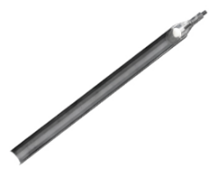
    - ring case
  - Eijkelkamp 30 cm gouge auger
    - Hammering handle
    - 30 cm x 3.3 cm gouge auger for top soil
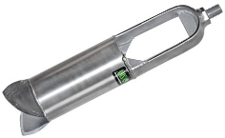
  - Eijkelkamp riverside bucket auger
    - Hammering handle
    - Marked Extension rod
  - Rubber mallet & wrench set for driving samplers to sampling depth and disconnecting
  - Red handled spatula for trimming cores
  - Spoon for removing soil that falls back into sampling hole
  - Brush for clearing augers between samples
  - Secateur for cutting roots that obstruct the soil corers
- Sample storage and labeling materials
  - 6 clean 2-gallon buckets with lids for holding aggregated soil samples
  - 30 large plastic zip-locks for temporary sample storage
  - 1 reusable grocery bag for holding litter during subsampling
  - 2 sharpies for labelling bags
  - 2 large tote for carrying samples and augers and organizing materials in the field
- Sample measurement materials
  - 2 retractable measuring tapes with mm scale visible for measuring litter depth, depth of refusal organic horizon depth, core length and sample hole depth
  - Pesola scale for measuring field mass of sampled materials
- Finally, personnel are responsible for taking the following safety supplies
- First Aid Kit
- Technu poison ivy cleanser
- Nitrile gloves
- Helmets for all personnel
c. Measurement and Collection Procedures
For the purposes of this project, we define
- litter as any senesced plant tissue that is completely above the soil and entirely contained within the quadrat boundaries and is less than 1 cm in diameter.
- worm castings as any evidence of the activity of earthworms between the litter and the organic horizon.
- soil as the sediment that occurs below the litter down to the depth of refusal for a steel rod. We define the
- organic horizon as a discrete layer of darkly colored soil below the litter and above the mineral soil.
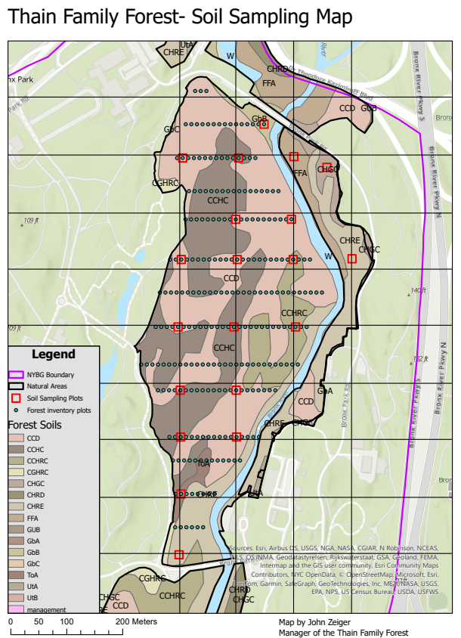
1. Locating plots and points
This procedure samples soils in the Thain Family Forest at an intensity of 1 20x20m plot per ha of forest, in an approximately regular array adjusted to maximize overlap with Continuous Forest Inventory (CFI) plots, soil types (Figure 1). The locations of 16 soil plots that overlap with CFI plots are fixed by rebar markers. The other 4 plots are located using high-resolution GPS.
Within each 20x20 soil sampling plot, measurements are made and samples collected in a regular square array of 9 sampling points (Figure 2) with three rows / columns spaced 10m apart along east / west or north / south. For the 16 soil plots that overlap with CFI plots, the rebar plot boundaries provide a permanent spatial reference for locating the sampling points. Different positions of rebars relative to the soil sampling plots may require different sets of measurements to locate plots. To minimize propagation of positional error, point locations are measured relative to adjacent rebar stakes whenever possible
Figure 1: Sampling strategy relative to existing CFI plots (small squares), soil types (polygons) and regular 1 ha grid.

Litter and soil sampling procedures vary depending on whether or not a soil plot, and contained sampling point, overlaps with CFI plots. Litter and surface soil samples (0-10cm, 10-20cm, 20-50cm) are collected individually for points within CFI plots; all other samples, except soil bulk density samples, are aggregated by depth within a plot. In cases where litter samples exceed approximately 1L volume or soil samples exceed 2kg mass, representative subsamples are collected in the field. In cases where soil C samples are less than approximately 250 ml for depth that is present, additional cores are collected.
plotIDs are created from two numeric values corresponding to the CFI transect and central plot or substitutes determined for soil plots not centered on CFI transect
Sample IDs are concatenated from the plotID + point ID [{N,C,S}x{E,C,W} or outer] + the level of the uppermost stratum of the sample [litter = “L”, soil = “0, 10,20,50,100…”] and the type of soil sample as needed [bulk density = “BD”, composition = “C”]

- CFI plots for any of the 16 soil sampling plots that includes CFI plots
  - Use Avenza maps to navigate to the vicinity of the northwesternmost rebar that marks an included CFI plot.
if teams are working in parallel on separate datasheets
○ Record the page number of the total pages
i.e. mapping datasheet & sampling datasheet = 1/2 & 2/2
○ Record initials of all Personnel and the Date dd-mm
○ Record plot as the ID code for the central CFI plot in the transect (e.g. 4-1) and add the plot id’s for the W and E CFI plots at the underlined spaces on the datasheet
  - Locate any other rebars in or adjacent to (within 7 m diagonally of) the soil sampling plots.
    - These rebars provide the “ref_ID” by plot name for locating sampling points.
    - Flag the rebars to improve visibility
  - Flag all 9 soil sampling points starting at the northwesternmost rebar
    - Determine which 2 or 4 sampling points are diagonally adjacent to the northwesternmost rebar.
○ Record ref_ID in the appropriate columns for those points on the datasheet
Figure 2: soil plot dimensions and sampling point locations (small squares) relative to CFI plots (horizontal strip of squares), including locations of rebar markers at northwest corners of odd-numbered plots, except for plots with an obstruction at an NW corner. Horizontal distances and bearings in degrees for locating sample sites in each soil plot relative to the typical placement of rebar. The plotID is “x-2”.

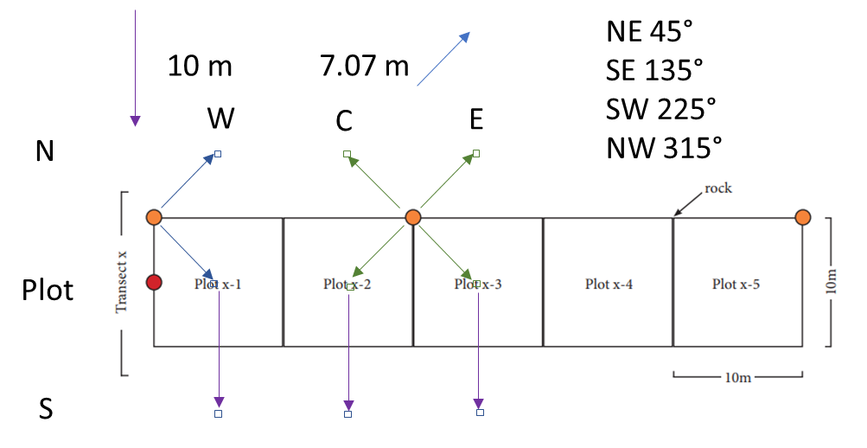
ii. Locate the sampling points and record relevant location measurements
NOTE 1: Sampling point locations are determined relative to horizontal distances. Because slope distorts distance along the ground relative to horizontal distances, slope should be measured using a clinometer and length should be adjusted, when needed, depending on whether measuring 10 m in a cardinal direction (N, E, S, W square) or 7.07 m in a diagonal direction (NE, NW, SE, SW) to reach a sampling point at the center of a plot from a rebar stake at the corner of a CFI plot (Figure 2).
NOTE 2: Sampling points may occur in areas that are not appropriate for sampling. Inappropriate places include place on or within 50 cm of (1) large rock outcrops (2) active trails (3) large tree bases (4) dense briar patches or ground wasp nests where team members cannot work without risk of injury. In any of these cases, team members should record why the prescribed point is inappropriate and attempt to choose a point within approximately 3 meters of the sampling location, and include alternative location measurements. Do not use adjusted points as Ref ids for subsequent points.
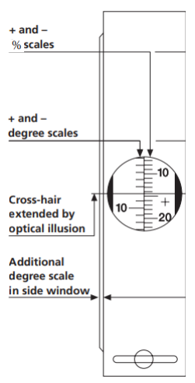
      - With one team member standing at the ref_ID, use the compass to direct another team member along the bearing to the first diagonally adjacent sampling point to a distance of 7 meters measured by laying the 50 m tape along the ground. These points will fall on the N or C transects.
If the approximate location of the point is inappropriate for sampling (see Note 2 above), record the cause in NOTES and search for an alternative location within 3 m. Collect all location information to the adjusted point center (i.e. bearing, slope, distance) directly from the rebar marker ID. Use the high precision GPS to record the adjusted point lat_dms and long_dms. If no location within 3 m is appropriate, skip the point and strike the corresponding fields. Otherwise, proceed with the prescribed measurement location.
○ Record bear_deg in degrees or direction if accurate for the appropriate column
      - Use a clinometer to record the slope and determine the distance correction necessary (Figure 3). To measure the slope from the rebar along the bearing to the sampling point: 1) pick a feature at eye level at the starting point of the line you are measuring 2) proceed to the end of the line being measured and, using the clinometer with both eyes open, align the cross-hair in the sight to that feature. The value read on the % scale is your percent slope.
○ Record slope_deg in degrees for the appropriate column
Figure 3: Clinometer window (above) and slope measurement scheme (right).

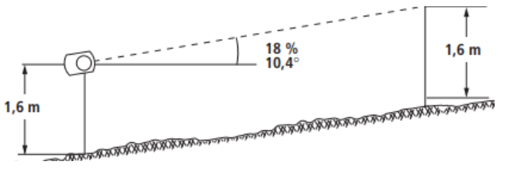
      - Have both team members hold the tape as straight as possible at along the ground and add the distance for the appropriate slope correction factor at right. Plant the pin flag with the appropriate code for the sample location.
○ Record dist_m.cm in meters to the nearest centimeter
iii. Repeat 1-3 above for the other 1-3 points diagonally adjacent to the same rebar
iv. Repeat i-iii above for any points diagonally adjacent to another rebar.
v. Repeat ii for all remaining sampling points, measuring in a cardinal direction from a previously flagged sampling point, recording flag id’s as ref_ID, 0°, 90°, 180°, 270° as bearings and corrected distances from the square basis.
if one of the orthogonally adjacent point was adjusted because of inappropriate sampling conditions, choose another point as the ref_ID. If no orthogonally adjacent point was in the prescribed location, map the point from a diagonally adjacent point, using a appropriate multiplication of the diagonal distance.

- Other plots
  - Use Avenza maps to navigate to the designated plot center location and mark with a pin flag
○ Record initials of all Personnel and the Date dd-mm
○ Record plotID
if the plot is located at the same latitude as a CFI transect, the plotID is the transect number + “-“ + the letter X
if the plot is not located as a CFI transect, the plotID is the next lowest transect number + “1/2“ + the letter X
  - Use the high resolution GPS to record the plot center location to the nearest decimal second (i.e. dd mm ss.s).
If the approximate location of the point is inappropriate for sampling (see Note 2 above), record the cause in NOTES and search for an alternative location within 3 m. Collect all location information to the adjusted point center (i.e. bearing, slope, distance) directly from the rebar marker ID. Use the high precision GPS to record the adjusted point latlon_dms. If no point within 3 m is appropriate, skip the point and strike the corresponding fields. Otherwise, proceed with the prescribed measurement location.
○ Record the plot center latitude in degrees, minutes and decimal seconds latlon_dms
C. Locate the remaining sampling points and record relevant location measurements
i. Locate 4 squarely adjacent points 10 meters away (W, E, N, S)
      - With one team member standing at the ref_ID, use the compass to direct another team member towards the bearing to the first diagonally adjacent sampling point to a distance of 10 meters measured by laying the 50 m tape along the ground
○ Record bear_deg in degrees [or orientation] for the appropriate column
      - Use a clinometer to record the slope and determine the distance correction necessary. To measure the slope of your plot: 1) pick a feature at eye level at the starting point of the line you are measuring 2) proceed to the end of the line being measured and, using the clinometer with both eyes open, align the cross-hair in the sight to that feature. The value read on the % scale is your percent slope.
○ Record slope_deg in degrees for the appropriate column
      - Have both team members hold the tape as straight as possible at along the ground and add the distance for the appropriate slope correction factor at right. Plant the pin flag with the appropriate code for the sample location.
○ Record distance_m.cm in meters to the nearest centimeter
ii. Locate 4 diagonally adjacent points on the plot corners (NW, SW, SE, SW)
1. Repeat i 1-3 for all remaining sampling points, measuring vertically or horizontally from flagged measurement points, recording flag id’s as ref_ID, 0°, 90°, 180°, 270° as bearings and corrected distances from the square basis.

A correctly flagged plot will have 9 flags in a square array oriented along the cardinal directions with all points 10 m apart in any cardinal direction, except for any points in documented inappropriate locations.

- Litter-related measurement and sampling
Litter-related measurements are recorded for every point in every plot. Litter sampling occurs in different ways depending on whether or not a sampling plot occurs within a CFI plot. Samples from CFI plots are processed individually, with samples collected into different labeled plastic bags. Samples from outside CFI plots are aggregated into a bucket and sampled collectively. Litter samples that exceed
i. Litter measurement and sampling
A. Situating the litter sampling quadrat
Prior to measuring or collecting litter, assemble the 0.5x0.5 m PVC quadrat and situate it so that the pin flag is located in the appropriate corner for the sampling campaign so that the with the sides of the quadrat are parallel to the 4 cardinal directions
→ During the main inventory, the sampling quadrat should have the pin flag in the southeast corner of the quadrat.
→ During the QA sampling, the sampling quadrat should have the pin flag in the southwest corner of the quadrat.
  - Label clean plastic bags for all expected samples with the sampleIDs
B. Measure litter depth
In the approximate center of quadrat, press a pin flag through the litter to the point of resistance from the soil. Grasp the pin flag between fingers, remove and measure the distance in mm to the nearest mm using calipers.
○ Record L_d_mm in millimeters
C. Collect litter and measure wet mass
a. Suspend the subsampling grocery bag from the Pesola scale and tare it to 0 g
b. Using a gloved hand, remove all recognizable plant material that occurs entirely within the quadrat boundaries into the grocery bag
○ Record the weight of the total LITTER in g to the nearest 10 g in (L_WM_g).
if the litter sample volume exceeds the capacity of the grocery bag, repeat and include multiple measurements
c. Remove the bag from the tared scale.
if the point is outside of a CFI plot, prepare the litter bucket for collecting the subsample
if the point is in a CFI plot, label a clean plastic bag with the plot, point and “L” to collect a representative subsample
d. Subsample the weighed total
i. Take a small handful of litter from the top, middle, and bottom of bag and place in the labeled container
ii. Using your gloved hand mix the litter that remains in the bag.
iii. Of the mixed litter, take a small handful of litter from the top, middle, and bottom of the bucket and place in a labeled plastic bag.
D. subsample material from the bucket into a labeled plastic bag.
A plot with CFI included will have 4 litter sample bags
A plot without CFI included will have 1 litter sample bag.
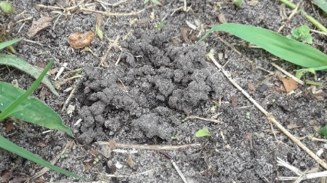
iii. Earthworm activity
Examine the quadrat area with the litter removed and record if you see evidence for earthworm activity as represented by living or dead worms or their casings on the forest floor within the quadrat (Figure 4).
○ Record worm_YN
Figure 4
3. Soil-related measurements and sampling
Soil-related measurements are recorded for every point in every plot from within the quadrat after removing litter. Two different sets of samplers (soil bulk density [SBD] and gouge augurs) produce two different samples (constant volume and open profile) useful for different measurements (moisture content, bulk density and organic matter vs. organic horizon depth and carbon content). Soil sampling occurs in different ways depending on whether or not a sampling plot occurs within a CFI plot. Samples from CFI plots are processed individually. Samples from outside CFI plots that are not in SBD rings are aggregated into a bucket and sampled collectively. Soil chemical analyses require approximately ½ cup (200 mL) of sieved dry soil. Additional gouge auger cores may be necessary to collect this volume.
Note: rocks can damage the soil samplers. Examine the cleared quadrat area and avoid locations with surface rocks and roots. Test other locations with the soil probe when measuring Depth of Refusal. Choose to sample from an area with the deepest measurements. When sampling that area, use only enough force to sever small roots. If the sampler does not move when struck with the rubber mallet, remove the sampler and try again nearby.
i. Notes on coring:
A. If roots interrupt coring using the bulk density corer for the 0‐10 cm sample then start again nearby (within 10 cm). If roots interrupt the 10‐20 cm sample, attempt to cut them with a sharp knife or secateurs. A large rubber mallet can be used to hammer the corer through large roots, but care is needed to avoid damaging the core tip on stones. You may use the bucket auger to reach the approximate depth in subsequent locations.
B. The weight of soil for the 0‐10 cm and 10‐20 cm samples taken with the constant volume corer is used to calculate bulk density, so it is of critical importance that the sample is taken to the correct depth and that (to the extent possible) the entire sample is recovered from the sample ring. If a small amount of sample remains in the corer pulled out from the ring, you may use the spatula to transfer the sample and fill the ring, without packing or compressing the soil.
C. A small amount of soil occasionally drops back into the bore hole when sampling the 0‐10 cm depth. This is evident if some soil is missing from the base of the core sample. This problem can usually be prevented by keeping the corer straight when removing from the hole.
D. Take care to minimize soil from the surface, which is rich in carbon, falling into the coring hole and contaminating deeper samples. It is usually clear if dark material has fallen into the hole as it will sit at the top of an auger sample and can be removed easily (e.g. by removing the top 2 cm of soil from the core sample) before placing the remaining sample in the bag or bucket.
E. Some locations may have a thin ‘mat’ of very fine roots that lie on the soil surface, but underneath the leaves. Prior to sampling, remove decaying leaves by hand but leave the fine roots on the surface – these should be included in the sample.
F. If the water table is encountered, continue sampling until it is impossible to bring the soil to the surface (i.e., the soil is so wet that it falls from the auger before reaching the surface).
G. If there is a sign of soil disturbance (track, termite nest) at site of sampling then move to an undisturbed area as close as possible to the sampling point. Record the distance from the ref_id and compass bearing of the new sampling location
ii. Measuring the soil and identifying a sampling location
Soil depth is measured by using bodyweight to push a steel rod into the soil to the depth of refusal.
Check that the location for measurement is free of rocks seedlings, surface roots or other obstructions.
- Use even pressure to push the steel rod perpendicularly into the soil until it stops moving or is completely inserted.
- Grasp the rod firmly with your hand at the soil surface, remove the rod and use a measuring tape or meter stick to measure the length of the rod that was inserted
If the DOR is less than 20 cm, choose another location and try again
○ Record DOR_cm in cm to the nearest mm.
C. Strike any rows for the sampling point the that start with a number greater than the measured DOR.
- Soil Bulk Density (SBD) sample core
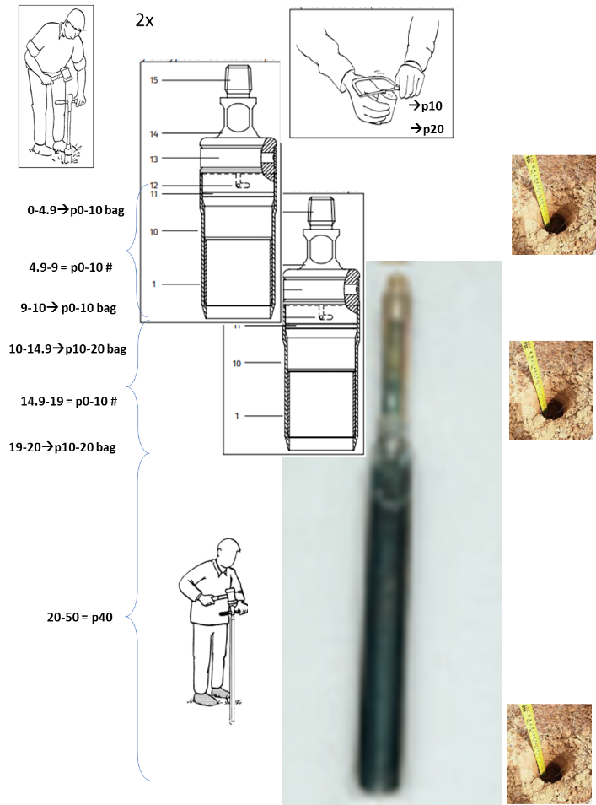
Soil bulk density samples are collected using the fixed volume sampler at two consecutive depths (see Figure 5). The distance from the open cup of the sampler to the quick connect notch is 10 cm. The distance from the open cup of the sampler to the marked location on the sample handle is 20 cm. Driving the sampler to each successive depth in the same hole collects cores within the target depth using the contained fixed volume ring. The material in the ring is trimmed with a straight spoon. The actual depth of the sampling hole is recorded after collecting each sample and capped sampling rings have their numbers recorded. Deeper samples may be inaccessible from the first sampling hole. In these cases, subsequent shallow holes are attempted and surface soils discarded before collecting into a sampling ring from a deeper hole.
A. Prepare the sampling materials and area
  - Arrange the materials for the soil bulk density sampler outside of the quadrat and check that they are clean. If they have adhered sediment, brush them.
Figure 5: Soil Bulk Density sample core schematic diagram

  - Prepare sampling rings and caps for the 0-10 cm and 10-20 cm sampling depths (Figure 2).
  - Assemble the soil bulk density (SBD) sampler by placing one stainless steel ring inside the bulk density cup, after which the bulk density cap is twisted onto the sampler cap and the sampler cap is screwed onto the handle. An extension rod may be added.
  - Assemble the 30cm x 3.3 cm first step gouge auger
  - Choose a location within the quadrat that is near the DOR measurement location.
  - Prepare three buckets corresponding to 0-10, 10-20, 20-50, depths
If the sampling plot overlaps the CFI, prepare 3 bags corresponding to 3 depths from each of point that occurs within CFI plots and additional buckets that are from within the DOR (e.g. 50-100)
B. Collect the 0-10 cm SBD samples
a. Using body weight and gentle strikes from the rubber mallet to the handle, drive the SBD sampler until the notch for the quick connect is at the soil surface
b. Gently rock the sampler back and forth to break the core from the underlying soil. Pull the sampler up and out of the hole, keeping the sampler as vertical as possible.
c. Check that the soil core is all the way to the bottom of the sampler.
if soil has fallen from the sample ring, move the sampler and try again
d. Disassemble the sampler by rotating the cup at the quick connect and pulling apart. Doing so close to the ground reduces the likelihood of the sampler flying apart upon disassembly. Use the red handled spatulas to trim excess soil from the open ring ends, and replace missing soil that may remain adhered to the sample cup holder. Place caps firmly on both ends of the sampling ring
○ Record the embossed number on the sampling ring # in the appropriate column
e. Insert the measuring tape against an edge of the core hole
○ Record the hole depth 0-d_cm from the bottom to the edge in cm to the nearest mm in the appropriate column.
- Collect the 10-20 cm SBD sample
a. brush clean the SBD sampler, add a clean sampling ring and reassemble
c. Repeat steps a-c above
○ Record the hole depth 10-d_cm from the bottom to the edge in cm to the nearest mm in the appropriate column and ring #
if an obstruction blocks the sampler, remove any soil from the sampler, brush it clear and use the bucket auger to remove and discard the top 10 cm of soil from a nearby location. Try sampling again.
- IF within DOR in a CFI plot, collect the 20-50 cm sample into a bag labeled with the sample ID [this sample will be used for both moisture content and composition analysis]
  - Place the top level, large diameter gouge auger in the sample hole. Using body weight and gentle strikes with the rubber mallet, drive the auger down to the point where the mark on the extension rod is level with the soil surface.
  - Rotate the gouge auger to cut the core and pull vertically from the hole. Carefully remove the sample from the hole. Transfer the sample to a labeled bag (if within a CFI plot) or into the 20-50 cm bucket otherwise.
○ Record the core length 20-d_cm from the bottom to the edge in cm to the nearest mm in the appropriate column.
E. IF within DOR and sampling point along central transect (W, C, E), continue collecting in 50 cm increments to a depth of 150 cm [this sample will be used for both moisture content and composition]
a. Use the bucket auger with marked extension rods as necessary, adding additional rows with hole depth measurements in the notes field
iv. Soil composition sample core(s)
The soil composition sample cores come from the same quadrats as the SBD cores and serve two purposes. First, using gauge auger provides a clear view of the soil profile for measuring the organic horizon depth. Second, taking additional cores provides supplemental material (minimum 200 ml soil volume) for measuring the biological, geological and chemical composition of the soil profile.
- Prepare the sampling materials and area
  - Label clean plastic bags for all expected samples with the sampleIDs in CFI or arrange buckets for samples if in the Outer transects.
- Collect a surface core to 30 cm or depth of refusal using the large diameter gouge auger.
a. Using body weight and gentle strikes with the rubber mallet, drive the auger down to the
end of the sampling cup.
b. Rotate the gouge auger to cut the core and pull vertically from the hole. Carefully remove the sample from the hole.
○ Using a measuring tape record the total core length org_len_cm in cm to the nearest mm
c. Lay the sample on the ground and examine the top of the core for evidence of an organic horizon
○ Using a measuring tape record org_d cm in cm to the nearest mm
if the core is abnormally short and uniform in color, determine whether the surface is organic or mineral based on the composition of other cores in the plot.
if the organic horizon boundary is gradual or unclear, make a note.
d. Split the core into the appropriate bags / buckets
i. Measuring from the top of the core, use a spatula to cut the portion of the core from 20 cm depth to the bottom of the core and use a spoon to scoop / scrape the material into the appropriate bag for a point within a CFI plot (i.e. 20-50) or otherwise the appropriate bucket.
ii. repeat step i above for the portion of the core corresponding to 10-20 cm depth and again for the top 10 cm portion of the core.
if in a CFI plot, or the material in the bucket for the target depth is less than approximately 250 ml, take another core and repeat the sampling only, without recording additional data.
If any soil sample exceeds approximately 1 kg, take a subsample.
    - Use your gloved hand to homogenize the soil in the bucket, making sure to break up any large clumps.
    - Take a handful of from the top, middle, and bottom of the bucket and place in a labeled plastic bag.
    - Using your gloved hand mix the soil that remains in the bucket.
    - Of the mixed soil, take a handful of soil from the top, middle, and bottom of the bucket and place in a labeled plastic bag.
    - Place the remaining soil in an open hole near a sample site.

4. Chain-of-Custody and interim storage
Samples should be checked in the field, transferred to the lab, and soil sampling rings should be emptied into plastic bags labeled with the sample ID.
Litter and soil samples can be stored temporarily in plastic bags in the lab fridge over night for upto a maximum of 28 days prior to further processing.
A. Inventory the samples before leaving the plot
plots with CFI and all points sampled should have
- 4 labeled litter bags (1 from each point in a CFI plot; 1 aggregate from other points)
- 18 filled SBD sample rings from the top two depths at all 9 points.
  - Record the number of filled bulk density rings in B#N4d_d
- 4-14 labeled soil composition bags (minimum where DOR is maximum of 10 cm in 3 CFI and 1 composited sample from outer transects; maximum represents 0-10, 10-20, 20-50 in 3 CFI plots, 50-100 and 100-150 under CFI plots and 0-10, 10-20 and 20-50 outside CFI plots).
  - Record the number of soil composition samples at each depth in C#N4d_d
plots outside the CFI should have a minimum of
- 1 labeled litter bag
- 18 filled SBD sample rings from the top two depths at all 9 points.
- 1-5 labeled soil composition bags (aggregates from 0-10, 10-20, 20-50). Check for additional bags collected at depths below 50 cm in the central transect.
  - Record numbers of each sample type as above
B. Transfer the samples in the tote to the autoclave room on the first floor of the Pfizer lab.
- Transfer the SBD samples from the sampling rings into new plastic bags labeled with the sampleID
o check the appropriate cell for transferring the sample ring->B
- For composition samples that are not paired with a bulk density sample (all samples except the top two depths from CFI plots [points W,C,E]) split the sample into bulk density and composition subsamples
      - Label a new plastic bag with the same sampleID and “B”
      - Homogenize the sealed plastic bag by agitating with your hands, breaking up large clumps and ensuring a uniform distribution of particles of different colors and compositions.
      - Transfer at least 100 ml of sample (1/4 c) to the new labeled bulk density “B”bag
o check the appropriate cell for transferring the sample C->B
- Carry the labeled sample bags in the blue tote and place them in the lab refrigerator in the phytochemistry lab.
  - Record the number of litter bags and the date they are placed in the fridge in L#N4d_d
  - Record the number of BD sample bags and the date they are placed in the fridge in B#N4d_d
  - Record the number of soil composition sample bags (from each depth) and the date they are placed in the fridge to C#N4d_d
d. Cleaning sampling materials
1. Brush adhered soil or litter from all sample rings, buckets, knives, spoons and augers into the soil trash.
2. Rinse all sample rings, buckets and augers in the sink
3. Leave all sample rings, buckets and augers on the bench next to the sink in the bulk prep room to dry before the next field sampling day.
e. Data Entry
1. Scan the completed datasheet and upload it to the google drive folder
SOILS/DATA/DATA_SCANS/TFF_soil_field
2. Place the scanned datasheet in the hanging folder in the lab
3. Within 28 days of sampling, the data should be entered into a google sheet
Revision history
1.0: added PPE to materials, clarified deep soil sample (>20 cm) splitting into moisture and composition subsamples, modified subsampling methods for soils to remove wet mass, changed materials used for litter subsampling, standardized terminology for sampling plots and points.
Added page of for parallel data collection. Added litter wet mass to field datasheet. Changed mapping to correct error on direction label. Changed “marker” to “ref”
Modified datasheet to emphasize length of core for 20+ sample and add version number. Added information about subsampling from buckets in the field.
1.1 Modified datasheet to include checks for transferring samples from rings to bags in lab and subsampling composited samples for moisture content. Split cells with rings and depths. Renamed other fields. Revised litter sampling methodology to always include field wet mass and subsampling.

REFERENCES

soil_carbon_sampling_protocol.pdf (si.edu)

APPENDIX 1: Safety information

Sun & Heat
To reduce the negative impacts of sun exposure, the CDC recommends wearing long clothing, hats, sunglasses, and sunscreen. Personnel are responsible for providing their own sun protection.

Heat stress is always a concern whenever working outdoors. It is essential that personnel remain hydrated. If any personnel is experiencing signs of heat stress, this must be reported to supervisory staff.

Poison Ivy & Other Plants
Poison Ivy and other plants such as Stinging Nettle are prevalent throughout the Forest and are known to cause skin irritation. To protect yourself from Poison Ivy exposure, the CDC recommends:
1. wearing long sleeves, long pants, boots, and gloves.
2. washing exposed clothing separately in hot water with detergent
3. using barrier skin creams, such as lotion containing bentoquatum, may offer some protection

Equipment will be wiped down periodically; however, it is possible that some equipment may still contain Poison Ivy oils from previous use. The best defense against all skin irritation is to make sure you do not have exposed skin, resist from touching exposed skin with contaminated tools or gloves and wash your hands and all exposed skin whenever possible.

To minimize your chances of exposing yourself to oils on your fieldwork clothes, bring a change of shoes, socks and pants to change into after completing fieldwork.

Ticks, Mosquitoes, Wasps & Other Pests
Ticks, Mosquitoes, Wasps and other pests are prevalent throughout the Forest. Tick Box systems are deployed throughout the Forest. These boxes contain the active ingredient Fipronil (see safety label in Appendix IV). They are marked using a large red flag. When seen, do not touch or remove. Though Tick Boxes help limit the spread of ticks via rodents throughout the Forest, they are only located along the western edge of the forest and do not provide 100% protection. Tick exposure can be reduced by:
1. frequently checking clothing for any ticks and removing any that are found
2. tucking in clothing (shirt into pants and pants into socks)
3. The CDC recommends treating clothing with Permethrin or using insect repellents containing DEET, picaridin, IR3535, Oil of Lemon Eucalyptus (OLE), para-menthane-diol (PMD), or 2-undecanone (see Appendix III). Note: no insect repellents or treatments will be provided.
It is personnel’s responsibility to provide their own insect repellent or treatment if they wish to use any.

Ground nesting wasps can be a serious concern, particularly for those with a history of severe allergic reactions. If you carry an EpiPen and wish to disclose this information to Supervisory Staff, please use the contact information below.

The Cornell Cooperative Extension states ”Yellow jackets, commonly mistaken for bees, are actually shiny, yellow and black wasps. In New York State these insects are annual nesters. Every spring, reproductive females start nests in small ground depressions and cavities. The only evidence of such a nest is a small ground-level entrance. Yellow jacket nests are usually not discovered until their populations are near their peak in late July or August. Disturbing a nest at this stage can be quite unpleasant and even dangerous. It should be noted that these wasps will often adopt cavities within the foundations or walls of houses. Foragers from late season Yellow Jacket nests can number in the thousands and sometimes become a nuisance in backyards and picnic areas. Yellow Jackets capture flies and other insects to feed their young, and also seek out flower nectar and other sweet liquids. Generally insect foragers are less aggressive than those individuals at the nest site.”

When working in the Forest, avoid any area that wasps are frequenting and report this to the Forest Manager.

Trips & Falls
Unlike working elsewhere in the Garden, the terrain of the Forest is highly variable. Many objects ranging from down trees and branches to research flagging and rebar may pose a tripping concern to personnel. It is important to always take your time walking through the forest. Whenever possible, walk around large objects versus climbing over them. Plan a clear route to your destination before you begin.

Trees & Limbs
As is common throughout many natural areas, trees throughout our forest are in varying degrees of growth and decline. Personnel should always:
1. look up for any safety concerns - Special attention should be given to standing dead and injured trees. Avoid prolonged work in these areas whenever possible. Do not cross under blown over or leaning trees. Instead, walk around to your destination. Routinely look up and be aware of safety concerns in your surrounding! Avoid passing under any broken limbs or branches that may be held in the canopy.
2. wear a hard hat at all times - Nothing should ever be worn underneath a hard hat, as this has the potential to reduce the effectiveness of the hard hat.

Weather
Severe wind and lightening have the potential to break limbs and uproot trees, thereby creating a safety concern in the Forest. In the event of severe wind or lightening, work will be postponed. If caught in a severe storm while in the forest, seek shelter immediately. If possible, grab the tablet when you leave the site, but if necessary leave all research equipment behind. We can always collect it once the storm has subsided. Any situation that feels unsafe should be reported immediately to Forest Staff and the Forest Manager. Dress appropriately for weather.

Reporting an Injury
All injuries or safety concerns must be reported to on-site Forest Staff and to the Forest Manager. Personnel must complete an Personnel Report of Accident/Injury form for all reported injuries.

If the emergency requires immediate medical attention and/or an EMT, personnel reporting the injury must radio/call Garden Security and the Forest Manager. Personnel should be prepared to report their current location using the Garden Grid system. Each personnel should be familiar with their grid locations for the day. Each team may also use their provided tablet or smartphone to identify their grid location using the Arc Collector map. If the injured person can safely move, they should be helped to one of the roads along the perimeter of the Forest. This location should be reported to the Forest Manager and Security before moving the victim. Note, a first aid kit is located in the Forest truck at all times.

Contact Information
Garden Security Radio Channel 1
o. 718-817-8080
Jerry Ordonez, Vice President for Security - c. 914-420-4783
John Zeiger, jzeiger@nybg.org, cell: (914) 420-6933
Brad Oberle, boberle@nybg.org / brad.oberle@gmail.com, cell: 314-640-0001

Appendix 2: Datasheet

