Forest-Nonforest Classification Workflow
**See “GUDEXCROSS_ForestMapping_MasterImageProcessingTable” spreadsheet in “japontiu>>Projects>>Projects Closed>>MacSten_share>>GudexCross_ForestMapping>>Workflow documentation” for all imagery + preprocessing info**
Image preprocessing steps for winter, spring, summer, and fall: 1985, 2000, and 2015
- Download best available (least cloud cover) Landsat scenes within a 5-year buffer of target year
  - 1985 = best scene between 1984 (start of Landsat record)-1990
  - 2000 = best scene between 1995-2005
  - 2015 = best scene between 2010-2018
  - For winter, only acquired scenes with significant snow/ice present; excluded ‘spring’ images if snow/ice present
- Spectral preprocessing to create analysis-ready imagery
  - Radiometric Calibration
    - Convert raw DN bands to surface reflectance, brightness temperature
  - Atmospheric Correction – Dark-object Subtraction
  - If clouds present, masked with band thresholds (Blue, NIR, and/or SWIR2)
    - Backfilled with best available image captured right before or right after the reference image within a two-year buffer period
- Derive seasonal spectral indices (See MasterImageProcessingTable)
  - NDVI
  - Tasseled Cap (not for WI)
  - Tasseled Cap Differences (SU-SP, SU-FA, SP-FA)
- Reduce all seasonal images/indices within each timestep to a common overlap area to remove seamlines and reduce edge effects
  - Stack all spectral bands, look at different band combos to identify overlap area
  - Subset via ROI (manually drawn polygon)
Creating regional mosaics for multiresolution segmentation and spectral thresholds in eCognition
- Mosaic individual bands using edge feathering w/ a distance of 10,000 pixels and histogram matching based on overlap area only (not entire scene)
  - Bands for multiresolution segmentation to create image objects:
    - Winter NDVI
    - **Summer NDVI
    - **Summer Tasseled Cap
    - **Summer – Fall Tasseled Cap Difference
**Spring or fall imagery + indices were substituted in cases where summer had too much forest masked due to cloud/cloud shadow (See MasterImageProcessingTable). Preference was given to the date phenologically most similar to summer (e.g., Sep was given preference over April).
When different seasons were combined for index mosaics (e.g. SU and SP tasseled cap bands), pixel values were standardized (0-100) prior to mosaicking using the following formula:
((x - x.min) / (x.max - x.min))*100.
The summer image was always used as the reference image for histogram matching during mosaicking (See the example given in Figure 1 at the end of this document).**
  - For forest/non-forest spectral thresholds:
    - Winter red band to mask non-forest using high reflectance of snow/ice
    - ***Spring near-infrared band to mask water
***If no spring image was available, the summer (preferred) or fall NIR band was used to mask water.
Multiresolution segmentation and spectral thresholding in eCognition
- Create “Create/Modify Project” algorithms in your ruleset for each individual spectral band
  - This embeds loading of the bands in the ruleset, which means you to only have to save the ruleset each time – not a massive project file that takes forever to load/save. Note this will not save the image objects though, so segmentations have to be rerun (advantage of saving the project).
- Chessboard segmentation with ‘Object Size = 1’ to create pixel objects
  - Assign ‘NoData’ based on spectral bands before multiresolution segmentation (MRS)
  - Also speeds up MRS
- Multiresolution segmentation with ‘Scale Parameter = 1’ and no shape/compactness weighting on unclassified pixels (See the MRS results example in Figure 2 at the end of this document).
  - Set ‘Loops & Cycles’ option in algorithm to ‘Loop while something changes only’
  - Really low scale parameter for large Landsat pixels, otherwise more mixing of land cover types in objects
  - Landsat pixels too coarse for discernible shape/compactness features to be useful
  - Weights for multiresolution segmentation:
    - Winter NDVI = 2
    - Non-Winter NDVI = 2
    - Tasseled Cap = 1
    - Tasseled Cap Differences = 1
- Hierarchical classification of forest, non-forest, and water using spectral thresholds
  - See Table pasted as figure below. This table is found in the “MasterImageProcessingTable” spreadsheet (‘Spectral Thresholds’ tab).

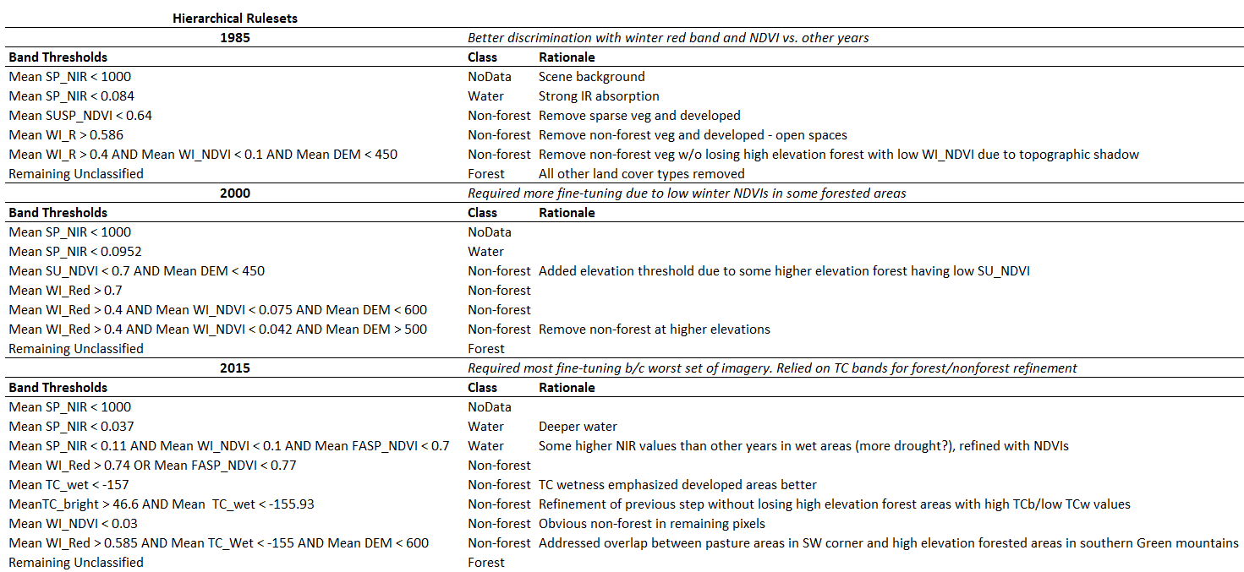

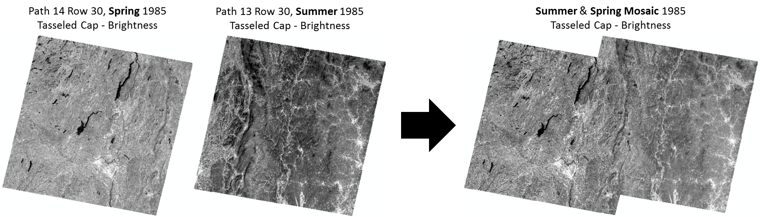
Figure 1. Example of a multi-season index mosaic following standardization, edge feathering, and histogram matching.
Standardization formula = ((x- x.min) / (x.max-x.min))*100; edge feathering distance = 10,000 pixels; histogram matching = overlap area only.

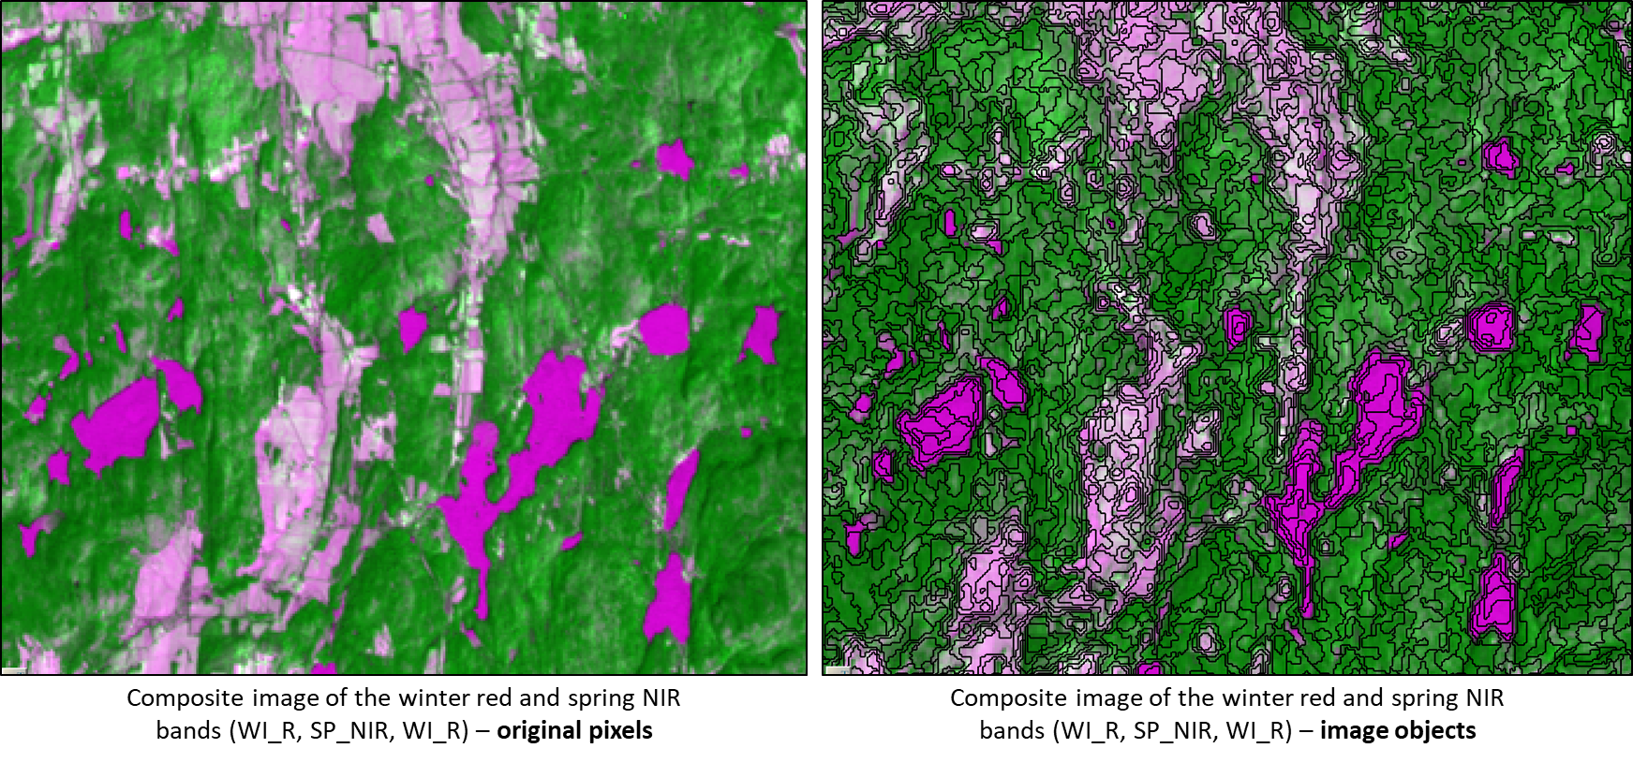
Figure 2. Example of the multiresolution segmentation results (chessboard>>multiresolution) based on Landsat imagery in an area with many different land cover types. Due to the relatively large pixels (30m) for object-based methods, the scale parameter for the multiresolution segmentation was set to 1 with no shape or compactness weighting; this segmentation was based on winter and growing season NDVIs, growing season tasseled cap indices, and seasonal tasseled cap differences.

