Procedure for Rating Root Starch

When to Sample

In the dormant season: after leaf fall and well before sap begins to run. Best time is October/November.

How to Collect Samples

Use whichever of the following methods will cause least damage to the tree:

- A 1-2” increment core from a main root below the soil line.
- Chisel out a 1” square block of root wood from a main root below the soil line.
- Follow the main root out until about ½” in diameter. Clip off a 6” length with hand pruners.

How to Store Samples

The roots must be bagged and kept cool from the time they are collected until they are frozen. They can be stored for a long time in the freezer. If roots are allowed to thaw, stored starch will change to sugar and ratings will be wrong.

How to Prepare Samples

- Have on hand:
  - slides, labeled by tree number
  - I₂KI with dropper (The solution must be less than a month old and must have been kept refrigerated.)
  - Water with dropper
  - Razor blades
  - Tissues
  - Pruning shears
  - Knife
  - Dissecting needle
  - Magnifying glass

- Line up slides, in order on a portable white surface (white paper on a tray or board). Put 2-3 drops of I₂KI solution in the center of each slide.

- Work on only one sample at a time. Return roots to the freezer after sections have been cut off so they can be re-rated if necessary.
- Debark a portion of the first sample and put it in a vise with the rays facing up. Moisten sample surface. With a single-edged razor, slice 6-8 thin sections across the growth rings from the wood closest to the bark. Sections should be no thicker than an index card, and thin enough to see light through. Put sections in water as soon as they are cut.

- Select the best sections to push into the iodine solution on a labeled slide. Wick away excess solution right away with the corner of a tissue. Add another drop of solution to each section.

- Let sit for five minutes. Wick away excess solution, and rinse twice by adding a drop of water to each section and wicking away excess water. Make sure the sections remain wet until rating.

How to Rate Starch

- Rate immediately (within an hour). Move slides to a well lighted area. Rearrange them in order of decreasing intensity of blue staining, concentrating on the rays.

- Rate sections as in the key, using photographs for sugar maple or red oak as a guide. Concentrate on how darkly stained the rays are. A magnifying glass may help.
- If sections are not rated immediately, they must be covered with a drop of glycerine and rated within 48 hours; otherwise the color will fade.

Interpreting the Ratings

Radial growth or branch dieback show how healthy a tree was in the past. The amount of starch in the roots over the winter show how healthy a tree is now. It reflects the amount of photosynthesis from the past season and how much leaf area will be produced the following spring. This system tells you how “full” the tree’s “tank” is, not how big the tank is, because the rater concentrates on the rays. Starch storage is quite uniform throughout the root system, so one sample per tree is enough.

For More Information

Wargo, P. M. 1975. Estimating starch content in roots of deciduous trees – a visual technique. USDA Forest Service Research Paper NE-313, 9 pp.

Wargo, P. M. 1978. Judging vigor of deciduous hardwoods. USDA Agriculture Information Bulletin No. 418, 15 pp.
Key to Rating Sugar Maple Root Starch

Is there any blue color in the section?
No
Depleted

Yes
Yes
No
Are the rays dark blue?
Is there dark blue between the rays?
Is the wood between the rays generally blue?
Yes
Yes
No
No
Low
High
Medium

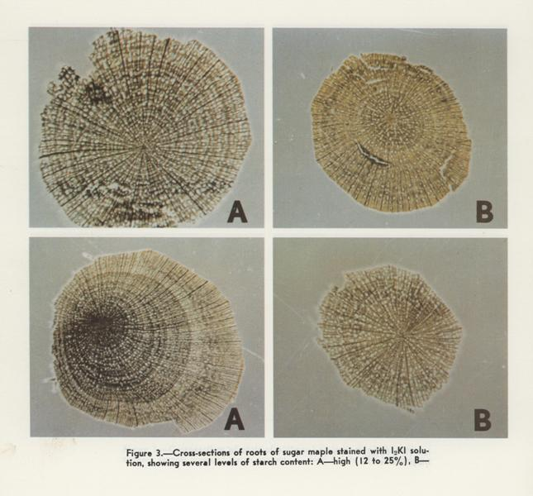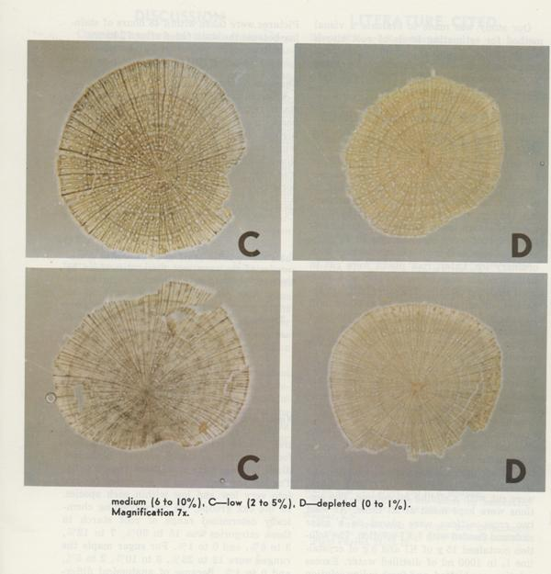

B. Burns, VT Division of Forestry, revised 8/05

