Application Cover Page
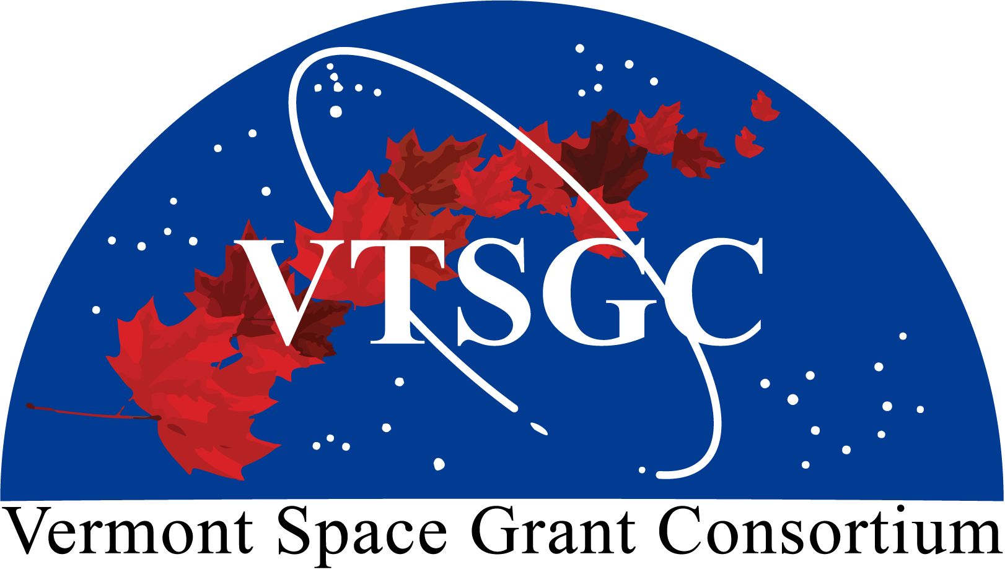
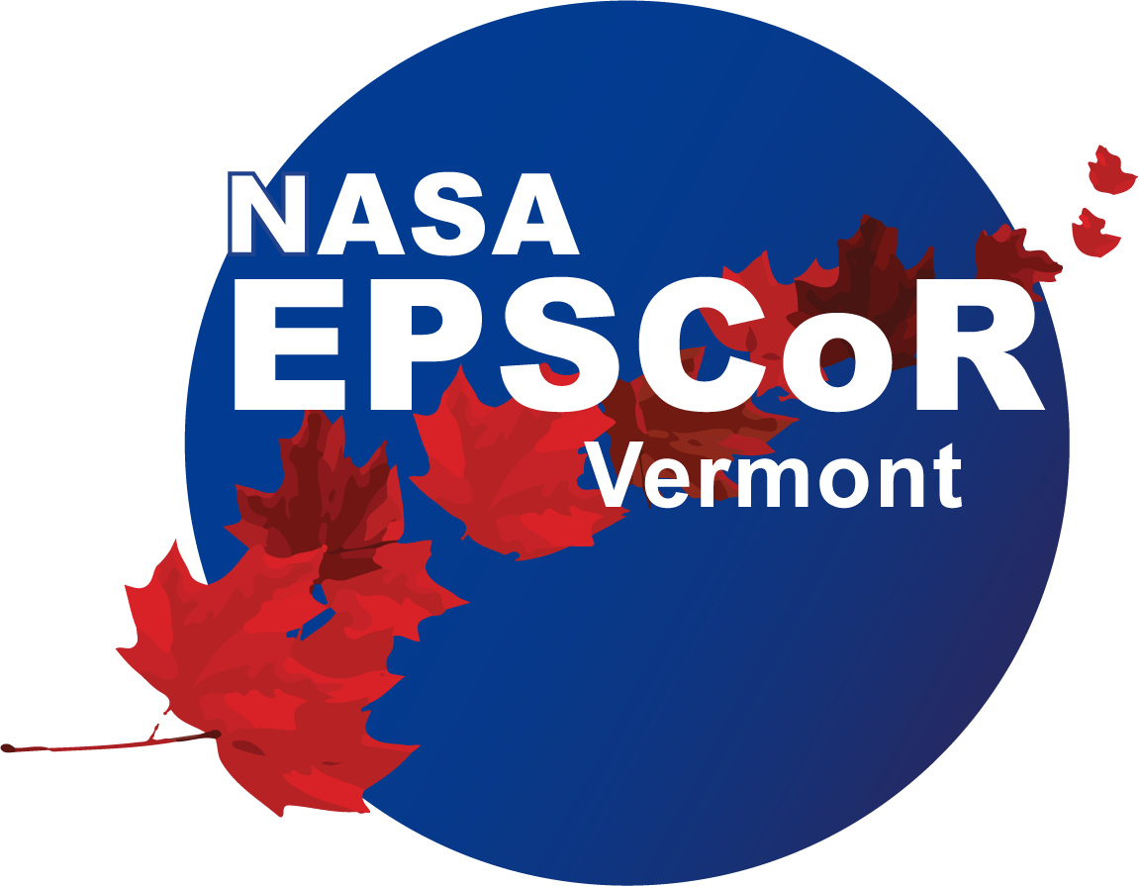

Vermont Space Grant Consortium

and Vermont NASA EPSCoR

2027 Faculty

Research Grant Program
Application Deadline: February 12, 2027 at 11:59 pm

Principal Investigator:

Project Title:

Academic Affiliation:

E-mail: Telephone:

Grant Type (please indicate your preference):

VTSGC Small-Scale Grant (June 2027 – May 2028)
VTSGC Pilot-Grant (June 2027 – May 2028)
VT NASA EPSCoR Small-Scale Grant (October 2027 – September 2028)
VT NASA EPSCoR Pilot Grant (October 2027 – September 2028)

Principal Investigator Signature:

Authorizing Official Signature:

Checklist:
Required component (listed in order of assembly) | Page limit
- Cover page | 1 page
- Project description | 5 pages (Small-Scale) or 3 pages (Pilot), excluding references
- NASA Alignment | 1 page
- References cited | As needed
- Budget table and budget narrative | As needed
- Biosketches | As needed
SciENcv-formatted biosketches for the principal investigator and any co-investigators.
- Cost-sharing commitment letter(s) | As needed
Include letters of commitment from the appropriate institution officials responsible for the source of matching funds
- Other letters of commitment | As needed
Include letters documenting specific project commitments; letters of endorsement are not permitted.
- Subrecipient commitment form | As needed
For non-UVM PIs only, include a completed, signed subrecipient commitment form. The form is available from the UVM Sponsored Project Administration website.

The application packet must be saved as a single PDF file and emailed to SG.Director@uvm.edu using the subject line “2027 Faculty Research Grant Application”.

