Why Nature Matters

Research shows many physical and mental health benefits of spending time in nature for both children and adults. ^{1,2}

Tips on Creating a Nature Routine
- Start small: Try activities you can easily fit into your schedule, even for just 5-10 minutes a day.
- Do what you enjoy: Combine nature with what your family enjoys, whether going on a picnic, taking walks, playing catch, or gardening.
- Build it into your day: Plan outdoor time into your daily routine such as after school or after dinner.
- Try new activities: Explore new activities like hiking, star-gazing, leaf or rock collecting, birdwatching or fishing.
- Engage your senses: Slow down and notice what you see, hear, smell, feel, and taste.

Books on Nature
- For Children: The Hike by Allison Farrell
- For Teens: Braiding Sweetgrass by Robin Wall Kimmerer
- For Adults: The Nature Fix: Why Nature Makes Us Happier, Healthier, and More Creative by Florence Williams
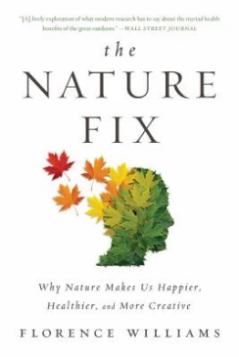
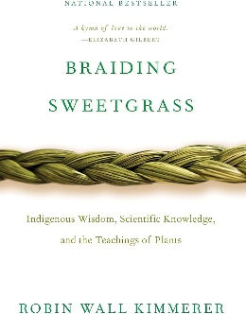
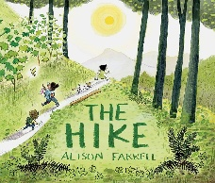

1. Lomax T, Butler J, Cipriani A, Singh I. Effect of nature on the mental health and well-being of children and adolescents: meta-review. The British Journal of Psychiatry. 2024;225(3):401-409.
2. Kondo MC, Jacoby SF, South EC. Does spending time outdoors reduce stress? A review of real-time stress response to outdoor environments. Health & Place. 2018;51:136-150.

Tools and Websites

- AllTrails (www.alltrails.com): Discover local trails for walking, hiking, or biking.
- iNaturalist (www.inaturalist.org): Identify plants and animals; participate in a community of nature observers.
- ParkRx (www.parkrxamerica.org): Learn more about nature prescriptions and the benefits of spending time in nature.
- Plant a Garden for Health and Climate Action (https://www.healthychildren.org/English/safety-prevention/all-around/Pages/victory-gardens-for-climate-and-children.aspx): How growing some of your own food saves money, improves well-being, and helps the planet.
- Nature Conservancy (www.nature.org): A nonprofit with volunteer opportunities and guides on how to reduce your carbon footprint.
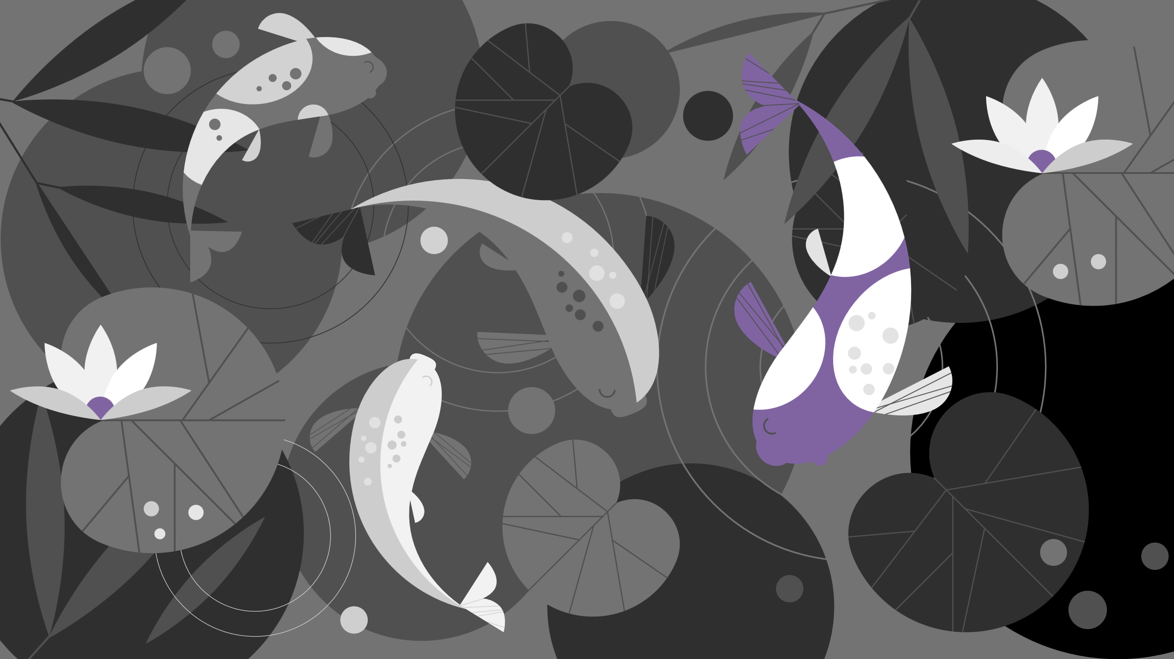
- Children and Nature Network (www.childrenandnature.org): Free toolkits and resources for families such as “Nature Activity Cards” and “Gardening for Children and Teens.”

