UVM Larner College of Medicine Vermont Campus

Clerkship Level Site Exemption Request Form

Submit this form through OASIS if you wish to request an exemption consistent with the stipulations outlined in Medical Student Handbook Policy 524.00 Site Assignments: Clerkship Level.

Site Exemption Request Deadlines, no later than noon on:
- August 1: Student Accessibility Services (SAS) documentation request, if applicable
- September 1: OASIS request (accompanied by SAS accommodation letter, if applicable)

IMPORTANT: Documentation to support a medical request should not include any medical information. When working with SAS, medical information should be submitted directly to SAS, and only the SAS accommodation letter should be uploaded to OASIS with this form.

Check the box next to the applicable ground(s) then upload this form and any relevant non-medical supporting documentation, including applicable SAS accommodation letter, to your “Exemptions” academic history tab in OASIS [“Exemption Request (Student Upload)” section]. OASIS will notify you when the Office of Medical Education has uploaded your exemption request decision.

Requests received after the annual deadline will not be considered except in the case of emergent personal or medical issues and are subject to capacity limitations. In such cases, students have the option to request a temporary re-assignment to UVM Medical Center for an upcoming clerkship. To request temporary exemption students will also need to complete and submit this form via OASIS. Please note that this uploaded form is accessible to department clerkship/course coordinator(s).

Name: Click here to enter text. Date Uploaded to OASIS: Click here to enter a date.

Type of exemption requested:
☐ Clerkship Year—all rotations within one hour driving distance from Burlington.
☐ Temporary—specific rotation within one hour driving distance from Burlington, specify rotation: Click here to enter text.

Check Applicable Grounds:
☐ I have children under age 18 living in my household.
☐ I have a significant medical condition/disability that requires ongoing treatment locally or limits my ability to travel. (SAS accommodation letter required. Please note that completed documentation may take four weeks for review.)
☐ I have a family member with a significant medical condition for whom I provide care locally.

Alternative/Individualized Distance Request: Click here to enter text.

Note that the default for local placement is within one hour driving distance of Burlington. If you need to be placed within a different driving distance from the Burlington area provide alternative distance requirements and the clinical clerkship team will strive to reasonably accommodate your individualized request. If based on medical/ADA grounds, the SAS accommodation letter must stipulate support for the alternative distance request.
Decision:
☐ Approved
☐ Denied

Electronic Signature, Associate Dean for Students: Click here to enter text.
Decision Date: Click here to enter a date.
Review Notes (for office use only): Click here to enter text.
Instructions for Requesting a clerkship Year Policy Exemption
To request approval for an exemption from the Associate/Assistant Dean for Students or their designee, please follow the step-by-step instructions below. Also please be sure to familiarize yourself with related policies in the Student Handbook.
- Populate the top of the form.

- Rename the form keeping it as a docx file so that the Associate/Assistant Dean for Students or their designee can easily add to/edit it upon receipt.

The preferred file name protocol is “LastName FirstInitial_SiteExemptionRequest_Date” with date formatted as yyyymmdd. Save the file on your computer. (e.g., Smith J_SiteExemptionRequest_20250228.docx)

- Log-in to OASIS

- Click on “View your Academic History” in the Announcements box.

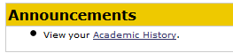
- Choose the “Exemptions” tab and click “Edit On” in the upper right corner of the screen.

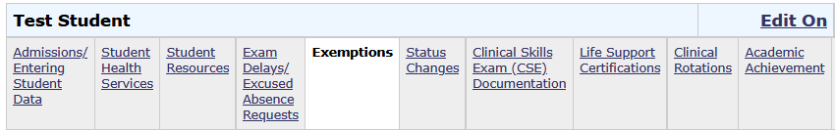
2
1
- Upload your saved exemption request docx file to the “Exemption Request (Student Upload) section. Do this by:
  - Click on “Add file” to browse for your saved document(s).
  - Once selected, click on “Upload” to actually upload it.
  - The click on “Save & Notify”—not just “Save”—to submit your request and to generate an automated email notification to the Associate/Assistant Dean for Students or their designee and their assistants.

(See screenshot next page.)
- The Associate/Assistant Dean for Students or their designee will review your request. If more information is needed, they will send you an email. Otherwise, they will complete the second page of the form and upload the decision to the “Exemption Decision (Student View)” section.

- Check your Academic History file to monitor the status of your request.

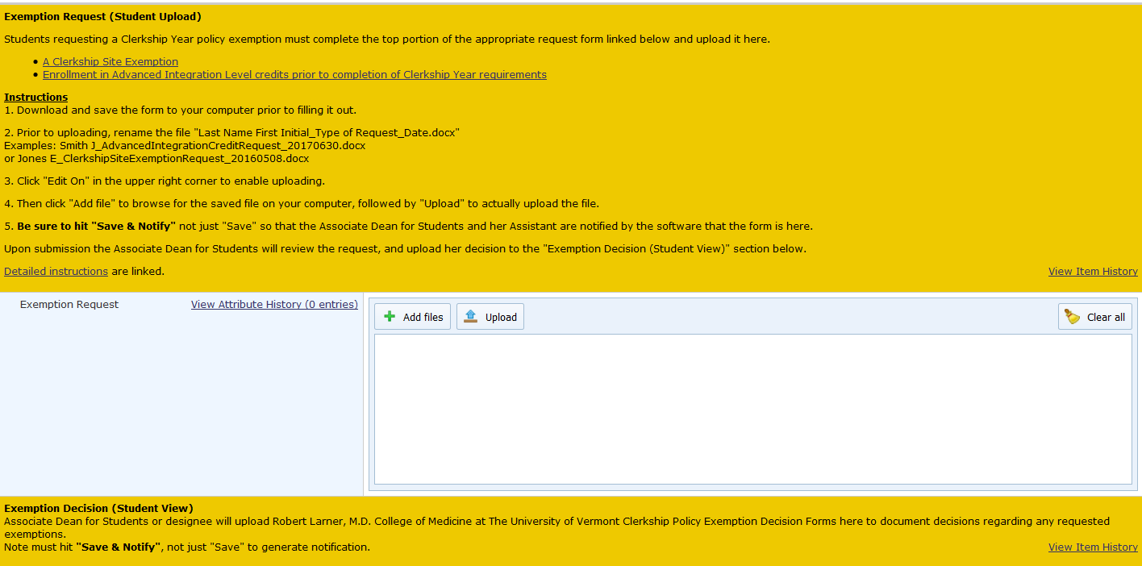
2
1
4 Monitor status here
––––
3

