

Advanced Integration Level Credit Request

Students requesting permission to enroll in up to 12 weeks of Advanced Integration Level elective credit prior to completion of their Clerkship Year per the criteria specified in the Student Handbook should fill-in the top section of this form and upload it to the Exemption Request section of the “Exemptions” tab in their OASIS Academic History file.

Name the file: “Last Name FirstInitial_AdvancedIntegrationCreditRequest_Date.”
(Example: Smith J_AdvancedIntegrationCreditRequest_20250630.docx.)

Be sure to hit “Save & Notify” to generate an email notification (not just “Save”).

Upon review, the Associate Dean for Students or designee will append the decision and upload this form to the student’s OASIS Exemption Decision section of the Academic History tab. The request is not considered approved until documentation of such has been uploaded to this tab. If approved, students should work with the Advanced Integration Curriculum Coordinator to schedule coursework. Please note that this uploaded form is accessible to department clerkship/course coordinator(s).

Student completes this section

Student: Click here to enter text. Date Request Submitted: Click here to enter a date.

Dates that you wish to “step out” of clerkships to pursue Advanced Integration credit:
Start Date: Click here to enter a date. End Date: Click here to enter a date.

Reason for Exemption Request:
If the grounds for your request are medical, also upload supporting documentation.
Click here to enter text.

Specify replacement enrollment
Include course director approval if necessary
Click or tap here to enter text.

Notes
Click here to enter text.

Associate Dean for Students completes this section

Decision By: Click here to enter text. Date: Click here to enter a date.

Decision

☐ Approved

☐ Denied

Notes (Required documentation, confirmation of replacement enrollment, etc.)
Click here to enter text.
Instructions for Requesting a clerkship Year Policy Exemption

To request approval for an exemption from the Associate/Assistant Dean for Students or their designee, please follow the step-by-step instructions below. Also please be sure to familiarize yourself with related policies in the Student Handbook.

- Populate the top of the form.

- Rename the form keeping it as a docx file so that the Associate/Assistant Dean for Students or their designee can easily add to/edit it upon receipt.

The preferred file name protocol is “LastName FirstInitial_AdvancedIntegrationCreditRequest_Date” with date formatted as yyyymmdd. Save the file on your computer.
(e.g., JonesE_AdancedIntegrationCreditRequest_20250701.docx)

- Log-in to OASIS

- Click on “View your Academic History” in the Announcements box.

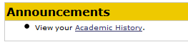

- Choose the “Exemptions” tab and click “Edit On” in the upper right corner of the screen.

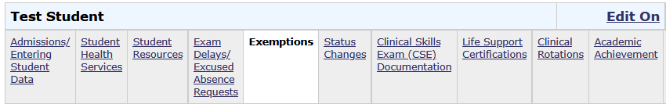
2
1

- Upload your saved exemption request docx file to the “Exemption Request (Student Upload) section. Do this by:
  - Click on “Add file” to browse for your saved document(s).
  - Once selected, click on “Upload” to actually upload it.
  - The click on “Save & Notify”—not just “Save”—to submit your request and to generate an automated email notification to the Associate/Assistant Dean for Students or their designee and their assistants.

(See screenshot next page.)

- The Associate/Assistant Dean for Students or their designee will review your request. If more information is needed, they will send you an email. Otherwise, they will complete the second page of the form and upload the decision to the “Exemption Decision (Student View)” section.

- Check your Academic History file to monitor the status of your request.

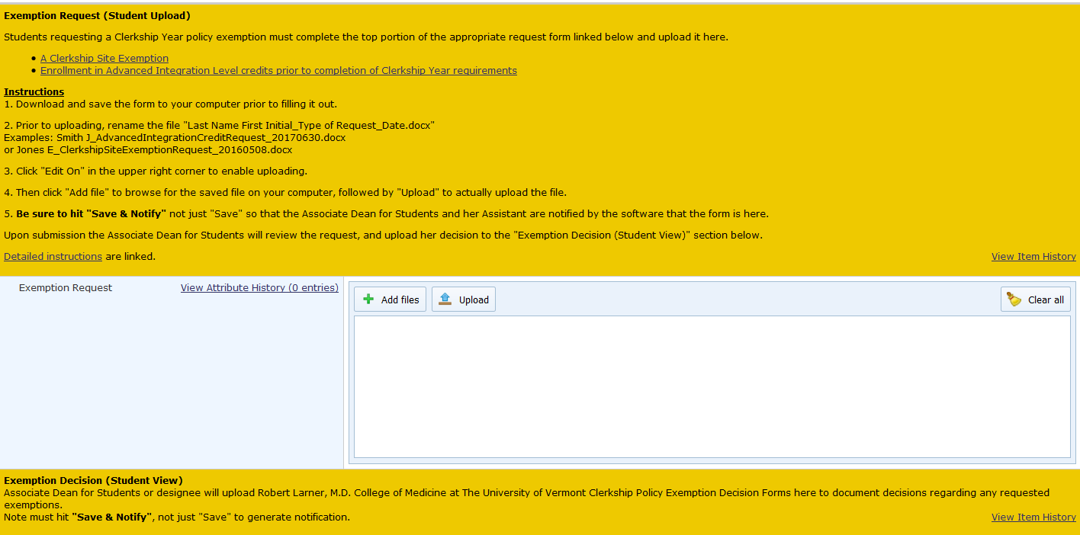
2
1
4 Monitor status here
––––
3

