UVM Larner College of Medicine Clinical Campus Change Request Form
Submit this form through OASIS if you wish to request a clinical campus change consistent with the stipulations outlined in Medical Student Handbook Policy 518.00 Clinical Campus Site Assignment.

Clinical Campus Change Request Deadlines, no later than noon on:
- August 1: Student Accessibility Services (SAS) documentation request, if applicable
- September 1: OASIS request (accompanied by SAS accommodation letter, if applicable)

IMPORTANT: Documentation to support a medical request should not include any medical information. When working with SAS, medical information should be submitted directly to SAS, and only the SAS accommodation letter should be uploaded to OASIS with this form.

Check the box next to the applicable ground(s) then upload this form and any relevant non-medical supporting documentation, including applicable SAS accommodation letter, to your “Exemptions” academic history tab in OASIS [“Exemption Request (Student Upload)” section].

Decisions will be made by the Clinical Campus Change Committee for students with extenuating circumstances, and an informal lottery system will be employed for remaining students based on availability on the desired campus. OASIS will notify you when the Office of Medical Education has uploaded your exemption request decision.

Requests received after the annual deadline will not be considered except in the case of emergent personal or medical issues and are subject to capacity limitations. In such cases, students have the option to request a temporary re-assignment to UVM Medical Center for an upcoming clerkship. To request a temporary exemption students will also need to complete and submit this form via OASIS. Please note that this uploaded form is accessible to department clerkship/course coordinator(s).

Name: Click here to enter text. Date Submitted/Uploaded to OASIS: Click here to enter a date.

Currently Assigned Campus: ☐ Connecticut ☐ Vermont
Requested Campus Assignment: ☐ Connecticut ☐ Vermont

Type of exemption requested:
☐ Clerkship and Advanced Integration Levels
☐ Temporary, specify rotation: Click here to enter text.

Check Applicable Grounds:
☐ I have a significant medical condition/disability that requires ongoing treatment locally or limits my ability to travel. (SAS accommodation letter required. Please note that completed documentation may take four weeks for review.)

☐ I have a responsibility to provide care to a family member with a significant medical condition and changing campuses would positively address the issue.

☐ I am requesting to be included in the campus change lottery if there are open slots available in both directions for a switch. (You are not required to provide an explanation below).

Decision:
☐ Approved
☐ Denied

Electronic Signature, Associate Dean for Students: Click here to enter text.
Decision Date: Click here to enter a date.
Review Notes (for office use only): Click here to enter text.
Instructions for Requesting a clerkship Year Policy Exemption
To request approval for an exemption from the Associate/Assistant Dean for Students or their designee, please follow the step-by-step instructions below. Also please be sure to familiarize yourself with related policies in the Student Handbook.
- Populate the top of the form.

- Rename the form keeping it as a docx file so that the Associate/Assistant Dean for Students or their designee can easily add to/edit it upon receipt.

The preferred file name protocol is “LastName FirstInitial_CampusChangeRequest_Date” with date formatted as yyyymmdd. Save the file on your computer. (e.g., Smith.J_CampusChangeRequest_20250728.docx)

- Log-in to OASIS

- Click on “View your Academic History” in the Announcements box.

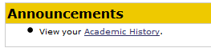
- Choose the “Exemptions” tab and click “Edit On” in the upper right corner of the screen.

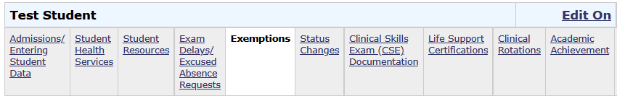
2
1

- Upload your saved exemption request docx file to the “Exemption Request (Student Upload) section. Do this by:
  - Click on “Add file” to browse for your saved document(s).
  - Once selected, click on “Upload” to actually upload it.
  - The click on “Save & Notify”—not just “Save”—to submit your request and to generate an automated email notification to the Associate/Assistant Dean for Students or their designee and their assistants.

(See screenshot next page.)
- The Associate/Assistant Dean for Students or their designee will review your request. If more information is needed, they will send you an email. Otherwise, they will complete the second page of the form and upload the decision to the “Exemption Decision (Student View)” section.

- Check your Academic History file to monitor the status of your request.

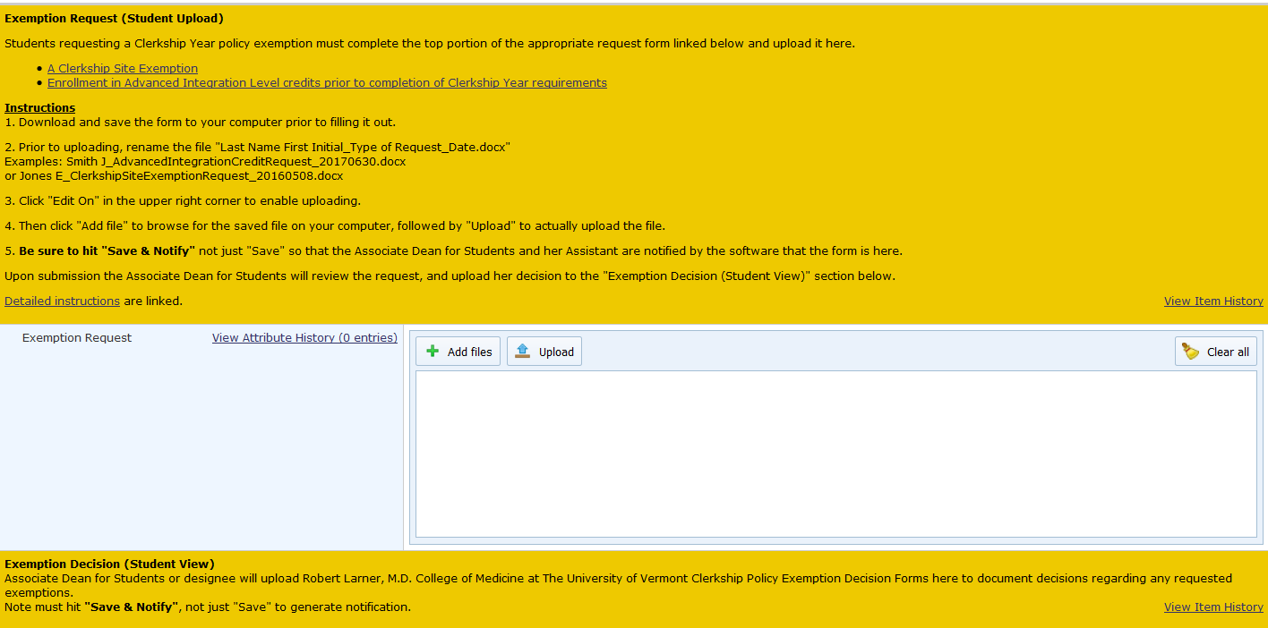
2
1
4 Monitor status here
––––
3

