The Robert Larner, M.D. College of Medicine at the University of Vermont
Exam Delay Request and Decision Form

Students requesting an exam delay complete the top section of this form and upload it as a MS Word document to the Exam Delay Request tab in their OASIS academic history file.

Name the file: “LastName FirstInitial_ExamDelayRequest_Date.” (Example: Smith J_ExamDelayRequest_20170228.docx). Be sure to hit “Save & Notify” to generate an email notification, not just “Save”.

Upon receipt and review, the Associate Dean for Students or designee will append information and upload this form to the student’s OASIS academic history Exam Delay Decision field. An exam delay is not considered approved until documentation of such has been uploaded to this tab.

Student completes this section (all fields required)

Student: Click here to enter text. Date Request Submitted: Click here to enter a date.
Course Title: Click here to enter text.
Name of Exam (specify type of exam – practical, Shelf, block, CSE, etc.): Click here to enter text.
Date of Exam: Click or tap to enter a date.

Reason for Exam Delay Request:
☐ Illness
☐ Significant Illness in a Family Member
☐ Death of a Family Member
☐ Conflict with a major religious holiday

Permission to delay an exam is generally given only for the above reasons.
☐ Other, specify: Click here to enter text.

Notes
Click here to enter text.

Note that the student:
- Is responsible for being familiar with related The Robert Larner, M.D. College of Medicine at The University of Vermont Student Handbook policies—specifically 540.24 Examination Delays, other examination and grading policies (540.20, 540.22, 540.30, 540.40, 540.50,540.60), and 310.00 Support for Disabilities;
- Is honor bound not to give, seek, or receive information to or from students taking the examination at the scheduled time;
- Should monitor their Academic History file in Oasis for posting of this document to view the status of their request.

Rules:
- No exams are given earlier than the scheduled times.
- Requests for exam delays must be communicated to the Associate Dean for Students (or designee) before the exam.
- A student who misses an examination without approval will fail and be assigned a score of zero.
- Delayed exams will not be scheduled during other course activities.

Reminder: In accordance with Policy 310.00, a Larner College of Medicine student may contact the UVM Student Accessibility Services Office at any time to initiate the process of requesting reasonable accommodations.
Associate Dean for Students completes this section

Decision By: Click here to enter text. Date: Click here to enter a date.

Decision

☐ Approved

☐ Denied

Notes (Required documentation, etc.)
Click here to enter text.

- Please note that this uploaded form is accessible to department clerkship/course coordinator(s).

- Appropriate curriculum coordinators in the Office of Medical Education will be notified when the decision is uploaded to OASIS. They are responsible for communicating with the course/clerkship director.

- The Office of Medical Education Course Coordinator will contact the student, proctor, course director, the Clinical Simulation Lab, and COMTS as needed to reschedule the examination.

Instructions for Requesting an exam delay

To request approval for an examination delay from the Associate Dean for Students, please follow the step-by-step instructions that follow. Also please be sure to familiarize yourself with related policies in the Student Handbook.

- Populate all fields on the first page of the form.

- Rename the form keeping it as a docx file so that the Associate Dean can readily add to/edit it upon receipt and save it to your computer.
The preferred file name protocol is “Lastname FirstInitial_ExamDelayRequest_date” with date formatted as yyyymmdd. (Example: Smith.J_LOArequest_20250228)

- Log-in to OASIS

- Click on “View your Academic History” in the Announcements box.

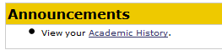

- Choose the “Exams Delay/Excused Absence Request” tab.

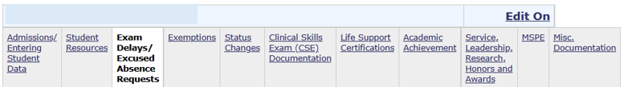
2
1

- Click “Edit On” in the upper right-corner of the screen.

- Upload your saved Exam Delay request docx file to the “Exam Delay Request (Student Upload) section. Do this by:
  - Click on “Add file” to browse for your saved document.
  - Once selected, click on “Upload” to actually upload it.
  - The click on “Save & Notify”—not just “Save”—to submit your request and to generate an automated email notification to the Associate Dean for Students and her Assistant.

(See screenshot next page.)

- The Associate Dean for Students will review your request. If more information is needed, she will send you an email. Otherwise, she will complete the second page of the form and upload the decision to the “Exam Delay Decision (Student View)” section.

- Check your academic history file to monitor the status of your request.

- Upon approval, Office of Medical Education curriculum coordinators will be notified. They will communicate the decision with the course director and necessary course personnel.

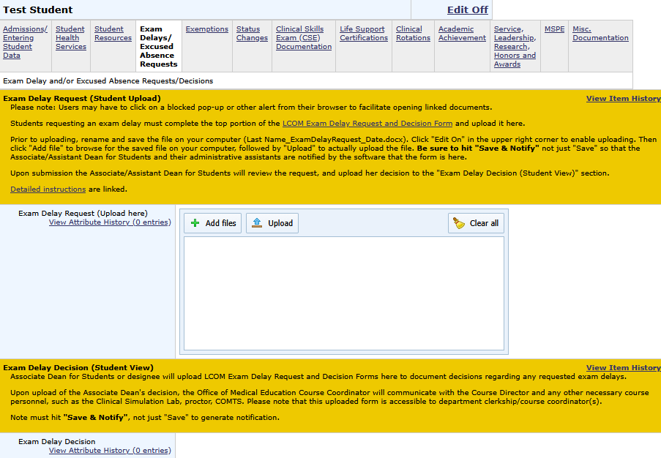
4 Monitor decision status here
2
1
3

