Application Cover Page
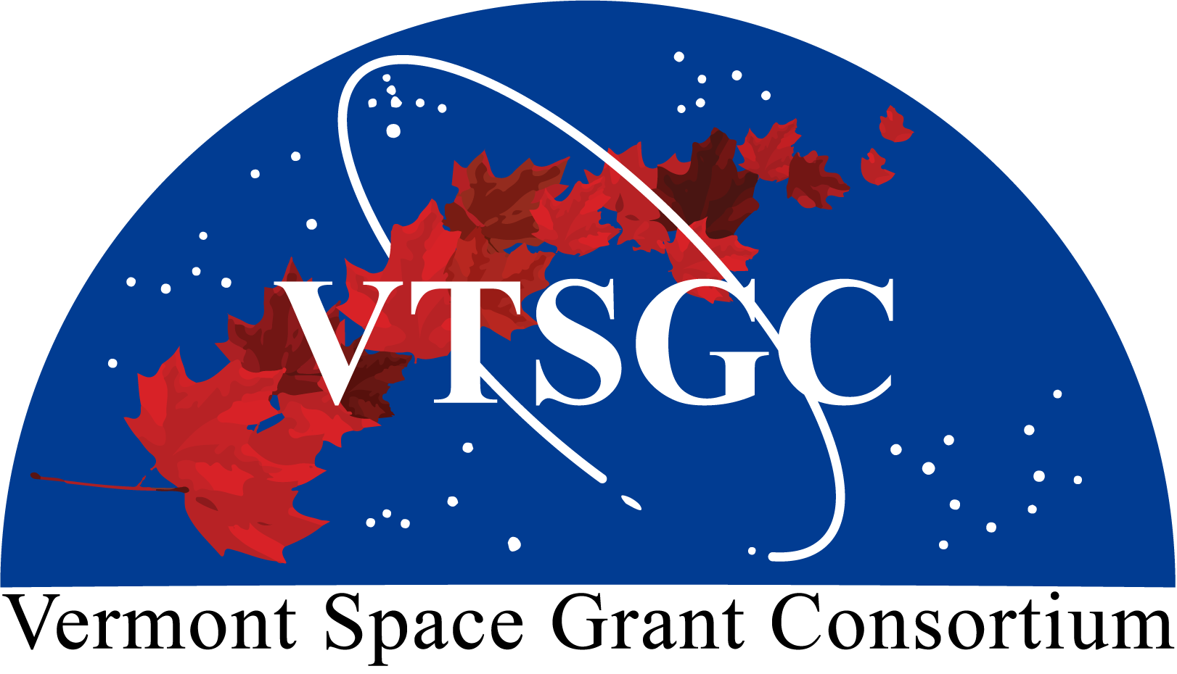
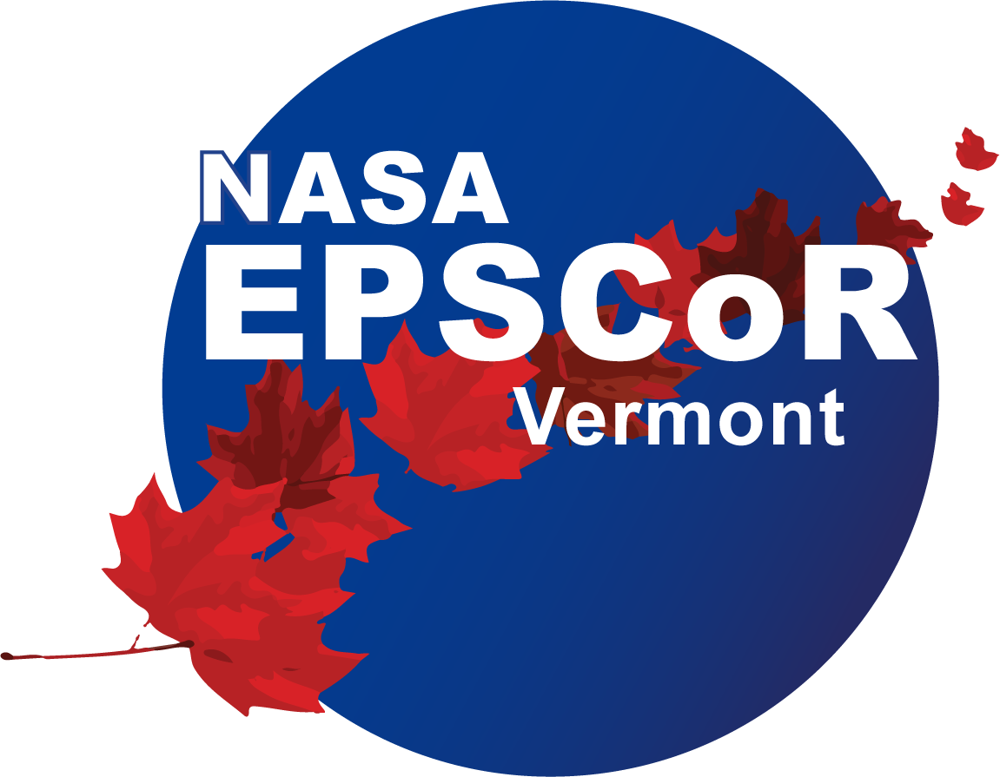

Vermont Space Grant Consortium

and Vermont NASA EPSCoR

2026 Faculty

Research Grant Program
Application Deadline: February 20, 2026 at 11:59 pm

Principal Investigator:

Project Title:

Academic Affiliation:

E-mail: Telephone:

Grant Type (please indicate your preference; however, the actual award source and performance dates might differ depending on the availability of funding):

VTSGC Small-Scale Grant (June 2026 – May 2027)
VTSGC Pilot-Grant (June 2026 – May 2027)
VT NASA EPSCoR Small-Scale Grant (October 2026 – September 2027)
VT NASA EPSCoR Pilot Grant (October 2026 – September 2027)

Principal Investigator Signature:

Authorizing Official Signature:

Checklist:

- Cover page
- Project narrative (limit: 5 pages for Small-Scale Research Grant; 3 pages for Research Pilot Grant, exclusive of references)
- NASA alignment (limit: 1 page)
- Biosketches for the principal investigator and co-investigators. Biosketches may be SciENcv-formatted as for federal grants (https://www.ncbi.nlm.nih.gov/sciencv/); otherwise, they are limited to 2 pages each. Biosketches should include identifying information, organization and location, professional preparation, appointments and positions, and research-related products relevant to the application
- Budget detail and narrative, including matching plan
- Letters of support (e-mail is acceptable) from NASA collaborators for small-scale applications. Update (posted 2/6/2026): We understand that investigators are having difficulty in some cases procuring letters of support from NASA, possibly owing to recent changes at the agency. In response, Small-Scale Faculty Research applications will not require NASA letters of support for this award cycle. If you have already obtained a letter, please include it with your application; otherwise, in lieu of a letter, please include a brief statement describing your outreach to secure a NASA letter (this statement will not count toward the application page limit).
- A signed letter of commitment from the appropriate institution or other official responsible for the source of matching funds

In addition to the above, non-UVM applicants are requested to submit a subrecipient monitoring form. This form can be found here.

The application packet must be saved as a single PDF file and emailed to SG.Director@uvm.edu using the subject line “2026 Faculty Research Grant Application”.

