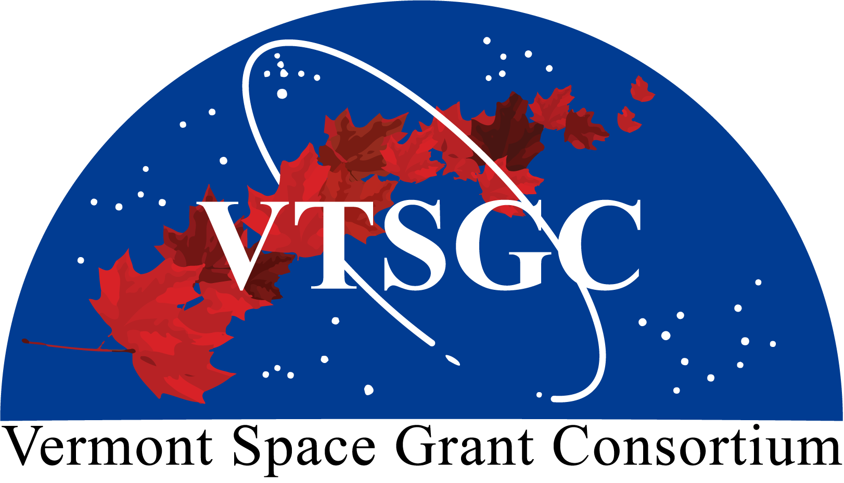
Application Cover Page

Vermont Space Grant Consortium

2026 Vermont Intern Share Program
Deadline: February 6, 2026 at 11:59 pm

Internship Mentor:

Project Title:

Industry Affiliation:

Mentor E-mail: Telephone:

Anticipated Intern Hiring Date:

*If you have already hired an intern for this project, please provide their details below. Otherwise, leave blank and you can provide intern details at point of hire.

*Intern Name:

*Intern E-mail: *Telephone:

*Is the Intern a U.S. Citizen? ☐ Yes ☐ No (VTSGC funding is restricted to U.S. Citizens)

Mentor Signature:

Authorizing Official Signature (if different than mentor):

Checklist:

- Cover page
- Project narrative (limit: 1 page). Please include details as to what an intern will be actively doing for the project, the importance of that work for the project and company as a whole, and the potential impact for the intern’s professional and technical skills development.
- NASA alignment (limit: 1 page). See NASA Mission Directorates for current NASA priorities.
- Budget detail and narrative, including matching plan.

The application packet must be saved as a single PDF file and emailed to SG.Director@uvm.edu using the subject line “2026 Vermont Intern Share Application”.

