Pre-Training Exam
PSA Grower Training with Hydroponic and Aquaponic Supplements
Please choose the best answer for each question.

- When must hands be washed in hydroponic and aquaponic (HP/AP) operations?
- Every two hours
- Before using the toilet
- Any time your hands may be contaminated
- Handwashing is not necessary if gloves are worn

- Which of the following poses the greatest produce safety risk?
- Amendments stored in a separate building requiring transport for use.
- An amendment which is not listed by the Organic Materials Review Institute (OMRI).
- A nutrient solution derived from fish waste in a coupled aquaponic system which has no contact with the harvestable portion of the crop.
- A substrate which has been stored in an area with obvious signs of rodent activity and which will come into contact with the harvestable portion of the crop.

- Of the following practices, which is the best way to prevent cross-contamination of amendments in HP/AP operations?
- Keep amendments close to the production systems for ease of access
- Use tools without cleaning them between uses
- Store substrates, fertilizers, and cleaning chemicals in separate areas
- Use organic amendments from local producers

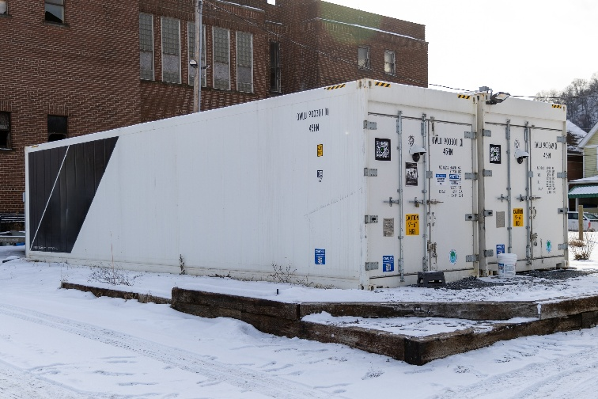
- What is a key requirement for pest and wildlife management in a fully enclosed production building?
  - Allow cats inside the building to control rodents naturally.
  - Routine monitoring and exclusion of pests.
  - No pest management is required in a fully enclosed building.
  - Immediate extermination of all wildlife found near the structure.

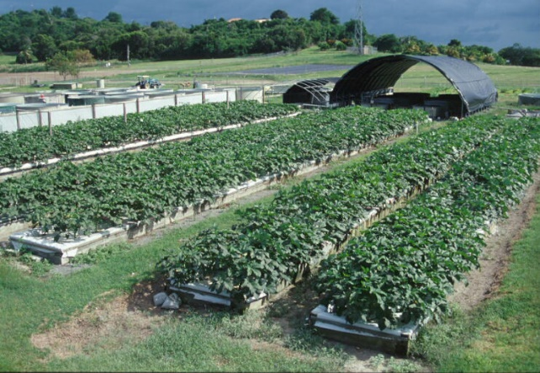
- What is a key requirement for pest and wildlife management in partially enclosed or outdoor production areas?
- Perform pre-harvest assessments for contamination.
- Rely on natural predators to manage pests and wildlife.
- No pest management is needed unless there is visible contamination.
- Close all possible entry points to completely exclude wildlife and pests.

- Carlos is setting up an aquaponic operation indoors, with limited space between the fish tanks and the area where he will grow cherry tomatoes.
What should he do to prevent cross-contamination between the fish and the growing produce?
- Increase the pH of the water to kill any potential pathogens in the fish waste.
- Place fans between the fish tanks and produce to promote airflow.
- Install physical barriers between fish tanks and plant production systems.
- Use gloves when harvesting both produce and fish.

- What is the definition of agricultural water?
- Water for irrigation of crops that are usually cooked before consumption.
- Recirculating water that is intended to wash covered produce.
- Water used on a farm for cleaning and sanitizing of food contact surfaces.
- Water that is intended or likely to touch the harvestable portion of the crop and/or food contact surfaces.

- Joe grows and harvests microgreens which sometimes droop over the edges of their trays and into the nutrient solution.
Is Joe’s nutrient solution considered agricultural water?
- Yes
- No

- Shawna grows hydroponic head lettuce in a movable gutter system. At harvest time, each gutter is lifted and moved so the ends swing over the younger growing plants.
What practice would be most effective to reduce the likelihood that pre-harvest water in the channels will drip on to covered produce that is still growing?
- Perform pre-harvest crop assessments.
- Treat the irrigation water with a sanitizer.
- Stop irrigation ahead of harvest to allow the channels to dry.
- In the standard operating procedures (SOP) for harvest, make a note that the channels should be balanced carefully while being moved.

- Which of the following requirement for postharvest water is true?
- Use municipal water sources.
- Ensure there is no detectable Salmonella in 100mL of water.
- Ensure there is no detectable generic E. coli in 100mL of water.
- Add a chemical product which kills 99.9% of the microorganisms in the water.

- Rebecca operates a hydroponic farm growing leafy greens. After harvest, she uses water to lightly mist the produce before packaging. She doesn’t test or treat the water, assuming it’s safe.
What is the primary produce safety concern with Rebecca’s practice?
- Water used in postharvest handling must meet water quality standards, including having no detectable generic E. coli in 100 mL, even if it met pre-harvest requirements during the growing stage.
- Misting produce is a low-risk activity, so water quality standards don’t apply.
- If the water looks clean, it's safe for both preharvest and postharvest uses.
- Because she is not submerging the produce, she doesn’t need to worry about the water’s microbiological quality.

- When harvesting a crop as a whole plant with the roots intact, which of the following practices introduces a potential produce safety hazard?
- Keep plants upright to avoid dripping water on to the edible portion of the crop.
- Allow the roots to dry before harvest to minimize dripping on to other produce when the plants are lifted.
- Manage the quality of the irrigation water by adding a sanitizer and monitoring key water quality variables.
- Turn each plant upside down to wind the wet roots around the base of the plant before packing it in a single-use clamshell.

- Why is it essential to clean and sanitize food contact surfaces in HP/AP growing, harvesting, packing, and holding areas?
- Water used in HP/AP systems naturally eliminates the need for surface cleaning and sanitization.
- The continuous growing season and close proximity of activities increase the risk of cross-contamination through hands and surfaces.
- Since HP/AP systems are soil-free, they are free from contamination risks.
- Only harvesting tools need to be cleaned, as other surfaces do not come into contact with produce.

- The use of intermittent welds in the pictured joint creates a harborage point for microorganisms.
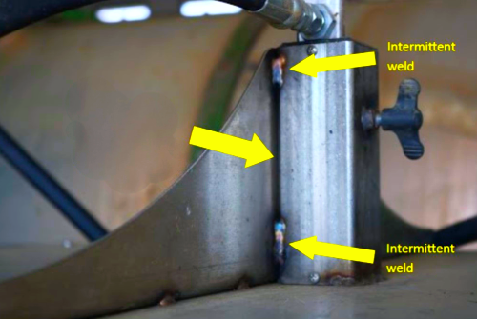
How would applying a continuous weld improve produce safety?
- Intermittent welds are better for sanitary and hygienic design because they allow airflow, which helps dry the surface faster.
- A continuous weld is unnecessary because bacteria cannot survive on metal surfaces for long periods.
- A continuous weld, when ground smooth, eliminates gaps that allow debris and moisture to accumulate, ensuring surfaces are cleanable.
- Harborage points are not a concern in food packaging environments as long as surfaces are cleaned and sanitized regularly.

Post-Training Exam
PSA Grower Training with Hydroponic and Aquaponic Supplements
Please choose the best answer for each question.

- When must hands be washed in hydroponic and aquaponic (HP/AP) operations?
- Every two hours
- Before using the toilet
- Any time your hands may be contaminated
- Handwashing is not necessary if gloves are worn

- Which of the following poses the greatest produce safety risk?
- Amendments stored in a separate building requiring transport for use.
- An amendment which is not listed by the Organic Materials Review Institute (OMRI).
- A nutrient solution derived from fish waste in a coupled aquaponic system which has no contact with the harvestable portion of the crop.
- A substrate which has been stored in an area with obvious signs of rodent activity and which will come into contact with the harvestable portion of the crop.

- Of the following practices, which is the best way to prevent cross-contamination of amendments in HP/AP operations?
- Keep amendments close to the production systems for ease of access
- Use tools without cleaning them between uses
- Store substrates, fertilizers, and cleaning chemicals in separate areas
- Use organic amendments from local producers

- What is a key requirement for pest and wildlife management in a fully enclosed production building?
  - Allow cats inside the building to control rodents naturally.
  - Routine monitoring and exclusion of pests.
  - No pest management is required in a fully enclosed building.
  - Immediate extermination of all wildlife found near the structure.

- What is a key requirement for pest and wildlife management in partially enclosed or outdoor production areas?
- Perform pre-harvest assessments for contamination.
- Rely on natural predators to manage pests and wildlife.
- No pest management is needed unless there is visible contamination.
- Close all possible entry points to completely exclude wildlife and pests.

- Carlos is setting up an aquaponic operation indoors, with limited space between the fish tanks and the area where he will grow cherry tomatoes.
What should he do to prevent cross-contamination between the fish and the growing produce?
- Increase the pH of the water to kill any potential pathogens in the fish waste.
- Place fans between the fish tanks and produce to promote airflow.
- Install physical barriers between fish tanks and plant production systems.
- Use gloves when harvesting both produce and fish.

- What is the definition of agricultural water?
- Water for irrigation of crops that are usually cooked before consumption.
- Recirculating water that is intended to wash covered produce.
- Water used on a farm for cleaning and sanitizing of food contact surfaces.
- Water that is intended or likely to touch the harvestable portion of the crop and/or food contact surfaces.

- Joe grows and harvests microgreens which sometimes droop over the edges of their trays and into the nutrient solution.
Is Joe’s nutrient solution considered agricultural water?
- Yes
- No

- Shawna grows hydroponic head lettuce in a movable gutter system. At harvest time, each gutter is lifted and moved so the ends swing over the younger growing plants.
What practice would be most effective to reduce the likelihood that pre-harvest water in the channels will drip on to covered produce that is still growing?
- Perform pre-harvest crop assessments.
- Treat the irrigation water with a sanitizer.
- Stop irrigation ahead of harvest to allow the channels to dry.
- In the standard operating procedures (SOP) for harvest, make a note that the channels should be balanced carefully while being moved.

- Which of the following requirement for postharvest water is true?
- Use municipal water sources.
- Ensure there is no detectable Salmonella in 100mL of water.
- Ensure there is no detectable generic E. coli in 100mL of water.
- Add a chemical product which kills 99.9% of the microorganisms in the water.

- Rebecca operates a hydroponic farm growing leafy greens. After harvest, she uses water to lightly mist the produce before packaging. She doesn’t test or treat the water, assuming it’s safe.
What is the primary produce safety concern with Rebecca’s practice?
- Water used in postharvest handling must meet water quality standards, including having no detectable generic E. coli in 100 mL, even if it met pre-harvest requirements during the growing stage.
- Misting produce is a low-risk activity, so water quality standards don’t apply.
- If the water looks clean, it's safe for both preharvest and postharvest uses.
- Because she is not submerging the produce, she doesn’t need to worry about the water’s microbiological quality.

- When harvesting a crop as a whole plant with the roots intact, which of the following practices introduces a potential produce safety hazard?
- Keep plants upright to avoid dripping water on to the edible portion of the crop.
- Allow the roots to dry before harvest to minimize dripping on to other produce when the plants are lifted.
- Manage the quality of the irrigation water by adding a sanitizer and monitoring key water quality variables.
- Turn each plant upside down to wind the wet roots around the base of the plant before packing it in a single-use clamshell.

- Why is it essential to clean and sanitize food contact surfaces in HP/AP growing, harvesting, packing, and holding areas?
- Water used in HP/AP systems naturally eliminates the need for surface cleaning and sanitization.
- The continuous growing season and close proximity of activities increase the risk of cross-contamination through hands and surfaces.
- Since HP/AP systems are soil-free, they are free from contamination risks.
- Only harvesting tools need to be cleaned, as other surfaces do not come into contact with produce.

- The use of intermittent welds in the pictured joint creates a harborage point for microorganisms.
How would applying a continuous weld improve produce safety?
- Intermittent welds are better for sanitary and hygienic design because they allow airflow, which helps dry the surface faster.
- A continuous weld is unnecessary because bacteria cannot survive on metal surfaces for long periods.
- A continuous weld, when ground smooth, eliminates gaps that allow debris and moisture to accumulate, ensuring surfaces are cleanable.
- Harborage points are not a concern in food packaging environments as long as surfaces are cleaned and sanitized regularly.

- What specific changes do you intend to make as a result of this training?

- Any other comments or feedback on the training?

