 ANNUAL FACULTY REVIEW

Instructions:
Section I and III: to be completed by Department Chair OR designee
Section II: To be completed by Faculty undergoing annual review

NOTE: Faculty going up for re-appointment/promotion and/or tenure may use “See CV” in the following sections: Sections II A-C;
- Faculty NOT going up for re-appointment/promotion and/or tenure in the year of annual review must fill out ALL sections.

- General Information and Expectations
(to be completed by Department Chair OR designee)

Date of Evaluation:

Faculty Name:

Department/Division:

Faculty Current Rank:

Faculty Pathway:
Date of Last Promotion:

Hire Date or Date of Last Promotion

Date of Last Promotion:

Percent Effort (per Department Chair OR designee)
Percent Effort | Defined Role/Funding | Approx. Percentages  Current Year | Approx. Percentages  Next Year
Teaching* | *Teaching: defined as classroom or other teaching, mentoring/advising, curriculum development, administrative leadership and/or assessment
Research/Scholarship | Grant or other funding
Clinical | Serving Patients
Administration/Service | e.g. Directing a Center or Clinic, Department Vice Chair, Residency Director, Course Director, Journal Editor

- Faculty’s Summary of Accomplishments in the Current Academic Year

(to be completed by the faculty member)

For efficiency, faculty may use “See CV” in Section II A. Service, B. Teaching, and C. Scholarship
ONLY when faculty are going up for reappointment, promotion and/or tenure this year
- Faculty NOT going up for re-appointment/promotion and/or tenure in the year of annual review must fill out ALL sections.
- Service: (Include assignment, dates, specific roles/responsibilities in each category)
- Major Administrative (Leadership/Funded) Positions:
- Service: Department
- Service: Larner College of Medicine
- Service: UVM Medical Center/Network
- Service: University of Vermont

- Service: Government(s) (i.e. study section, advisory panels, NIH, FDA, NSF)
- Service: Societies and to Professional Organizations
- Service: Professional Publications (e.g. reviewer, editorial board)
- Other Service- not captured above (e.g. public service)
- Teaching:
- Direct teaching (formal scheduled courses for undergraduates, medical students, graduate students, and faculty/CME) can cut and paste current teaching table from CV and/or Teaching Academy Portfolio.
- Curriculum/Course Development

- Mentoring of undergraduate, predoctoral, medical students, postdoctoral, residents and/or fellows, faculty, and interprofessional/staff.

- Predoctoral Dissertation/Thesis Committee(s)
- Informal Teaching: e.g. “bedside teaching”, lab rounds, journal clubs, etc.
- Scholarship:
- Active/on-going (during reporting period) grants, contracts and clinical trials Identify: agency, title, entire project dates, salary percentage, amount funded, and role on project.
- Pending or planned grants, contracts, and clinical trials; Identify: agency, title, entire project dates, salary percentage, amount funded and position on project.
- Published articles, books, editorials, and reviews; Include: exact reference with full title, publisher, dates (note if publication was done with mentee/trainee)
- Works submitted for publication; Indicate status: under revision, accepted, etc.
- Invited presentations, presentations/workshops at professional meetings; Include: date and institution or place and name of meeting (note if presentation was done with mentee/trainee)
- Other research and scholarly activities (e.g. patents, peer review of articles, teaching aids).
- If applicable, quality improvement and patient safety activities.
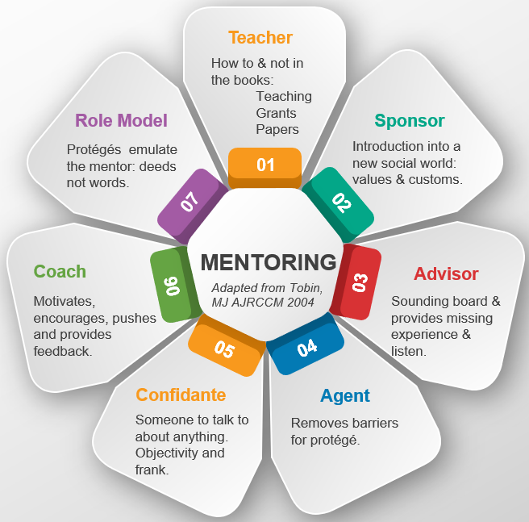
- Mentoring: Briefly describe the mentoring you are receiving for your professional development. Review the essential types of mentoring in provided image and assess the following: Are there gaps or deficiencies in the mentoring that you are receiving? Please describe these. If you currently have no mentors, please include finding a mentor or mentors in your goals for the following year.

Please list your current mentor(s):

- Inclusive Excellence: The Larner College of Medicine community contributions to inclusive excellence through teaching, service, and scholarship. They embrace and advance the values of Our Common Ground: openness, respect, responsibility, integrity, innovation, and justice. List any specific activities in which you have contributed to Our Common Ground Values and advanced inclusive excellence for LCOM and/or our greater community (e.g. committees, mentoring, recruitment, curriculum development etc.) or formal/informal professional development related to inclusive excellence.
- Honors and Awards: List any awards/honors received or nominated for this academic year, local/regional or national/international; If you received a Professional Accolade (from the LCOM Learning Environment) please list here.
- Professional Development: Professional development includes, but is not limited to, activities that enhance/improve skills in clinical practice, teaching, leadership, research, and personal development (e.g. professionalism).
List any professional development activities in which you participated (including courses locally, regionally or nationally, lectures, faculty meetings, professional society meetings/sessions related to faculty development).
- Annual SMART Goals and Self-Assessment:
- List (cut and paste from last year’s annual review) your SMART goals/objectives from the past year.
- Reflecting on last year’s annual review SMART Goals, provide a brief self-assessment summarizing performance during this year: highlight what you consider your most significant accomplishments and indicate areas where you were not able to reach your goals and why.
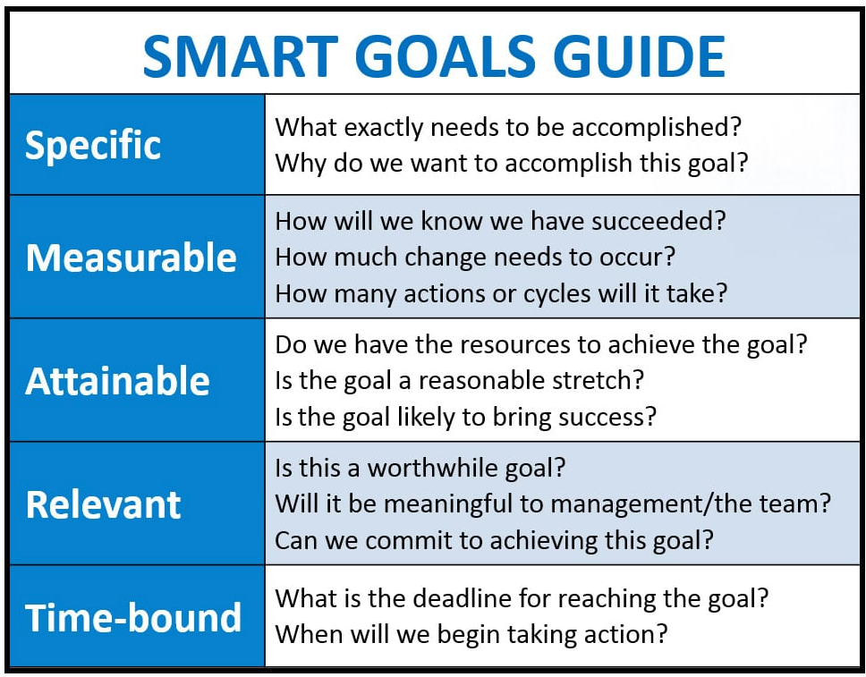
- List your SMART goals for the upcoming year. Using the SMART guide, be concise but specific and realistic in what can be accomplished in an academic year. You may want to include plans for faculty development, and, where applicable, for reappointment/promotion/tenure. Identify the resources needed to achieve your goals including mentorship.

- Assessment/Comments:
(to be completed by Department Chair or designee)

Was Promotion and/or Tenure Discussed with the faculty at this Annual Review?
YES

NO

Is Promotion and/or Tenure being considered in the coming 1-2 years

YES

NO
Has this faculty reviewed their trainee/student teaching evaluations.

YES

NO

To your knowledge, is this person aware of the Statement on Professionalism?
In your opinion, has this person demonstrated professionalism?

Use the box below to provide your summary comments and feedback to the faculty undergoing annual review.

Reviewed on (date): _________________________________________

If applicable:
Reviewed as Designee by _________________________________________
(Name & Title)

Signature – Faculty Member ____________________________________________

Signature –Departmental Chair __________________________________
*(Name of Chair & Department)

*If reviewed by designee: I have reviewed this Annual Faculty Review Form and recommend (faculty name) for reappointment.

