Publications
The Routledge Handbook of the New African Diasporic Literature
Postcolonial Agency in African and Diasporic Literature and Film: A Study
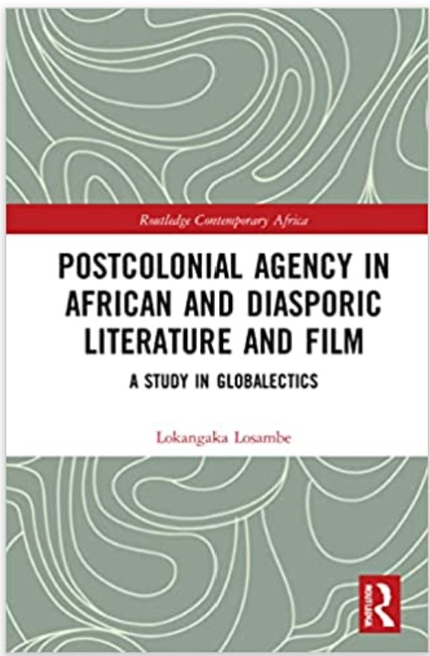 | Postcolonial Agency in African and Diasporic Literature and Film (Routledge Contemporary Africa: January, 2022)
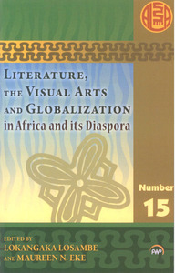 | With Maureen Eke and Helen Scott, eds. Literature, the Visual Arts and Globalization in Africa and its Diaspora (Trenton, NJ: Africa World Press: 2011)
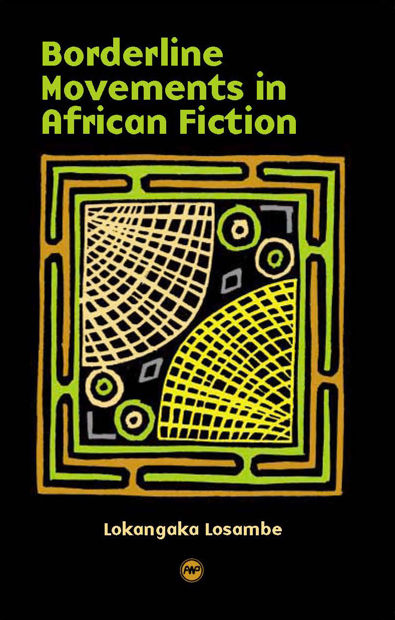 | Borderline Movements in African Fiction (Africa World Press: 2005)
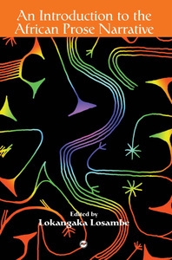 | Ed., An Introduction to the African Prose Narrative (Pretoria: Kagiso Publishers, 1996)
 | With Devi Sarinjeive , eds. Precolonial and Postcolonial Drama and Theatre in Africa (Cape Town & Trenton, N.J.: New Africa Education Publishing & Africa World Press, 2001).

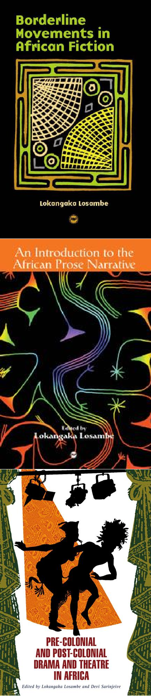
Boídeíli⭲e Mo»e½e⭲īs i⭲ €ríica⭲ Iicīio⭲ (Aríica Woíld Pícss: 2005)
Ed., €⭲ I⭲īíoducīio⭲ īo ī”e €ríica⭲ Níose Naííaīi»e
(Pícťoíia: Kagiso P"bliskcís, 1996)
Wiťk Kc:i Saíi⭲jci:c , cds. Níecolo⭲ial a⭲d Nosīcolo⭲ial Kía½a a⭲d ľ”eaīíe i⭲ €ríica (Capc ľow⭲ & ľíc⭲ťo⭲, N.J.: Ncw Aríica Ed"caťio⭲ P"bliski⭲g & Aríica Woíld Pícss, 2001).

