Drawing a Systems Map

Class activity for Chapter 1
Food, Farms and Community

Material Requirements: None
Time Requirement: 30-45 minutes

A powerful tool for studying systems is the systems map. A systems map is a graphic developed to illustrate how a system functions. Systems maps typically include stocks, flows and elements that influence them. This activity will introduce students to the basics of systems mapping. To carry out the activity, break students into small groups that you will use eventually, but not initially. First, offer students a basic lecture on systems mapping that includes an overview of stocks and flows. This doesn’t have to be long, and should include the following information:
Stocks are system elements that we can count or measure at any given time, while flows are processes that increase or decrease the level of a stock. Stocks to consider when mapping a system can include important resources used by the system, such as energy, nutrients, materials, or financial resources. Stocks can be represented by a box, while flows can be represented by pipes with valves, as illustrated in the graphic below using someone’s personal wealth as an example. Personal wealth can be thought of as a stock of wealth, like a bank account. A person’s income adds to that stock, and their spending removes from it.
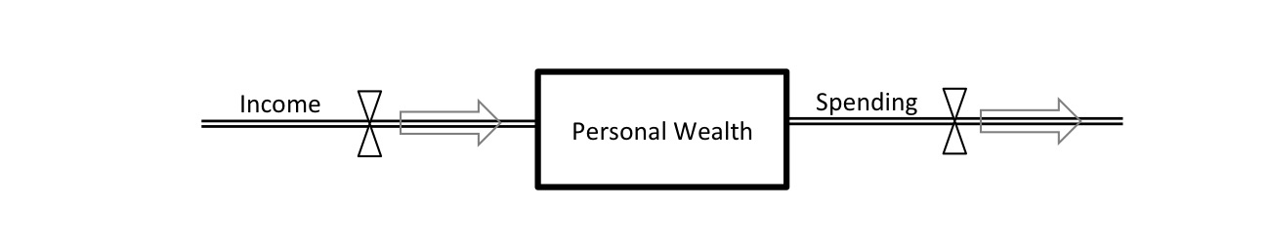
Once students seem to have a sense for stocks and flows, break into small groups and invite students to brainstorm a few different stock-flow combinations that are relevant to food systems. Remember, stocks are measurable and can increase and decrease, while flows actively add to or remove from those stocks. Once students have had 10 or so minutes to discuss a few options, bring the class back together for some sharing before you move on.

Once students have an understanding of stocks and flows, it’s time to add other elements into their systems maps that influence stocks and flows. Building on the example of personal wealth we started with, here’s a more in-depth systems map of that system. Offer a brief lecture during class illustrating how to add additional elements to the systems map that influence flows or their associated stocks, and how to illustrate connectivity between these elements. Some elements will directly influence stocks or flows, while others only do so indirectly. The following example is not intended to be thorough or even necessarily accurate, but is offered to give readers a sense for how stocks, flows and other elements can be combined to portray the workings of a system.
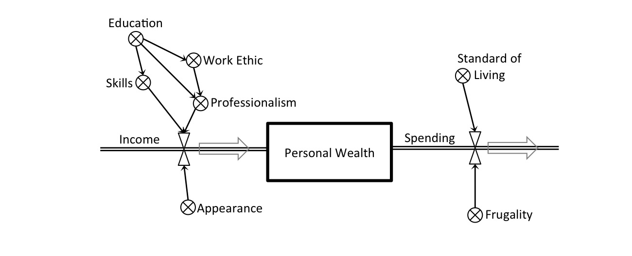
Once students seem to grasp how to represent elements beyond stocks and flows, invite them to spend time in their small groups expanding on one of their original ideas of a stock-flow system relevant to food systems. This is just an exploratory exercise, so does not need to include in-depth research nor does it need to be accurate. Students’ systems maps may be fairly simple, or they may quickly expand to include 10, 20 or more elements beyond the initial stock and its associated flows. After students have had 20 or so minutes to explore this, bring them back together to discuss the process of systems mapping as a class.
This activity will be suggested for other parts of the class as well, so you may want to revisit this description as needed.

