Sarah E. Turner
PUBLICATIONS
Books
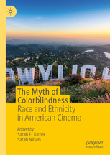 | The Myth of Colorblindness: Race and Ethnicity in American Cinema, eds. Sarah E. Turner and Sarah Nilsen, Palgrave Macmillan, forthcoming November 2019
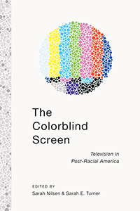 | The Colorblind Screen: Television in Post-Racial America. Co-edited with Sarah Nilsen. NYU Press 2014.
Work in Progress. | 2nd Ed. With Sue Dinitz. Pearson Publishers, August 2001.
Articles and Chapters
“BBFFs: Interracial Friendships in a Post-Racial World." | The Colorblind Screen: Television in Post-Racial America, NYU Press 2014.
“Disney Does Race: Black BFFS in the New Racial Moment.” | Networking Knowledge: Girls in Popular Culture (Special Issue) February 2012.
“Blackness, Bayous and Gumbo: Encoding and Decoding Race in a Colorblind World.” | Diversity in Disney Films: Critical Essays on Race, Ethnicity, Gender, Sexuality and Disability. Ed. Johnson Cheu. McFarland: 2013.
“Reaganomics, Cocaine, and Race: David Cronenberg’s Off-Kilter America and The Dead Zone.” | The Films of Stephen King, Ed. Tony Magistrale, Palgrave Press, 2008.
"Critical Essays: Engaging with the Text and the World Around You" | An Introduction to English  Studies: Reading, Writing, and the Study of Texts. Coeditors Toby Fulwiler and William Stephany. McGraw Hill, 2002.
"Spider Woman's Granddaughter: Autobiographical Writing by Native American Women" | MELUS: The Journal of The Society for the Study of the Multi-Ethnic Literature of the United States Winter 1997 v22(4)

