Sarah Alexander
PUBLICATIONS
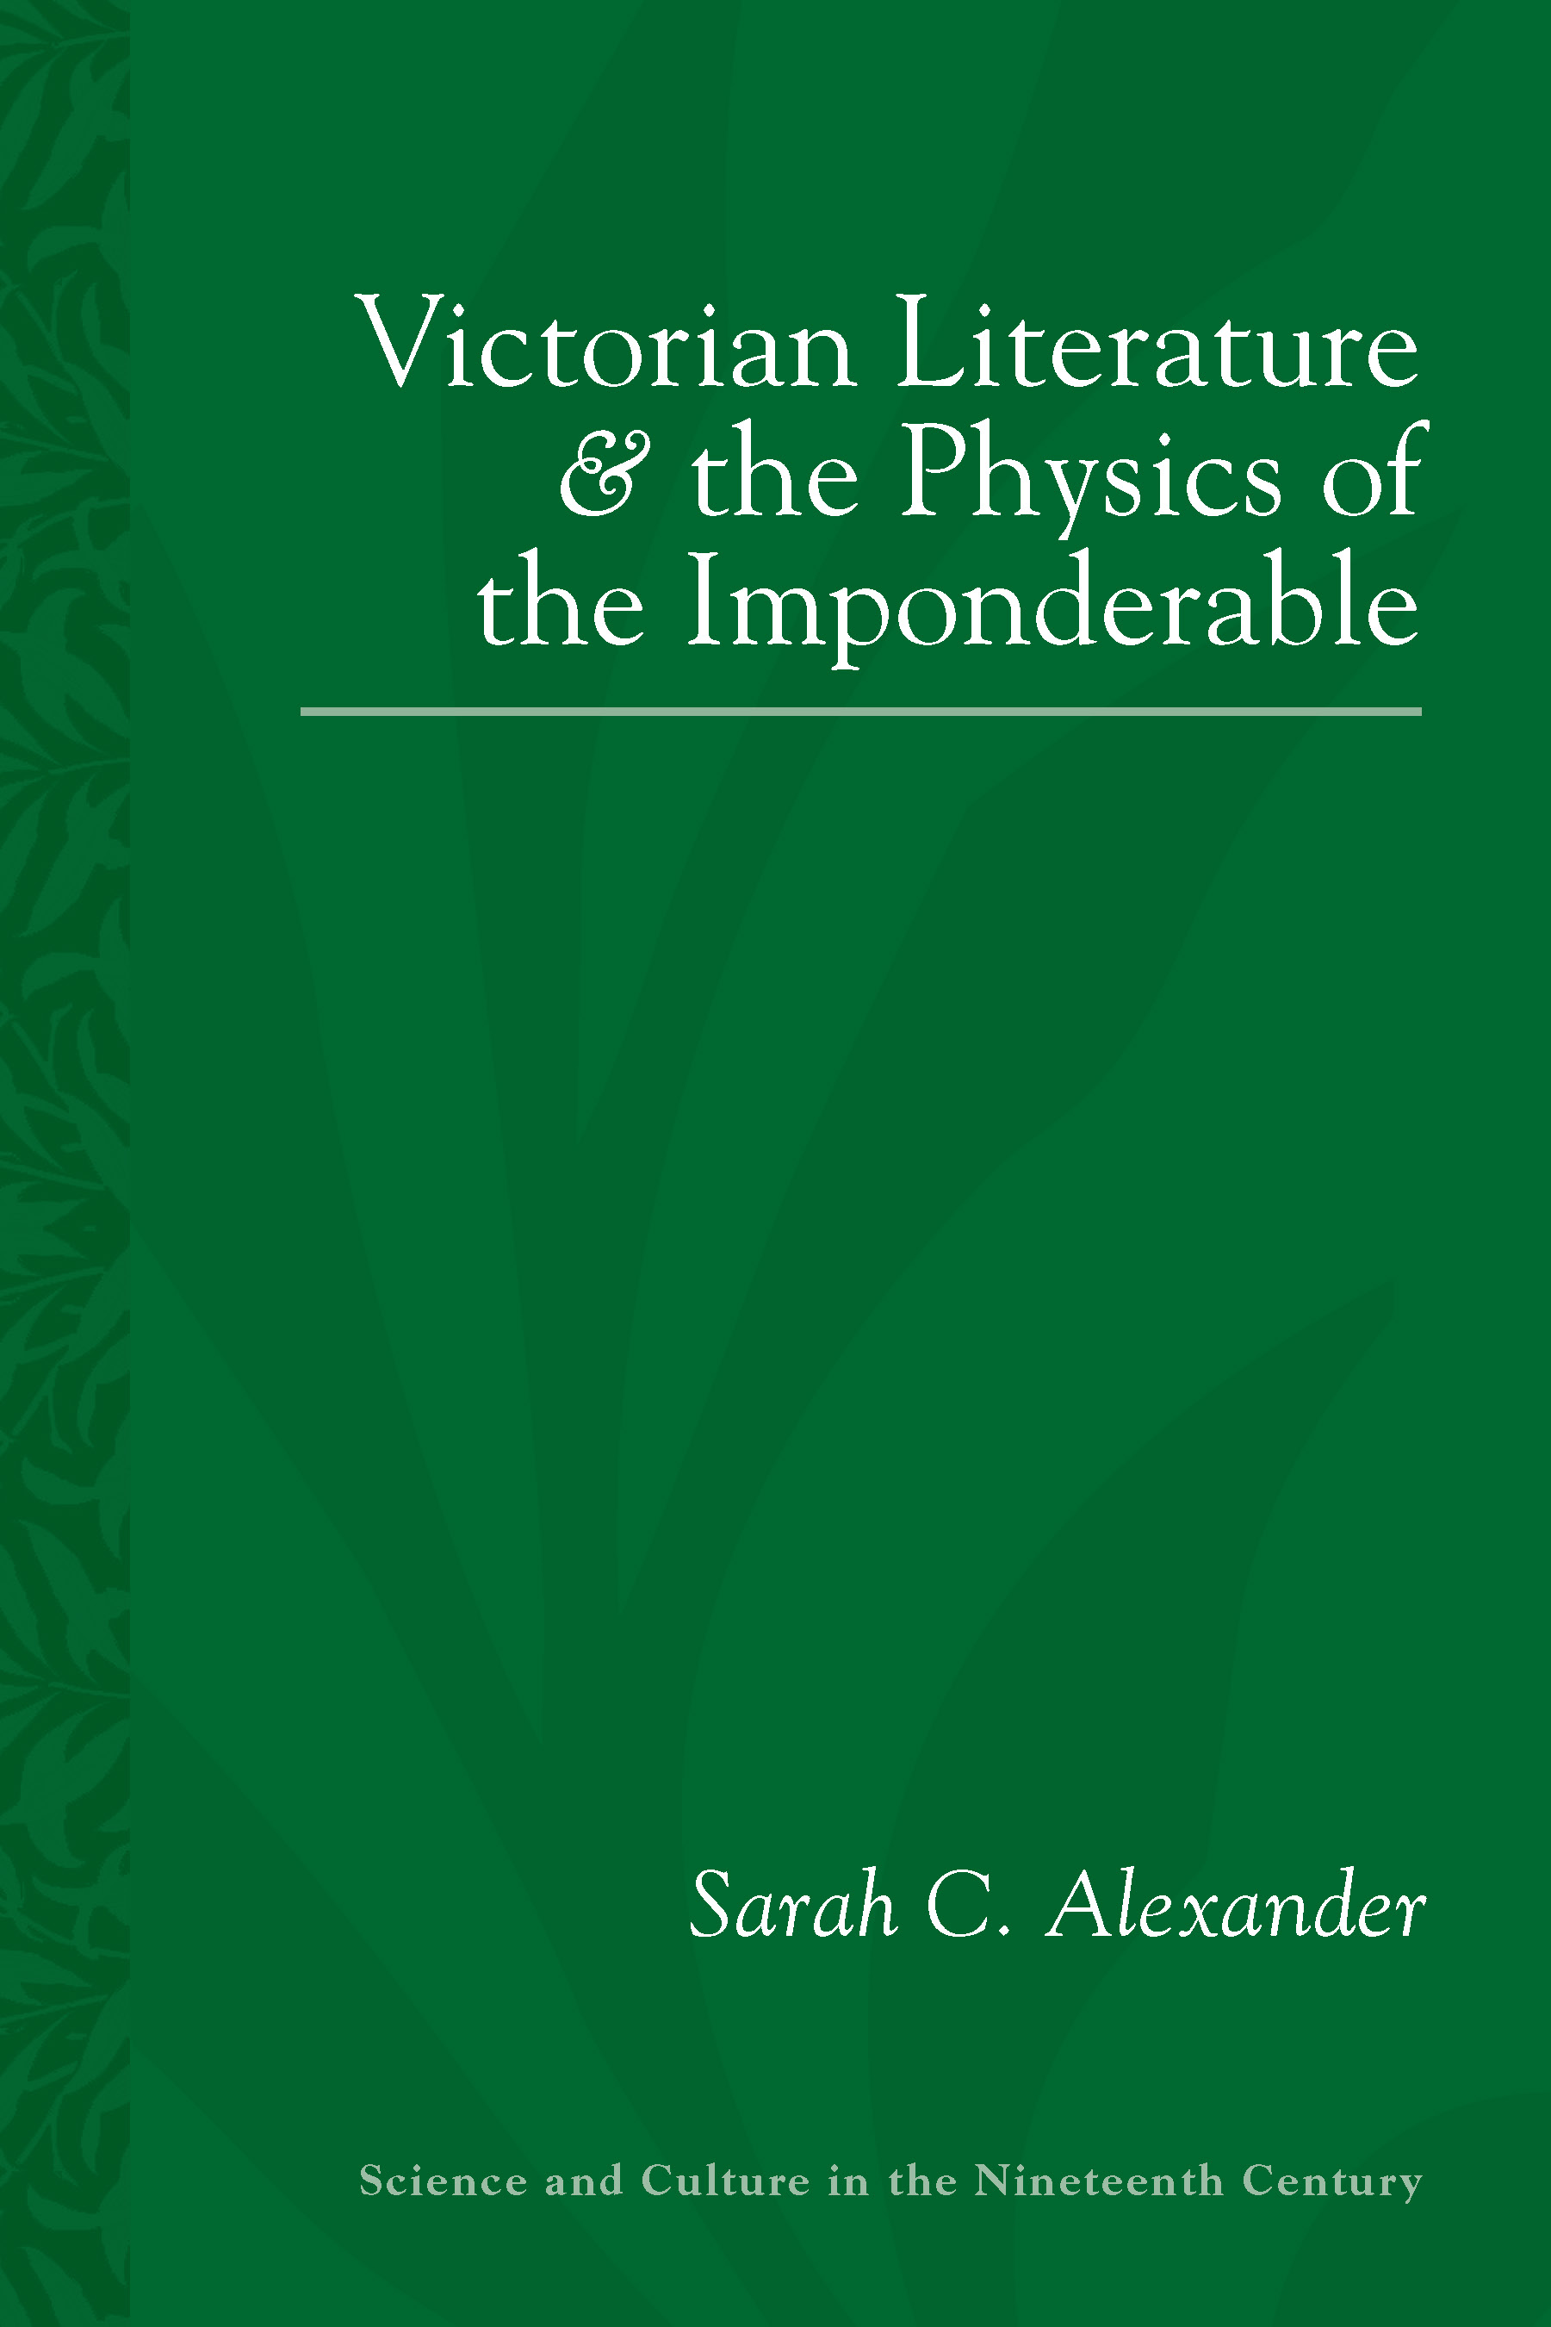 | Victorian Literature and the Physics of the Imponderable,  University of Pittsburgh Press, December 2016.

Articles
“Saving Time: Nineteenth-Century Time Travel and the Temporal Logic of Late  Capitalism” | Victorian Studies, 60.2. 2018
“The Residuum, Victorian Naturalism, and the Entropic Narrative” | Nineteenth-Century  Contexts, 35:2 (2013): 99-120.
“Arthur Morrison” | The Wiley-Blackwell Encyclopedia of Victorian Literature, Malden,  MA: Wiley-Blackwell, July 2015.
“A Tale of Two Dandies: Gore, Dickens, and the ‘Social-Fork’ Novel.” | Women’s Writing.  16.2 (2009): 283-300.

