Nancy Welch
RESEARCH AND/OR CREATIVE WORKS
Selected Fiction
“Pretty.” | Ploughshares 39 (Fall 2013). Guest editor: Peter Ho Davies. 142-55. Recipient of Best American Short Stories 2014 and Best American Nonrequired Reading 2014 citations. Selected for  the New York Public Library’s Subway Reads program Winter 2017-18.
“Free Country.” | Prairie Schooner 86 (Summer 2012): 87-103.
“Havazik.” | Seven Days. Winter Reading issue. December 17–24, 2008: 30A–33A

PUBLICATIONS
Books
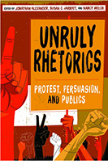 | Unruly Rhetorics: Protest, Persuasion, and Publics  University of Pittsburgh Press, November 2018
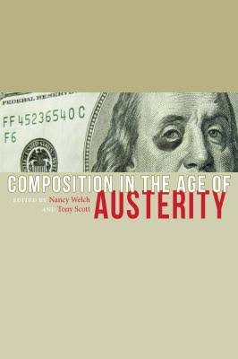 | Composition in the Age of Austerity. Ed. Tony Scott and Nancy Welch. Logan, UT: Utah State University Press, 2016.
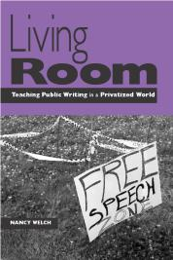 | Living Room: Teaching Public Writing in a Privatized World. Portsmouth, NH: Boynton/Cook, 2008.
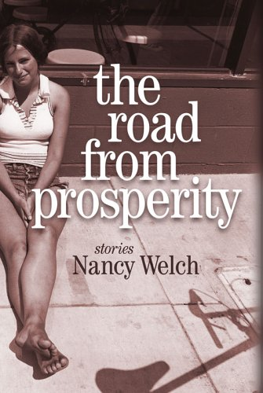 | The Road from Prosperity: Stories. Dallas: Southern Methodist University Press, 2005.
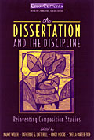 | The Dissertation and the Discipline: Reinventing Composition Studies. Co-edited with Kate Latterell, Cindy Moore, and Sheila Carter-Tod. Portsmouth, NH: Boynton/Cook, 2002.
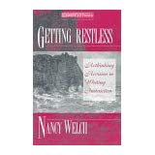 | Getting Restless: Rethinking Revision in Writing Instruction. Portsmouth, NH: Boynton/Cook, 1997.
Selected Articles and Chapters
“Informed, Passionate, and Disorderly: Uncivil Rhetoric in a New Gilded Age.” | Originally published  in Community Literacy Journal 7.1 (Fall 2012). Special issue: Writing Democracy (winner of the Council of Editors of Learned Journals 2013 Best Public Intellectual Special Issue). 33-51.  Expanded and updated version to appear in Unruly Rhetorics.
“Introduction: Composition in the Age of Austerity.” | With Tony Scott. In Composition in the Age  of Austerity. Ed. Tony Scott and Nancy Welch. Logan, UT: Utah State University Press,  2016. 3-17.
“First-Year Writing and the Angels of Austerity: A Re-Domesticated Drama.” | Composition in the Age of Austerity. 132-145.

