James Williamson
RESEARCH AND/OR CREATIVE WORKS
“W.Hears a Whine” and “W. Encounters a Splice” | 05401PLUS

PUBLICATIONS
Books
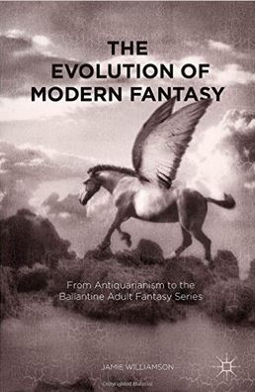 | The Evolution of Modern Fantasy: From Antiquarianism to the Ballantine Adult Fantasy Series, Palgrave, July 2015.
Chapters and Essays
Preface to Idols With Tears | by Sierra Leonan author Michael Kallon (2005)
“Emblematic Bodies” | The Body in Tolkien’s Legendarium, edited by Chris Vaccaro, published by McFarland August 2013
“The Fourfold Myth of Death and Rebirth in George MacDonald’s  Phanstastes” | North Wind No. 33 (2014), a scholarly journal dedicated to the work of George MacDonald, and appeared in May 2015
Blogpost: “Kenneth Morris/Cenydd Morus” | Literature Wales website

