Hyon Joo Yoo
PUBLICATIONS
Books
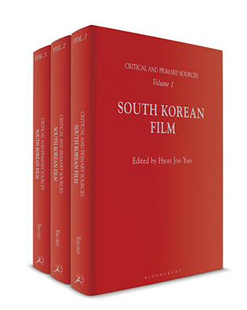 | South Korean Film: Critical and Primary Sources Volume I-III  Bloomsbury Publishing, 09 Sep 2021
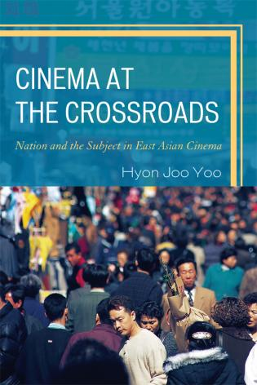 | Cinema at the Crossroads: Nation and the Subject in East Asian Cinema Lexington Books/a part of the Rowman and Littlefield Publishing Group Inc., 2012
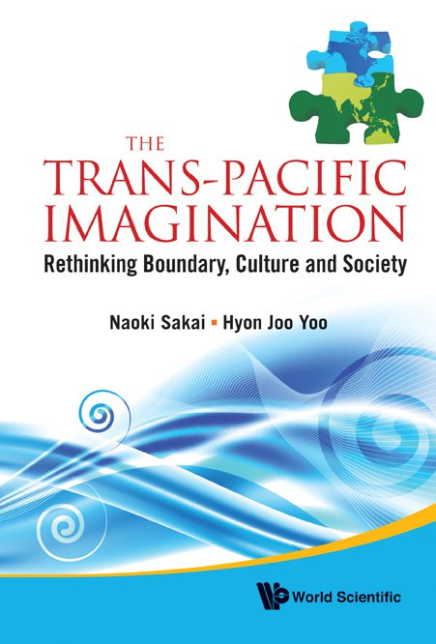 | Editor (with Naoki Sakai, Cornell University), The Trans-Pacific Imagination: Rethinking Boundary, Culture and Society (World Scientific Publishing, 2012): wrote its Introduction and a chapter entitled “The Incurable Feminine: Women Without a Country in East Asian Cinema”
South Korean Cinema | (a series of three books: Bloomsbury, forthcoming). I edited the entire series and wrote four introductory essays.
Essays
“Cartography of the Abject Nation in Thirst and Still Life.” | Forthcoming in Studies in Humanities
“The Chronotope of Trauma in National Cinema.” | Journal of Japanese and Korean Cinema (Routledge). Vol. 7, No. 1, 2015.
“Transnational Cultural Production and the Politics of Moribund Masculinity.” | positions: east asia cultures critique Vol. 16, Issue 3 (2008). 661-688 (as Hyon Joo Yoo Murphree).
“Class and Ethnicity in the Global Market for Organs: The Case of Korean Cinema.” | (with Rebecca Garden) Journal of Medical Humanities Vol. 28, No. 4 (2007), 213-229 (as Hyon Joo Yoo Murphree).
“The Stranger’s Passage in Cyberspace.” | Postcolonial Studies Vol. 8, No.2 (2005), 181-197 (as Hyon Joo Yoo Murphree).

