Eric Lindstrom
PUBLICATIONS
Books
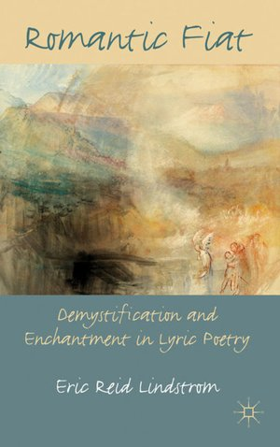 | Romantic Fiat: Demystification and Enchantment in Lyric Poetry; Palgrave  Macmillan, 2011 (272 pages); review in Studies in Romanticism 51 (Winter  2012): 624-7.
Selected Articles and Essays
“Money, Painting, and the Generic Abidance of Elizabeth Bishop’s ‘Poem’ ” | forthcoming in Modernism/ Modernity April 2018
“Mourning Life: William Wordsworth and Percy Bysshe Shelley” | Romanticism 23.1 (2016): 38-52
“Romanticism, Poetics, and Lyric Theory” | “Teaching Romanticism and Literary Theory” issue of Romantic Pedagogy Commons (December 2016 online); volume editor, Brian McGrath
Book Chapters
“Austen, Philosophy, and Comic Stylistics” | Jane Austen and Comedy, ed. Erin Goss (Bucknell University Press, 2017)
“Judging Correct and Free Indirect Style” | Style and Romantic Fiction, ed. Anne Toner (Cambridge University Press)

