David Jenemann
PUBLICATIONS
Books
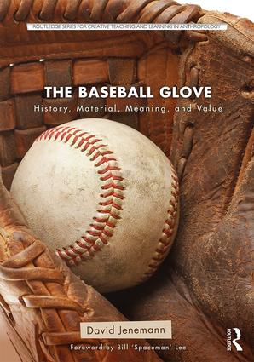 | The Baseball Glove: History, Material, Meaning, and Value (Routlege Taylor & Francis Group, 2018)
 | Adorno in America (Minneapolis: University of Minnesota Press, 2007)
Selected Articles and Book Chapters
“Racket and Relevance” | nonsite.org special issue on Max Horkheimer’s “On the Sociology of Class Relations” nonsite, 18 (2016)
“Stupider and Worse: The Cultural Politics of Stupidity” | parallax, Volume 19, Issue 3 (2013), 134-149
“Strangling the Malcontents: Critical Theory and Pseudo-Conservatism Today” | Constelaciones. Revista de Teoría Crítica, Vol. 3 (2011): “Teoría Crítica de la industria de la cultura.” 227-233
“Camouflage Work: The Hidden Subject of Modernism” | Individualism: The Cultural Logic of Modernity, Edited by Zubin Meer (Lanham, MD: Lexington Books, 2011) 191-202
“Stop Being an Elitist, and Start Being an Elitist” | Flow 13.5, (December 2010)

